Research assignment presented in partial fulfilment for the requirements for the degree of MEng (Structured) (Industrial Engineering) in the Faculty of Engineering at Stellenbosch University
Supervisor: Prof. Evan Gilbert
November 2026

In Search of the Holy Grail of Factor Timing:
Application of Machine Learning to the South African Equity Market
by
Cathy Catherine Hlungwani

Declaration
By submitting this research assignment electronically, I declare that the entirety of the work contained therein is my own, original work, that I am the sole author thereof (save to the extent explicitly otherwise stated), that reproduction and publication thereof by Stellenbosch University will not infringe any third party rights and that I have not previously in its entirety or in part submitted it for obtaining any qualification.
During the preparation of this research assignment, the author used artificial intelligence-assisted tool(s) to identify relevant literature, generate code, generate images, improve the readability and language of the thesis. After using the artificial intelligence-assisted tool(s), the author reviewed and edited the content and takes full responsibility for the content of the work.
Date: November 2026

Copyright © 2026 Stellenbosch University
All rights reserved
Abstract
Momentum, value and quality earn long-term premia, but their relative performance varies over time. This study tests whether machine learning can predict which of these factors leads in the South African equity market, and whether more flexible models predict better. Regularised logistic regression, a generalised additive model (GAM) and XGBoost are trained on trend-scanned labels for three factor pairs, tuned by combinatorial purged cross-validation and evaluated on weekly walk-forward predictions. The evidence of predictability is weak. XGBoost has the best point estimate on every measure for every pair, with areas under the ROC curve of 0.585 to 0.660, but its block-bootstrap confidence interval excludes chance only for value versus quality, and its lead over logistic regression is not statistically significant for any pair. The GAM ranks below logistic regression on this measure for two pairs, but its weak results partly reflect the weakly penalised settings selected in tuning rather than the model class alone. Value versus quality is the most predictable pair, whereas XGBoost's accuracy for momentum versus value comes mainly from predicting momentum in the great majority of weeks. Relative-volatility measures rank among the top ten features of eight of the nine fitted models. Machine learning therefore offers at most a weak, pair-specific signal, better suited to moderating the tilt between two factors than to switching between them. Whether that signal survives transaction costs is left for future research.

Acknowledgements
xxxx

Contents
- Introduction 9
1.1 Background 10
1.2 Problem statement 12
1.3 Scope and objectives 12
1.4 Research methodology 13
1.5 Contribution to data science 14
1.6 Research assignment outline 15
- Literature Review 17
2.1 Machine learning in finance 17
2.2 Application of machine learning to factor timing in the global literature 22
2.3 Application of machine learning factor timing strategies in South African equity markets 28
- Methodology 30
3.1 Research design and empirical framework 30
3.2 Factor definitions 31
3.3 Motivation for using relative factor performance 33
3.4 Data sources and pre-processing 36
3.5 Trend-scanning target label construction 37
3.6 Feature selection 40
3.7 Model training 43
3.8 Hyperparameter tuning and model validation 49
3.9 Performance evaluation 52
3.10 Feature importance 54
- Results 56
4.1 Overview of the Evaluation Framework 56
4.2 Out-of-Sample predictive performance 56
4.3 Consolidated confusion-matrix analysis and probability quality 63
4.4 Feature importance 65
- Conclusion 70
- References 75
- A.1: Feature Selection 84
A.2: Feature selection 87
A.3: CPCV and walk-forward formulation 92

List of Figures
Figure 1: Rolling 12-month active returns of the momentum, value and quality factors 33
Figure 2: Rolling 36-month correlations of active returns 34
Figure 3: Trend-scanning results for momentum vs value 38
Figure 4: Trend-scanning results for value vs quality 38
Figure 5: Trend-scanning results for momentum vs quality 39
Figure 6: Hierarchical agglomeration clustering applied to the features space 40
Figure 7: CPCV with N = 5 chronological splits and k = 2 validation splits, giving ten combinations and four back-test paths 49
Figure 8: Expanding-window walk-forward validation with a 12-week purge and retuning every 52 predictions. 51
Figure 9: Out-of-sample ROC curves for momentum versus value 57
Figure 10: Walk-forward predicted probability that momentum leads value, with the realised class 58
Figure 11: Out-of-sample ROC curves for momentum versus quality 59
Figure 12: Walk-forward predicted probability that momentum leads quality, with the realised class 60
Figure 13: Figure 13: Out-of-sample ROC curves for value versus quality 61
Figure 14: Walk-forward predicted probability that value leads quality, with the realised class 62

List of Tables
Table 1: Summary of the 50 modelling features by category 42
Table 2 Model comparison 48
Table 3: Hyperparameter search grids 51
Table 4: Out-of-sample accuracy, ROC-AUC and log-loss by factor pair and model 56
Table 5: Realised class distribution in the 156-week evaluation block 64
Table 6: Confusion-matrix diagnostics 64

List of acronyms and abbreviations
Acronym or abbreviation | Definition
AI | Artificial Intelligence
ARI | Adjusted Rand Index
AUC | Area Under the Curve
CAPM | Capital Asset Pricing Model
CART | Classification and Regression Trees
CDS | Credit Default Swap
CPCV | Combinatorial Purged Cross-Validation
Diff | First-Difference Transformation
DXY | US Dollar Index
EBIT | Earnings Before Interest and Taxes
EBITDA | Earnings Before Interest, Taxes, Depreciation and Amortisation
Ent | Entropy (market uncertainty measure)
EntDyn | Entropy under Dynamic Encoding
FNN | Feedforward Neural Network
FTSE | Financial Times Stock Exchange
FX | Foreign Exchange
FY1 | Financial-Year Earnings Estimate (current financial year in this study)
GAM | Generalised Additive Model
GretX | X-Month Geometric Return
GRU | Gated Recurrent Unit
JSE | Johannesburg Stock Exchange
L1 | Absolute-Value Regularisation Penalty
L2 | Squared-Value Regularisation Penalty
LASSO | Least Absolute Shrinkage and Selection Operator
LSTM | Long Short-Term Memory Network
MI | Mutual Information
ML | Machine Learning
MSCI | Morgan Stanley Capital International
NB | Nominal Bonds
NMI | Normalised Mutual Information
OOS | Out-of-Sample
PC1 / PC2 | First / Second Principal Component
PCA | Principal Component Analysis
PE | Price-to-Earnings Ratio
PMI | Purchasing Managers’ Index
PPP | Purchasing Power Parity
QS | Quantile-Scaled Transformation
RB | Real Bonds
RNN | Recurrent Neural Network
ROC | Receiver Operating Characteristic
ROC-AUC | Area Under the Receiver Operating Characteristic Curve
ROE | Return on Equity
ROIC | Return on Invested Capital
RV_X | X-Month Realised Volatility
SA | South Africa / South African
SB | Structural Break Indicator
SHAP | Shapley Additive Explanations
SWIX | Shareholder Weighted Index
TOP40 | FTSE/JSE Top 40 Index
TS | Trend-Scanning t-Statistic
US | United States
USD | United States Dollar
USD/ZAR | US Dollar–South African Rand Exchange Rate
VIX | Cboe Volatility Index
VolX | X-Month Rolling Volatility
XGBoost | Extreme Gradient Boosting
ZAR | South African Rand

Introduction
Equity factors such as momentum, value and quality earn well-documented long-term premia (Fama & French, 1993; Jegadeesh & Titman, 1993; Asness, Frazzini, & Pedersen, 2019), but their returns vary materially over time, with extended periods of strong performance interrupted by deep drawdowns (Daniel & Moskowitz, 2016; Ilmanen, Israel, Lee, Moskowitz, & Thapar, 2021). If changes in relative factor performance are partly predictable, investors could tilt their allocation towards the factor expected to outperform (Asness, Friedman, Krail, & Liew, 2000; Gupta & Kelly, 2019; Arnott, Kalesnik, & Linnainmaa, 2023). This study examines whether machine learning models can predict which of the momentum, value and quality factors will lead in the South African equity market, and whether more flexibility improves predictive accuracy.
Recent South African studies have begun to apply machine learning to style rotation (Makamo, 2023; Page, McClelland, & Auret, 2024). But limited evidence isolates the incremental contribution of nonlinearity and interaction effects. Factor timing is framed as a classification problem for three factor pairs, momentum versus value, momentum versus quality and value versus quality, with trend-scanned labels (López de Prado, 2018; López de Prado, 2020) identifying which factor of each pair outperforms. The labels are predicted from lagged market, macroeconomic, valuation, sentiment and factor-specific variables, with redundant candidates removed by mutual-information clustering (López de Prado, 2018; Sulaiman & Labadin, 2016). Three model classes of increasing flexibility are compared: logistic regression as the linear benchmark (Hosmer, Lemeshow, & Sturdivant, 2013), a generalised additive model (GAM) that allows smooth nonlinear effects (Hastie & Tibshirani, 1986), and XGBoost, which also captures interactions between predictors (Chen & Guestrin, 2016). To guard against overfitting, hyperparameters are selected by combinatorial purged cross-validation (López de Prado, 2018; López de Prado, 2020). The models are then evaluated on three years of weekly predictions from a walk-forward validation using accuracy, ROC-AUC and log-loss. Shapley values (Shapley, 1953; Lundberg & Lee, 2017) then show which predictors each model relies on.

Background
The empirical study of equity factors developed from the recognition that market beta alone does not explain the cross-section of expected returns. The Capital Asset Pricing Model (CAPM) provided the starting point (Lintner, 1965; Sharpe, 1964), and multi-factor models subsequently identified systematic differences in expected returns associated with company characteristics known as factors (Fama & French, 1992; Fama & French, 1993). Momentum (Jegadeesh & Titman, 1993; Carhart, 1997), value (Fama & French, 1993), quality (Asness, Frazzini, & Pedersen, 2019; Piotroski, 2000), profitability (Fama & French, 2015) and low volatility (Blitz, Falkenstein, & van Vliet, 2014; Blitz D. C., 2007) are widely documented sources of long-term return, with the momentum and value premia documented across markets and asset classes (Asness, Moskowitz, & Pedersen, 2013). The economic origin of these premia remains debated, straddling rational risk-based (Fama & French, 1993; Fama & French, 2015) and behavioural bias-based explanations (Lakonishok, Shleifer, & Vishny, 1994; Daniel, Hirshleifer, & Subrahmanyam, 1998), suggesting that their drivers are multifaceted and not attributable to a single, unified theory.
These premia do not offer consistent rewards. Factor returns exhibit significant cyclicality and regime dependence, with prolonged periods of outperformance, deep drawdowns and occasional crashes that challenge static, buy-and-hold factor investing (Ilmanen & Kizer, 2012; Barroso & Santa-Clara, 2015; Daniel & Moskowitz, 2016; Bessler, 2021). This time variation creates the empirical motivation for factor timing: if changes in relative factor performance are partly predictable, investors may be able to allocate capital dynamically towards the factors expected to outperform (Arnott, Beck, Kalesnik, & West, 2016; Arnott, Kalesnik, & Linnainmaa, 2023).
The evidence supporting factor timing is mixed. Several studies report that dynamic rules based on valuation, momentum or common factor signals improve risk-adjusted returns (Asness, Friedman, Krail, & Liew, 2000; Gupta & Kelly, 2019; Haddad, Kozak, & Santosh, 2020), while others find that most factor timing relationships are weak, unstable or difficult to exploit consistently out of sample, and that valuation-based timing adds little beyond a static factor allocation (Asness, Chandra, Ilmanen, & Israel, 2017; Ilmanen, Israel, Lee, Moskowitz, & Thapar, 2021). The relevant empirical question is therefore whether a specified forecasting method produces reliable out-of-sample improvement, rather than whether factor timing is theoretically possible.
Classical econometric approaches have been a source of valuable insights in generating factor timing signals, but their reliance on linearity assumptions limits their ability to capture nonlinear interactions and complex market dynamics that may underpin short-run factor rotations (Campbell, Lo, & MacKinlay, 1997; Cont, 2001). Machine learning (‘ML’ hereafter) methods can account for these complexities and offer complementary perspectives to conventional approaches (Moritz & Zimmermann, 2016; Gu, Kelly, & Xiu, 2020; Giglio, Kelly, & Xiu, 2022; Wang, 2023). However, this greater flexibility also increases the capacity to fit noise. This concern is particularly important in finance, where predictive signals are weak, samples are limited and relationships may change over time, and where backtests can overstate performance when model selection repeatedly uses the same observations or when training information overlaps with the period used for evaluation (Harvey, Liu, & Zhu, 2016; Arnott, Harvey, & Markowitz, 2019; Israel, Kelly, & Moskowitz, 2020).
These issues are especially relevant in emerging equity markets. Greater informational inefficiency may leave more exploitable structure, but shorter data histories, higher idiosyncratic risk and more frequent structural breaks increase the risk that flexible models extract spurious patterns (Leung, Lohre, Mischlich, Shea, & Stroh, 2021; Cakici, Fieberg, Metko, & Zaremba, 2023). Although ML methods have shown predictive value in emerging-market return studies, their performance is not necessarily transferable across markets (Hanauer & Kalsbach, 2023).
The South African setting provides a relevant but comparatively under-researched context. Value and momentum effects have long been documented on the Johannesburg Stock Exchange, and subsequent work has shown that local style returns vary through time (Fraser & Page, 2000; Muller & Ward, 2013). Early evidence on equity style timing (Mutooni & Muller, 2007) and on short-term style rotation (Page, McClelland, & Auret, 2022) has been followed by studies that apply machine learning to the same broad problem (Makamo, 2023; Page, McClelland, & Auret, 2024). This literature establishes the relevance of local factor timing, but it does not isolate the incremental contribution of nonlinearity and interaction effects through a controlled comparison of a linear model, an additive nonlinear model and an interaction-capable tree model using identical targets, predictors and evaluation periods.

Problem statement
This study addresses whether machine learning models can identify predictive signals in the relative performance of South African equity factors. Existing local research provides limited evidence comparing models with different levels of flexibility using the same factor pairs, predictor set and time-series validation framework. This study therefore compares logistic regression, generalised additive models and XGBoost to determine whether greater model flexibility improves the out-of-sample prediction of relative momentum, value and quality performance.

Scope and objectives
The forecasting problem is defined in terms of the relative performance of three factor pairs: momentum versus value, momentum versus quality, and value versus quality, a formulation consistent with recent applications of ML to directional financial prediction (Cotturo, Liu, & Proner, 2024; Piovezan, de Andrade Júnior, & Ávila, 2024). The study concentrates on statistical predictive performance rather than portfolio construction. Transaction costs, portfolio turnover, market impact and probability-based allocation rules fall outside the primary empirical scope and are identified as areas for future research.
The primary objective of this study is to determine whether machine learning models with different levels of functional flexibility can predict the relative performance of momentum, value and quality factors in the South African equity market. Within this scope, the study has the following specific objectives:
- Construct pairwise classifications of relative factor leadership using trend-scanning labels for momentum versus value, momentum versus quality, and value versus quality.
- Implement a time-series-consistent validation framework combining combinatorial purged cross-validation for hyperparameter selection with walk-forward validation of out-of-sample performance.
- Compare the out-of-sample predictive performance of logistic regression, generalised additive models and XGBoost, and assess whether greater model flexibility produces consistent improvements across the three factor pairs.
- Identify the features that most influence model predictions and examine how their importance varies across factor pairs and model classes.

Research methodology
The empirical design consists of three primary methodological components. The first is a target-labelling technique suited to financial time series, the second a comparison of model classes of increasing flexibility, and the third a cross-validation procedure that preserves the temporal ordering of the data. We focus on predicting relative outperformance between factor pairs rather than return magnitudes.
The empirical analysis uses weekly factor return data spanning 2007-2025. These returns are combined with a broad set of lagged explanatory variables drawn from market, macroeconomic, valuation, sentiment, and volatility indicators. The inclusion of multi-domain predictors reflects evidence that factor premia are state-dependent and influenced by both price-based and macroeconomic conditions (Gu, Kelly, & Xiu, 2020; Feng, Giglio, & Xiu, 2020).
Binary labels are constructed using the trend-scanning methodology (López de Prado, 2018; López de Prado, 2020). This approach allows the labelling process to adapt to varying market dynamics without imposing a fixed prediction window. Given the high dimensionality of the feature space, an information-theoretic clustering procedure based on mutual information is employed to reduce redundancy while preserving nonlinear dependencies (López de Prado, 2018; Sulaiman & Labadin, 2016). This produces a compact and diversified predictor set appropriate for supervised learning.
To assess the incremental value of model flexibility, three progressively sophisticated model classes are compared: a linear logistic regression (Zou & Hastie, 2005; Hosmer, Lemeshow, & Sturdivant, 2013) , a semi-parametric GAM (Hastie & Tibshirani, 1986; James, Witten, Hastie, & Tibshirani, 2021), and a nonlinear tree-based method XGBoost (Friedman, 2001; Chen & Guestrin, 2016).
Model development and evaluation follow a temporally ordered validation framework designed to limit information leakage. Hyperparameters are selected using combinatorial purged cross-validation (‘CPCV’ hereafter) (López de Prado, 2020). It evaluates each candidate setting on several training–validation combinations and, in each combination, purges the training observations whose information horizon overlaps with the validation data, so that no setting is evaluated on data whose information was used in training. The selected parameter configuration is then evaluated using an expanding walk-forward procedure, which approximates sequential real-time forecasting (Campbell, Lo, & MacKinlay, 1997).
Model performance is assessed using a set of complementary classification metrics, including average accuracy, the area under the receiver operating characteristic curve (ROC-AUC), and log-loss. Together these measures capture directional accuracy (average accuracy), ranking ability (ROC-AUC), and probability calibration (log-loss) (James, Witten, Hastie, & Tibshirani, 2021). To further understand the structural drivers of model predictions, feature importance is analysed using Shapley value decompositions, which quantify the marginal contribution of each predictor while accounting for nonlinear interactions (Shapley, 1953). This approach has been widely applied in finance to enhance model interpretability and identify the most influential predictors across various applications (Lundberg & Lee, 2017; Molnar, 2022).
Through this integrated framework, the study evaluates the predictive performance, stability, and interpretability of machine learning models applied to factor timing, providing evidence on whether nonlinear modelling techniques offer meaningful advantages over traditional linear approaches in forecasting relative factor performance.

Contribution to data science
This study makes three principal contributions to applied data science and financial machine learning.
First, the study makes a comparative modelling contribution: it provides a comparison of linear, semi-parametric, and nonlinear machine learning models for factor timing within the South African equity market. This hierarchical evaluation of the three different model classes applied to the same observations, predictor set and evaluation period permits a direct assessment of whether additional functional flexibility improves out-of-sample generalisation.
Second, the study makes a methodological contribution by integrating trend-scanned binary labelling, mutual-information-based clustering for feature reduction, and combinatorial purged cross-validation for hyperparameter selection. Final out-of-sample performance is assessed using a walk-forward evaluation framework that preserves the temporal ordering of the data.
Third, the study uses global Shapley-value attribution to examine the information used by each fitted model. This provides an exploratory link between predictive model behaviour and economically motivated categories of market, macroeconomic, valuation, volatility, sentiment and factor-specific information.
Collectively, these contributions extend the international discourse on ML-driven dynamic allocation strategies while grounding the analysis in a methodologically disciplined framework.

Research assignment outline
The structure of this research assignment follows a systematic progression from theoretical foundations to empirical evaluation and synthesis of findings. Each chapter builds upon the preceding discussion to ensure conceptual coherence and methodological continuity.
Chapter 1 - Introduction: This chapter establishes the context and motivation for the study. It introduces the theoretical and empirical background to equity factor premia and machine learning–based factor timing, formulates the research problem, and defines the objectives and scope of the investigation. The chapter further presents an overview of the research design and methodological framework, and articulates the study’s contribution to data science.
Chapter 2 – Literature Review: Chapter 2 situates the research within the broader academic literature. It reviews the foundational theory of factor premia and the evolution of factor timing strategies, followed by a structured examination of machine learning applications in asset pricing. Particular attention is given to empirical evidence from developed and emerging markets, methodological challenges such as nonlinearity and regime dependence, and concerns regarding overfitting and economic interpretability. The chapter concludes by identifying the research gap addressed by this study, particularly in the context of the South African equity market.
Chapter 3 – Methodology: Chapter 3 presents the empirical framework and modelling strategy adopted in the study. It details the construction of the momentum, value, and quality factors, and motivates the relative factor timing formulation. The chapter further outlines the data sources, preprocessing procedures, trend-scanning label construction, and mutual-information–based feature selection process. The specifications of the three model classes are formally introduced, followed by a description of the hyperparameter optimisation procedure using CPCV and the walk-forward validation. Performance metrics and Shapley-based interpretability analysis are also defined. Collectively, this chapter establishes the statistical safeguards implemented to mitigate look-ahead bias, temporal leakage, and overfitting.
Chapter 4 – Research Results: This chapter presents the out-of-sample results. It compares the three models on accuracy, ROC-AUC and log-loss for each factor pair, with their ROC curves and predicted probabilities, examines how the classification errors are distributed between the two classes and the quality of the predicted probabilities, reports the features with the largest global SHAP importance, and assesses whether the more flexible models add predictive value beyond the regularised linear benchmark.
Chapter 5 – Conclusions and Recommendations: The final chapter synthesises the principal findings of the study and evaluates whether machine learning methods enhance the timing of relative factor performance in the South African equity market. It summarises the key empirical insights, reflects on the incremental value of model complexity, and discusses the broader implications for quantitative asset management and emerging market applications. The chapter concludes by outlining the study’s limitations and proposing directions for future research, including portfolio implementation considerations and regime-sensitive model extensions.

Literature Review

Machine learning in finance
ML is a branch of artificial intelligence (‘AI’ hereafter) concerned with algorithms whose performance on a task improves with experience, that is, with exposure to data, rather than through explicitly programmed rules (Mitchell, 1997; Bishop, 2006). While traditional econometric approaches rely on pre-specified functional forms, ML methods emphasise flexible function approximation, statistical learning theory, and generalisation to unseen data (Bishop, 2006; James, Witten, Hastie, & Tibshirani, 2021). These properties have motivated their growing adoption in financial economics. The central econometric challenge in factor timing is modelling the dynamic, and potentially nonlinear, relationship between predictive signals (macroeconomic, valuation, or sentiment indicators) and the future returns of a factor style portfolio (Cotturo, Liu, & Proner, 2024; Cochrane, 2011). The choice of model family fundamentally determines what kind of relationships can be uncovered. ML literature commonly categorises learning paradigms according to the nature of the available information and the learning objective (Bishop, 2006; Hastie, Tibshirani, & Friedman, 2009; Sutton & Barto, 2018):
- Supervised learning refers to a family of predictive modelling techniques in which algorithms learn a mapping from input variables (predictors) to an output variable (label) using historical data. Formally grounded in statistical learning theory, supervised learning is framed as a risk minimisation problem in which model parameters are estimated by minimising an expected loss function, often subject to regularisation to control model complexity and improve generalisation (Hastie, Tibshirani, & Friedman, 2009; Vapnik, 1999). The parameters are estimated from historical examples of inputs and outcomes and then used to predict outcomes for new inputs (James, Witten, Hastie, & Tibshirani, 2021).
- Unsupervised learning, by contrast, involves algorithms that learn patterns and structures from input data without any labelled outcomes or supervision (Jain, Murty, & Flynn, 1999; Bishop, 2006). Rather than predicting a response variable, these methods aim to model the underlying distribution, geometry, or dependency structure of the input space. Typical tasks include clustering and dimensionality reduction (Jain, Murty, & Flynn, 1999).
- Reinforcement learning represents a distinct goal-oriented learning paradigm where an autonomous agent learns to make decisions by performing actions in an environment to maximise a cumulative reward signal (Sutton & Barto, 2018). The agent learns a policy, a rule that maps states to actions, by trial and error. Reinforcement learning is particularly suited to control and sequential decision problems but is typically more complex and data-intensive than supervised or unsupervised approaches.
Within supervised learning, the literature distinguishes between model families according to their functional flexibility, interpretability, and capacity to capture nonlinear interactions. Regularised linear models, semi-parametric methods, tree-based ensembles, and deep learning architectures occupy distinct positions along this spectrum, reflecting trade-offs between transparency, robustness, and expressive power (Bishop, 2006; Gu, Kelly, & Xiu, 2020). This body of work provides the conceptual foundation for the model families considered in this study.

Regularised and semi-parametric models
A central concern in empirical return prediction is the instability of parameter estimates in the presence of high-dimensional and strongly correlated predictors, a feature that is particularly pronounced in macro-financial datasets (Hastie, Tibshirani, & Friedman, 2009). Statistical literature addresses this challenge through regularisation, which constrains model complexity by penalising large coefficient estimates, thereby reducing variance and improving out-of-sample generalisation (Vapnik, 1999).
Ridge regression introduced an L2 penalty that stabilises linear models under multicollinearity by shrinking coefficients toward zero without eliminating predictors (Hoerl & Kennard, 1970). The LASSO extended this framework by applying an L1 penalty that induces sparsity by setting some coefficients exactly to zero, facilitating variable selection and interpretability (Tibshirani, 1996). Subsequent research highlighted limitations of pure L1 regularisation in environments with highly correlated predictors, motivating the elastic net, which combines L1 and L2 penalties to balance sparsity and stability (Zou & Hastie, 2005).
While regularisation addresses estimation instability, linear models remain limited by their global linear functional form. This limitation motivated the development of semi-parametric models, such as Generalised Additive Models (GAMs), which extend linear predictors by replacing fixed coefficients with smooth, data-driven functions of individual covariates (Hastie & Tibshirani, 1986). By allowing nonlinear marginal effects while preserving additivity, GAMs capture economically intuitive relationships without resorting to fully nonparametric complexity. Penalised regression splines are used to control smoothness and prevent overfitting, positioning GAMs as an intermediate class between linear and fully nonlinear models (Wood, 2017). As such, GAMs provide an interpretable yet flexible framework for modelling gradual, regime-dependent dynamics in financial time series.

Tree-based models
Within supervised learning, tree-based models represent a further departure from parametric and semi-parametric specifications by learning nonlinear decision rules through recursive partitioning of the predictor space (Breiman, Friedman, Olshen, & Stone, 1984; Hastie, Tibshirani, & Friedman, 2009). The aim is to create partitions that are as pure as possible with respect to the target variable, typically evaluated using measures such as Gini impurity or entropy. These models construct interactions and threshold effects endogenously from the data, allowing for locally adaptive relationships between predictors and outcomes. This flexibility makes tree-based methods particularly well suited to capturing regime shifts and higher-order interactions that are difficult to model using linear or additive frameworks.
Early studies documented that single decision trees suffer from high variance and limited out-of-sample robustness, often fitting noise rather than persistent structure (Breiman, Friedman, Olshen, & Stone, 1984). To address these shortcomings, the literature developed ensemble methods that aggregate information across multiple trees. Random forests employ bootstrap aggregation and random feature selection to decorrelate individual trees, yielding more stable and robust predictions (Breiman, 2001). Gradient boosting methods construct trees sequentially, with each iteration focusing on correcting the errors of the existing ensemble through gradient-based optimisation of a loss function (Friedman, 2001). Subsequent innovations such as XGBoost and LightGBM introduced regularisation, shrinkage, and computational optimisations that significantly improved performance and scalability, leading to their widespread adoption in empirical finance and asset pricing research (Chen & Guestrin, 2016; Ke, et al., 2017).
Within the empirical asset-pricing literature, tree-based ensemble methods are frequently characterised by competitive predictive performance in some settings and ability to model complex nonlinear interactions, albeit at the cost of reduced interpretability and increased sensitivity to model tuning relative to linear and semi-parametric approaches (Gu, Kelly, & Xiu, 2020).

Deep learning and hybrid models
Deep learning architectures extend nonlinear function approximation through multiple layers and can represent complex relationships in high-dimensional data (Goodfellow, Bengio, & Courville, 2016). Unlike earlier model classes, deep neural networks employ multiple layers of nonlinear transformations that allow features to be learned hierarchically from the data, rather than being manually specified or implicitly constructed through tree splits. This expressive capacity has driven their increasing adoption in empirical finance, particularly in settings characterised by weak signals, evolving regimes, and complex interaction structures (Gu, Kelly, & Xiu, 2020).
Feedforward neural networks (FNNs) constitute the foundational deep learning architecture and represent a direct extension of nonlinear function approximation within supervised learning (Goodfellow, Bengio, & Courville, 2016). In empirical finance, this flexibility has made neural networks attractive tools for modelling nonlinear predictor interactions and high-dimensional return structures in asset pricing and return prediction problems. Recent studies report that neural network architectures can capture complex interactions among firm characteristics, macroeconomic variables, and style factors that traditional linear models fail to identify (Gu, Kelly, & Xiu, 2020; Chen, Pelger, & Zhu, 2019; Feng, He, Polson, & Xu, 2024). However, because FNNs treat observations as conditionally independent, they do not explicitly model temporal dependence, and their effectiveness in time-series applications often hinges on the quality of engineered lagged inputs or summary features (Goodfellow, Bengio, & Courville, 2016).
To address the inability of feedforward architectures to model temporal dependence directly, the literature introduced recurrent neural networks (RNNs), which incorporate feedback connections that allow information to persist across time steps (Rumelhart, Hinton, & Williams, 1986). This architectural feature enables RNNs to model sequential dependence and dynamic evolution, making them conceptually well suited to financial time series and factor premia that exhibit persistence, reversals, and regime shifts (Gu, Kelly, & Xiu, 2020; Fischer & Krauss, 2018). Early empirical studies, however, documented practical limitations of standard RNNs arising from vanishing and exploding gradient problems, which impede learning of long-horizon dependencies (Bengio, Simard, & Frasconi, 1994).
Subsequent advances addressed these limitations through gated architectures such as Long Short-Term Memory (LSTM) networks (Hochreiter & Schmidhuber, 1997) and Gated Recurrent Units (GRUs) (Chung, Gulcehre, Cho, & Bengio, 2014). By introducing gating mechanisms that regulate information flow and memory retention, these models significantly improve the ability to learn long-range temporal dependencies. Within the financial literature, LSTM and GRU architectures have been applied to persistence and nonlinear dynamics in asset returns, although their performance is context dependent and their complexity reduces interpretability relative to simpler learners (Fischer & Krauss, 2018; Krauss, Do, & Huck, 2017; Sirignano & Cont, 2019; Lim & Zohren, 2021).
More recently, transformer architectures have emerged as a powerful alternative to recurrent models for sequence modelling (Vaswani, et al., 2017). Transformers replace recurrence with self-attention mechanisms that explicitly quantify the relevance of past observations when forming predictions. This design enables the modelling of long-range dependencies and complex interaction structures while allowing for parallel computation, substantially improving training efficiency. Although initially developed for natural language processing, transformers have increasingly been applied in financial forecasting and market prediction tasks, where they offer a mechanism for representing nonlocal temporal relationships and cross-feature interactions (Lim & Zohren, 2021).
Alongside advances in deep learning, the literature has emphasised the value of hybrid and ensemble learning frameworks that combine the strengths of multiple model classes. Model combination approaches aggregate predictions from heterogeneous learners to improve predictive robustness and reduce sensitivity to model-specific assumptions (Dietterich, 2000; Sagi & Rokach, 2018). Stacked generalisation, in particular, integrates heterogeneous base learners, ranging from linear and semi-parametric models to tree-based and neural architectures, through a meta-learner that optimally combines their predictions (Wolpert, 1992).
The diversity of modelling approaches discussed above reflects the broader econometric challenge of forecasting time-varying factor premia in the presence of high-dimensional and potentially nonlinear predictive signals. While traditional linear asset pricing models provide a useful benchmark, growing evidence suggests that the drivers of factor returns may exhibit complex interaction effects, regime dependence, and nonlinear responses to macro-financial conditions (Cochrane, 2011; Gu, Kelly, & Xiu, 2020). These characteristics have motivated a growing body of research that applies machine learning techniques to the problem of factor timing, where predictive models forecast changes in relative factor performance using economic and market information.

Application of machine learning to factor timing in the global literature

Challenges in factor timing
Although the time variation in factor premia provides a clear rationale for factor timing as presented in Section 1.1, exploiting it in practice has proved difficult, whichever forecasting method is used. We outline some of the common challenges encountered when attempting to generate factor timing signals.
The first challenge is identifying which premia are genuine. Asset pricing research has uncovered a rapidly expanding set of cross-sectional return predictors, described as a “zoo” of factors (Cochrane, 2011), and subsequent work attributes much of this proliferation to insufficiently stringent statistical standards. Many proposed factors lack economic justification and fail to replicate out of sample (Harvey, Liu, & Zhu, 2016; Feng, Giglio, & Xiu, 2020). Even genuine premia shrink once they are published, as investors trade on them (McLean & Pontiff, 2016). Timing a factor whose premium is spurious cannot add value. A small core set of factors nevertheless remains widely used in research and practice (Asness, Moskowitz, & Pedersen, 2013; Fama & French, 2015), and the three factors in this study, value, momentum and quality, belong to it.
The second challenge is that the economic drivers of the premia are uncertain. Section 1.1 noted that risk-based and behavioural explanations both have empirical support, and the two point to different predictors. If the premia compensate for risk, they should vary with business conditions, as expected returns on stocks and bonds do (Fama & French, 1989); on the JSE, size and momentum premia have been found to vary with the business cycle (Kapche Fotso, 2019). If they reflect investor biases, they should be largest when mispricing is hardest to arbitrage away, since real-world constraints limit arbitrage (Shleifer & Vishny, 1997). Without a settled theory, a timing model cannot draw its predictors from a single explanation, and factor returns appear to be influenced by a multifaceted set of variables that extends beyond economic fundamentals.
The third challenge is the length of factor cycles. An equal allocation across factors is a demanding benchmark, because equal weighting is difficult to beat out of sample when allocating across assets (DeMiguel, Garlappi, & Uppal, 2009). Yet value crashes and growth rallies recur, and even a diversified factor portfolio can endure multi-year underperformance (Asness, Friedman, Krail, & Liew, 2000; Arnott, Beck, Kalesnik, & West, 2016). Because factor cycles are asynchronous, dynamic reallocation could improve on static diversification (Ilmanen & Kizer, 2012), but cycles that last several years also mean that a sample of a few decades contains few independent episodes from which a timing model can learn, a limitation that has been addressed by examining a century of data (Ilmanen, Israel, Lee, Moskowitz, & Thapar, 2021).
The fourth challenge is that reported timing gains are fragile. Section 1.1 noted that the evidence on factor timing is mixed, and several features of the problem explain why. The predictable component of factor returns is small relative to their noise (Israel, Kelly, & Moskowitz, 2020), and return predictors that perform well over a full sample often fail out of sample and in later subperiods, as has been shown for the equity premium (Welch & Goyal, 2008). Because many predictors and specifications are tested on the same data, the best reported result is biased upwards unless the search itself is taken into account (White, 2000). Results are also sensitive to the predictor, evaluation period, benchmark and treatment of implementation costs (Ilmanen, Israel, Lee, Moskowitz, & Thapar, 2021): relative valuations have been found useful for timing factors (Arnott, Beck, Kalesnik, & West, 2016), but value timing adds little beyond a static allocation (Asness, Chandra, Ilmanen, & Israel, 2017), and volatility-managed portfolios do not systematically outperform their unmanaged counterparts out of sample (Cederburg, O'Doherty, Wang, & Yan, 2020).
The fifth challenge is the complexity of the relationship between predictors and factor returns. The drivers of factor premia may operate over different horizons (Cotturo, Liu, & Proner, 2024), the relationship between predictors and factor performance may be nonlinear and interactive (Leung, Lohre, Mischlich, Shea, & Stroh, 2021; Bryzgalova, Pelger, & Zhu, 2023), and these relationships can change across market states (Ilmanen, Israel, Lee, Moskowitz, & Thapar, 2021). The set of candidate predictors is also large relative to the available sample (Rapach & Zhou, 2013; Feng, He, Polson, & Xu, 2024). These difficulties have led recent research to the machine learning methods reviewed in Section 2.1 (Gu, Kelly, & Xiu, 2020). Their ability to approximate nonlinear relationships does not, however, imply that the most flexible model will forecast best, which motivates the comparison of models with different levels of functional flexibility.

Model complexity trade-offs
The challenges set out above bear directly on the choice of model, because short samples, relationships that change over time and a low signal-to-noise ratio are the conditions in which a flexible model most readily fits noise rather than persistent structure (Israel, Kelly, & Moskowitz, 2020). Complex models such as LSTMs offer substantial functional flexibility for capturing intricate nonlinear and temporal dependencies (Krauss, Do, & Huck, 2017; Ma, Liao, & Jiang, 2023). However, the practical implementation of highly complex models in investment strategies introduces several challenges. These models can be sensitive to tuning and sample variation. Their trading signals and unstable predictions may also increase turnover and transaction costs (Panda, Gharanchaei, Chen, & Lyu, 2024). Furthermore, their performance is highly sensitive to market microstructures, such as data quality, liquidity, and idiosyncratic risk, making them less robust across diverse global markets (Cakici, Fieberg, Metko, & Zaremba, 2023; Leung, Lohre, Mischlich, Shea, & Stroh, 2021).
Tree-based models such as random forests and XGBoost provide a different trade-off between flexibility and robustness. They can represent nonlinearities and interactions without the parameter count associated with many deep-learning architectures. Empirical studies report competitive performance in some factor-timing applications, but the results remain dependent on the market, sample, tuning procedure and evaluation design (Panda, Gharanchaei, Chen, & Lyu, 2024; Cakici, Fieberg, Metko, & Zaremba, 2023).
More broadly, combination methods represent a pragmatic solution to the complexity-robustness trade-off inherent in financial prediction problems. By combining multiple models, they aggregate diverse predictive patterns, potentially improving out-of-sample robustness and mitigating the risk of over-reliance on any single, potentially unstable, complex model (Krauss, Do, & Huck, 2017; Cakici, Fieberg, Metko, & Zaremba, 2023). In environments characterised by weak and unstable predictive signals, such as factor return forecasting, this aggregation can improve out-of-sample robustness by reducing variance and mitigating overfitting (Dietterich, 2000; Gu, Kelly, & Xiu, 2020).
Consequently, the marginal benefits of increasingly complex models may diminish, or even turn negative, in practical portfolio applications. Empirical evidence suggests that simpler ensemble approaches, or even well-specified linear models, can sometimes match or exceed the net performance of more complex architectures on a genuinely out-of-sample basis and when implementation frictions such as transaction costs and turnover are considered (Israel, Kelly, & Moskowitz, 2020; Noguer i Alonso, Zoonekynd, & Srivastava, 2022). From a portfolio management perspective, the optimal modelling framework is therefore not necessarily the most complex, but the one that most effectively balances predictive power, robustness, and practical implementation.

Market-specific performance patterns
Empirical evidence shows that the performance of ML models in factor timing varies systematically across geographic markets, reflecting differences in data quality, market microstructure, and the stability of return-generating processes (Cakici, Fieberg, Metko, & Zaremba, 2023). Studies conducted in developed markets, particularly the United States, Europe, and Japan, report improvements in predictive accuracy and economic performance relative to traditional linear benchmarks (Chen, Pelger, & Zhu, 2019; Gu, Kelly, & Xiu, 2020; Krauss, Do, & Huck, 2017). However, the reported gains depend on the sample, prediction target and evaluation design. Within this literature, tree-based ensemble methods are often competitive (Krauss, Do, & Huck, 2017; Gu, Kelly, & Xiu, 2020).
Findings in emerging markets are more heterogeneous. Evidence indicates that machine-learning gains depend on market structure, sample depth, liquidity and predictor availability (Cakici, Fieberg, Metko, & Zaremba, 2023; Hanauer & Kalsbach, 2023; Leippold, Wang, & Zhou, 2021). These results do not establish that tree-based or deep-learning models will generalise uniformly across emerging markets. Market microstructure characteristics also play an important role in determining the effectiveness of machine learning models in factor timing. Predictive performance tends to be stronger in markets with deeper liquidity, faster reporting cycles, and larger cross-sections of firms, whereas environments dominated by state-owned enterprises, smaller firms, or infrequent trading exhibit weaker and more unstable factor signals (Wang, 2023; Leippold, Wang, & Zhou, 2021).
Overall, the evidence suggests that machine-learning performance is market contingent and that no model class is uniformly superior. Market structure, data availability and the evaluation design can all affect the apparent value of additional model flexibility. This variation motivates market-specific out-of-sample comparison rather than transferring results directly from developed to emerging markets.

Predictive accuracy and economic value generation
Despite the growing body of evidence documenting the potential of ML techniques to enhance factor timing strategies, the literature also raises several substantive critiques regarding their robustness, economic validity, and practical implementation (Harvey, Liu, & Zhu, 2016; Leung, Lohre, Mischlich, Shea, & Stroh, 2021; Israel, Kelly, & Moskowitz, 2020). These criticisms do not dispute the functional flexibility of ML models, but rather question whether reported predictive gains translate into reliable and economically meaningful performance once real-world constraints are considered.
A central criticism concerns overfitting and model instability, particularly in high-complexity architectures. While flexible models such as deep neural networks and boosted ensembles are capable of capturing intricate nonlinear relationships, numerous studies caution that these gains often reflect sensitivity to noise rather than persistent structure in factor returns (Leung, Lohre, Mischlich, Shea, & Stroh, 2021; Cakici, Fieberg, Metko, & Zaremba, 2023). Overfitting is more likely in emerging markets, where shorter data histories, higher idiosyncratic risk, and structural breaks increase the risk of spurious pattern extraction (Lim & Zohren, 2021; Page, McClelland, & Auret, 2024).
A second line of criticism relates to economic interpretability and theoretical coherence. Traditional asset pricing frameworks emphasise economic intuition, risk-based explanations, and behavioural mechanisms to justify factor premia. In contrast, many ML-based timing strategies operate as black boxes, offering limited insight into the economic drivers of their predictions (Gu, Kelly, & Xiu, 2020; Kelly, Pruitt, & Su, 2019). Critics argue that without interpretability, it becomes difficult to assess whether ML models are capturing genuine mispricing, time-varying risk premia, or transient statistical artefacts. This opacity complicates model validation, weakens confidence in long-horizon stability, and poses challenges for governance and risk oversight in institutional investment settings. Interpretability also affects adoption in practice. Investment managers must be able to explain a strategy to their clients, and a model whose forecasts cannot be explained is difficult to defend when it underperforms. Explanation methods such as Shapley additive explanations (Lundberg & Lee, 2017) partly address this by attributing each forecast to the predictors that produced it.
Transaction costs and portfolio turnover represent another major source of scepticism. Several studies report that ML-driven factor timing strategies generate frequent signal changes, leading to elevated trading activity that materially erodes gross returns (Panda, Gharanchaei, Chen, & Lyu, 2024). While many papers demonstrate statistically significant predictive improvements, fewer incorporate realistic transaction cost assumptions, liquidity constraints, or market impact effects. When such frictions are explicitly modelled, the economic advantage of complex ML strategies often diminishes substantially, and in some cases disappears entirely (Cakici, Fieberg, Metko, & Zaremba, 2023; Noguer i Alonso, Zoonekynd, & Srivastava, 2022). This has led to concerns that reported performance gains may overstate real-world investment results.
A related critique concerns data snooping. The flexibility of ML models adds feature selection, hyperparameter tuning and model selection to the specification search described above, increasing the risk of fitting sample-specific artefacts (Leippold, Wang, & Zhou, 2021; Harvey, Liu, & Zhu, 2016). Although recent studies increasingly adopt robust validation frameworks such as rolling windows, cross-validation, and out-of-sample testing, critics argue that many results remain sensitive to design choices, predictor availability, and evaluation horizons. This concern is particularly salient in factor timing, where signals are inherently weak and regime-dependent.
Finally, the literature questions the generalizability and persistence of ML-based factor timing strategies. Evidence indicates that model performance often varies substantially across markets, factor definitions, and time periods, challenging the notion of universally superior ML architectures (Cakici, Fieberg, Metko, & Zaremba, 2023; Wang, 2023). Even within developed markets, periods of strong ML outperformance tend to cluster around specific volatility or liquidity regimes, raising doubts about long-term persistence. As a result, the evidence supports treating ML as complementary to economic reasoning, with effectiveness depending on market structure, data quality and disciplined implementation.

Application of machine learning factor timing strategies in South African equity markets
International evidence indicates that machine-learning methods can sometimes improve predictive performance relative to linear benchmarks, but results vary across models, markets and evaluation designs (Cakici, Fieberg, Metko, & Zaremba, 2023; Gu, Kelly, & Xiu, 2020; Israel, Kelly, & Moskowitz, 2020).
The trade-off between the potential performance of complex models and the robustness of simpler ones is likely to be more pronounced in an emerging market such as South Africa, given the dependence of machine learning gains on market structure, sample depth and liquidity noted in Section 2.2.3. The criticisms reviewed in Section 2.2.4 do not undermine the relevance of machine learning for factor timing, but they require predictive gains to be assessed with validation that preserves temporal ordering, prevents information leakage and guards against overfitting.
South African factor-timing evidence predates recent ML studies. Section 1.1 noted that value and momentum effects have long been documented on the JSE and that local style returns vary through time. Among multifactor models, the four-factor model prices JSE returns best across market conditions, and the value factor becomes redundant in bullish markets (Mukoyi & Ogujiuba, 2023); size and momentum premia vary with the business cycle (Kapche Fotso, 2019); and momentum-based style rotation is strongest over short estimation and holding periods (Page, McClelland, & Auret, 2022). Equity style timing on the JSE has also been examined directly (Mutooni & Muller, 2007). Machine-learning studies are more recent: LSTM networks have been used to predict local factor and sector returns, with low in-sample prediction errors (Makamo, 2023), and random forests, XGBoost and LightGBM have been compared for JSE style rotation, with the tree-based models improving on a style-momentum benchmark after costs (Page, McClelland, & Auret, 2024). The local literature therefore establishes that JSE style returns vary through time and that ML models can be applied to style rotation. Evidence remains limited on how a transparent linear benchmark, an additive nonlinear model and a boosted-tree model compare when they use the same factor pairs, predictor set, labels and time-series evaluation framework. This controlled comparison defines the research gap addressed by the present study.
Building on these contributions, the present study evaluates a set of alternative modelling approaches that span different levels of functional flexibility, from regularised linear models to semi-parametric and tree-based machine learning models, in order to assess their relative effectiveness in predicting factor dynamics in the South African equity market. By comparing model classes with varying levels of complexity within a consistent validation framework, the study seeks to provide further evidence on the robustness and practical applicability of machine learning–based factor timing strategies in an emerging market setting.
The study also improves on the design of the studies reviewed above in five ways. First, rather than forecasting return levels over a fixed horizon, it labels relative factor performance using trend scanning, which selects the forward horizon with the most statistically significant trend (López de Prado, 2020). Second, hyperparameters are selected with combinatorial purged cross-validation, which removes training observations whose label horizons overlap the validation data (López de Prado, 2018). Third, out-of-sample performance is assessed with an expanding walk-forward procedure that also purges the 12 weeks before each prediction, so that no training label draws on information from the test period. Fourth, the three model classes are estimated on identical data, predictors and test dates, so that differences in performance can be attributed to the models rather than to the research design. Fifth, the models are compared on predictive measures rather than portfolio returns, so that the comparison does not depend on how forecasts are converted into positions.

Methodology

Research design and empirical framework
This study evaluates whether machine learning models can predict changes in the relative leadership of momentum, value and quality factors in the South African equity market. The empirical design compares regularised logistic regression, a generalised additive model (GAM) and extreme gradient boosting (XGBoost) using the same predictors, labels and evaluation dates. These models provide progressively greater functional flexibility.
The forecasting problem is formulated as a binary classification task for three pairs: momentum versus value, momentum versus quality, and value versus quality. A positive label favours the first-named factor in each pair. Rather than predicting return magnitudes, the objective is to identify periods of relative factor outperformance. This reframing is consistent with recent evidence suggesting that classification approaches are better suited to noisy, heavy-tailed financial return environments than direct return regression (Dixon, Klabjan, & Bang, 2017; Piovezan, de Andrade Júnior, & Ávila, 2024). Binary labels are constructed using the trend-scanning methodology (López de Prado, 2020), which identifies dominant forward-looking trends without imposing a fixed prediction horizon. By scanning across multiple horizons and selecting the trend with the largest absolute slope t-statistic, this approach mitigates arbitrary window selection. Because the labels are forward-looking by construction, the overlap they create with later observations is handled by purging during validation (López de Prado, 2018; López de Prado, 2020).
The modelling dataset has weekly factor returns from 2007 to 2025 with lagged market, macroeconomic, sentiment, valuation, and volatility indicators to prevent forward information leakage (Gu, Kelly, & Xiu, 2020; Feng, Giglio, & Xiu, 2020). The initial feature universe includes 359 predictors. To reduce redundancy while preserving nonlinear dependencies, feature selection is performed using mutual-information-based hierarchical clustering (López de Prado, 2018; Sulaiman & Labadin, 2016). Unlike correlation filtering, mutual information captures both linear and nonlinear associations, producing a compact yet diversified predictor set. The procedure retains 32 representative predictors, which are combined with 18 relative-factor features added separately on theoretical grounds, yielding a final set of 50 predictors used in the study.
Model hyperparameters are optimised using combinatorial purged cross-validation (CPCV), a procedure designed for financial time series to limit temporal leakage and overlapping information sets (López de Prado, 2018). Predictive performance is then measured over 156 weekly observations using a walk-forward procedure, ensuring that models are always trained on past data and evaluated on future observations (Campbell, Lo, & MacKinlay, 1997; López de Prado, 2018). The best parameters from CPCV are used as inputs to the walk-forward validation and are re-tuned annually to account for evolving market regimes.
Performance is evaluated using three complementary measures, accuracy, ROC-AUC and log-loss, supplemented by confusion matrices that show how classification errors are distributed between the two classes. Feature importance is analysed using Shapley values derived from cooperative game theory (Shapley, 1953; Lundberg & Lee, 2017; Molnar, 2022).
By combining trend-scanned labelling, information-theoretic feature selection, hierarchical model benchmarking, purged cross-validation, walk-forward testing, and Shapley-based interpretability, the methodology is designed to address common criticisms of machine learning applications in asset pricing, including overfitting, data leakage, and lack of economic interpretability (López de Prado, 2018; Harvey, Liu, & Zhu, 2016; Gu, Kelly, & Xiu, 2020).

Factor definitions
The factor definitions employed in this study are grounded in established academic asset-pricing theory and adapted for institutional implementation within the South African equity market. Momentum, value, and quality represent three of the most extensively documented style premia in the empirical finance literature (Fama & French, 1993; Fama & French, 1992; Asness, Moskowitz, & Pedersen, 2013; Asness, Frazzini, & Pedersen, 2019). Their persistence across markets and economic regimes motivates their selection as predictive targets for timing analysis. A review of South African factor portfolios by Momentum Investments reached the same conclusion. Momentum, value and quality were retained as the most persistent and distinctive factors on the JSE, whereas size, growth and low volatility were set aside because they did not outperform consistently or, in the case of growth, overlapped heavily with momentum (Gilbert, 2025; Masongweni, 2025).
The factor return series used in this study were supplied by Momentum Investments and follow the construction set out in that review (Masongweni, 2025). Three features of the South African market shape the design: high sector concentration in mining, financials and consumer goods; limited liquidity outside the largest shares; and cyclical earnings in resource-heavy sectors, which can distort factor signals. The portfolios are therefore built in four steps:
Universe: The universe is restricted to the 80 largest shares by weight in the FTSE/JSE Capped SWIX All Share Index. Excluding smaller, illiquid shares keeps the portfolios investable for institutional investors and limits the transaction costs that price impact would otherwise impose.
Descriptor scores: Each factor is defined by several descriptors rather than a single measure, which reduces noise and the influence of outliers, cyclical distortions and sector biases. Every descriptor is calculated for each company in the universe and standardised so that different metrics are comparable.
Factor scores: A company's score for a factor is the weighted average of its standardised descriptor scores, with each descriptor weighted according to its theoretical relevance and practical impact.
Portfolio construction: The factor portfolios are rebuilt monthly. Rather than the equally weighted portfolios common in academic studies, they are constructed relative to the market-capitalisation index and optimised to maximise the overall factor score within each sector, subject to practical constraints. This keeps each portfolio diversified across sectors, so that its returns reflect the factor rather than a concentrated sector position.
The momentum factor captures the tendency for stocks with strong recent performance to continue outperforming in the near term (Jegadeesh & Titman, 1993). It combines 6-month and 12-month price momentum with FY1 earnings revisions, the changes in analysts' consensus earnings forecasts for the current financial year. Price momentum alone is backward-looking. Adding earnings revisions brings in forward-looking information about changing expectations of company fundamentals, which keeps the measure responsive in a volatile market (Masongweni, 2025; Daniel, Hirshleifer, & Subrahmanyam, 1998).
The value factor reflects the tendency for relatively undervalued companies to outperform over longer horizons (Fama & French, 1993; Lakonishok, Shleifer, & Vishny, 1994). It combines five valuation ratios: book-to-price, earnings yield, cash-flow yield, sales-to-price and dividend yield. Using several ratios captures different dimensions of undervaluation and limits the effect of sector biases and company-specific anomalies on any single measure (Fama & French, 2015; Masongweni, 2025).
The quality factor captures the performance of firms with strong and sustainable profitability. It combines four descriptors: return on equity (ROE) and return on invested capital (ROIC), which measure financial strength and the efficient use of capital; free cash-flow conversion, which measures operational efficiency; and earnings stability, which rewards consistent earnings over time. The definition is adapted to South Africa. Momentum Investments' global definition relies on long-term measures such as the 10-year EBIT margin, but ten-year histories are often unavailable for smaller South African companies, and cyclical, resource-heavy sectors make profitability more variable than in diversified developed markets. The local definition therefore emphasises financial strength, cash conversion and earnings stability, while remaining broadly aligned with the 'Quality Minus Junk' framework (Asness, Frazzini, & Pedersen, 2019; Masongweni, 2025).

Motivation for using relative factor performance
Although momentum, value, and quality are individually well-documented return premia, their economic distinctness and time-varying interactions provide the primary motivation for relative factor-timing analysis. Empirical research demonstrates that style factors exhibit imperfect and regime-dependent correlations, with periods of convergence and divergence driven by macroeconomic conditions, investor sentiment, and risk appetite (Ilmanen & Kizer, 2012; Asness, Moskowitz, & Pedersen, 2013; Arnott, Kalesnik, & Linnainmaa, 2023).
Momentum strategies tend to perform strongly during sustained trending markets but are vulnerable during sharp reversals and market rebounds (Daniel & Moskowitz, 2016). Value strategies, by contrast, often outperform during economic recoveries and periods of mean reversion but may underperform in prolonged growth or speculative environments (Lakonishok, Shleifer, & Vishny, 1994). Quality typically exhibits defensive characteristics, performing relatively well during risk-off environments and periods of heightened uncertainty (Asness, Frazzini, & Pedersen, 2019). Because these factors are exposed to different underlying economic mechanisms, behavioural biases, risk compensation, and profitability persistence, their relative performance is inherently cyclical rather than static. Importantly, correlations between factors are not constant. During crisis periods, style premia often converge due to broad market deleveraging and liquidity shocks, while in expansionary environments they may diverge as distinct risk channels dominate (Bartram, Lohre, Pope, & Ranganathan, 2021; Ilmanen & Kizer, 2012).
Figure 1 illustrates this rotation for the three factors studied here. It plots rolling 12-month active returns, using monthly data from February 2007 to May 2025. Factor leadership changes repeatedly. Over the full sample, the annualised active return is 2.2% for momentum, −0.1% for value and −0.1% for quality, with tracking errors of 5.2% to 6.2%.

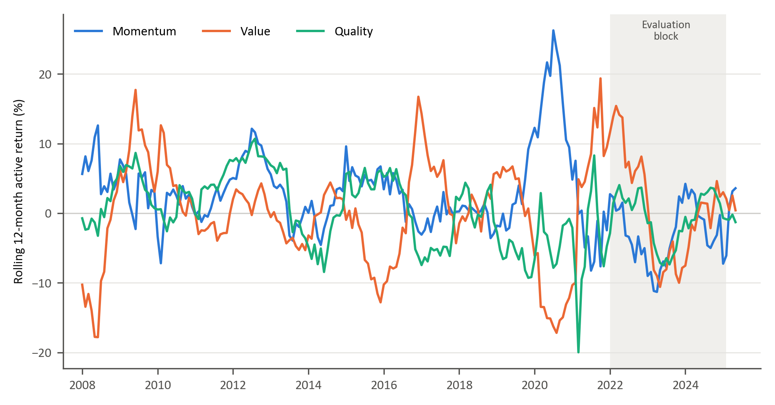
Figure 1: Rolling 12-month active returns of the momentum, value and quality factors

Figure 2 shows that these relationships are not stable. The 36-month correlation between momentum and value active returns ranges from −0.69 to 0.42, and the correlations involving quality range from −0.59 to 0.66 and change sign repeatedly.
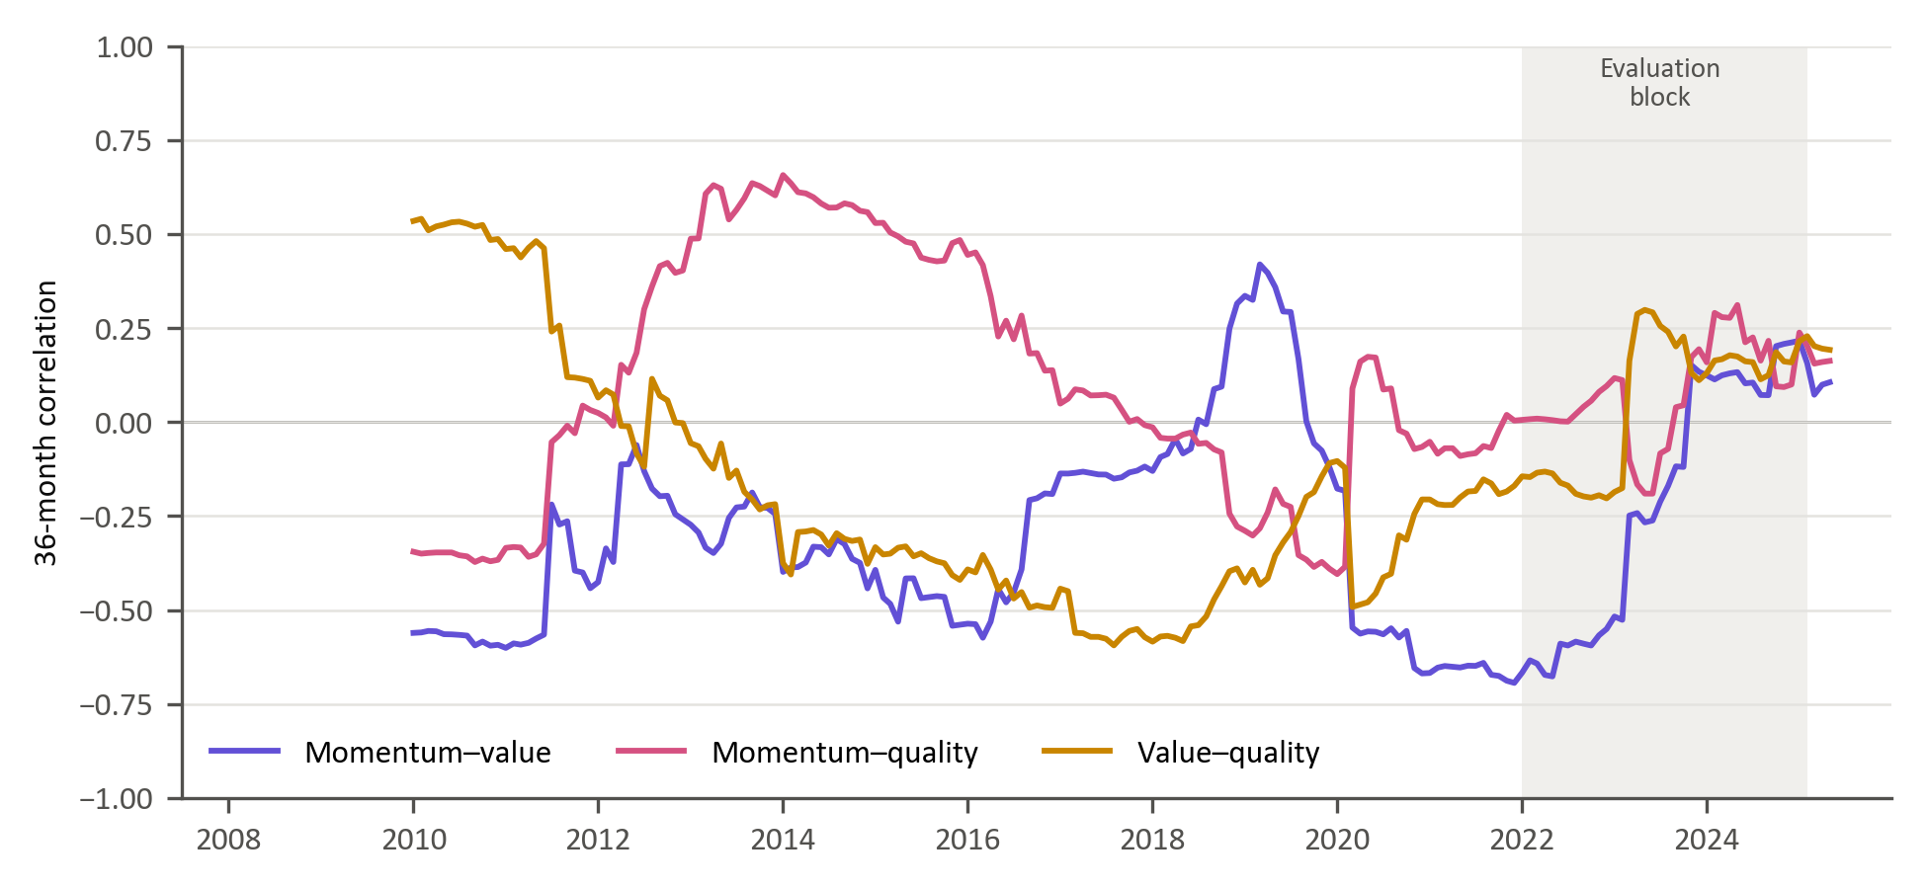
Figure 2: Rolling 36-month correlations of active returns

This time-varying correlation structure implies that absolute factor forecasting may obscure economically relevant rotation dynamics. Instead, modelling the relative performance between factor pairs directly captures style rotation. By focusing on pairwise relative returns (momentum vs value, momentum vs quality, value vs quality), the empirical framework isolates structural transitions in market leadership.
In addition to economic distinctness, modelling relative factor performance offers potential statistical advantages. Because style factors share exposure to common market-wide shocks, differencing factor returns may partially attenuate systematic noise components, isolating cross-style rotation dynamics. This relative performance-based representation is conceptually aligned with long-short factor construction in asset-pricing theory and empirical evidence that relative valuation spreads and factor momentum exhibit cyclical persistence (Fama & French, 1993; Arnott, Kalesnik, & Linnainmaa, 2023) . Consequently, relative factor series may exhibit more stable regime-dependent structure than absolute factor returns, potentially enhancing predictability.
Accordingly, the pairwise timing framework adopted in this study is grounded in the economic premise that style factors represent distinct yet interacting sources of return whose relative dominance evolves over time. The objective is therefore not to forecast aggregate market returns, but to identify transitions in factor leadership within a dynamically shifting economic environment. Predicting which factor is likely to outperform can inform the direction of a tilt between styles without requiring a precise forecast of either factor’s return over the investment period. The study therefore focuses on identifying changes in relative factor leadership as an input to allocation decisions.

Data sources and pre-processing
The empirical analysis uses weekly observations from April 2007 to March 2025, a total of 939 weeks. The modelling targets are derived from the weekly relative returns of three factor pairs (momentum versus value, momentum versus quality and value versus quality), computed from the factor returns defined in Section 3.2. The candidate predictors span market-based, macroeconomic and fundamental data. Section 3.6 describes how they are screened and selected, and Appendix A defines each modelling feature.
The feature set is prepared for modelling in three steps, following established practice in empirical finance and financial machine learning (Campbell, Lo, & MacKinlay, 1997; López de Prado, 2018):
- Lagging: To limit forward information leakage, all features are lagged by four weekly observations (approximately one month) relative to the target.
- Temporal alignment: Monthly macroeconomic and fundamental series are aligned to the most recent prior weekly date and carried forward within the month.
- Imputation: Remaining gaps are forward-filled. The values of a series before its first observation are back-filled, which copies a later value into earlier weeks. Five of the 50 modelling features begin later than the feature matrix (JALSH_Fundamental_PC1, SA_CDS_Slope, ZAR18M.Curncy_QS, USDZARV1M.Curncy_QS and USDZARV1Y.Curncy_QS), so each holds its first observed value for the first 19 to 140 weeks of the matrix. All of these weeks fall before April 2010, within the first CPCV split of the initial tuning sample, so no observation in the evaluation block is affected.
The resulting feature matrix contains 924 weekly observations.

Trend-scanning target label construction
We conceptualise the challenge of generating relative factor timing signals as a binary classification task. The aim is to identify periods in which one factor outperforms or underperforms another. Reframing the forecasting task as a binary classification problem helps mitigate statistical challenges inherent in financial time-series data. In particular, financial returns are typically characterised by heavy-tailed distributions and low signal-to-noise ratios, conditions under which classification-based approaches can provide more stable predictive performance than direct return regression (Cotturo, Liu, & Proner, 2024; Dixon, Klabjan, & Bang, 2017).
To convert continuous series of relative factor returns into target variables suitable for binary classification we apply the trend scanning method (López de Prado, 2020). Trend scanning identifies trends over the target variable by scanning forward across a range of time horizons to fit a regression line that identifies the dominant price movement. A key advantage of trend scanning is that it does not impose an arbitrary, fixed prediction horizon. A critical limitation in fixed horizons is the implicit assumption that the most significant points occur exactly at the end of the fixed interval, missing important information occurring between the set points (López de Prado, 2020).
We start the trend-scanning procedure by transforming weekly returns into a relative return series for each factor pair. For each distinct pair of factors $i$and $j,$the weekly relative return series is defined as:
$$R_{i,j,τ}= R_{i,τ}-R_{j,τ}$$ | (1)
To extract meaningful directional trends, the returns are compounded to form a cumulative relative performance series:
$${CR}_{i,j,t}= \prod_{τ≤t}{\left(1+R_{i,j,τ}\right)}$$ | (2)
We then proceed to generate binary labels using the trend-scanning methodology (López de Prado, 2020). Unlike fixed-horizon labelling, which imposes an arbitrary prediction window, trend scanning identifies the forward-looking trend with the largest absolute slope t-statistic. For each observation date, a range of forward windows $h ∈\left[1,H\right]$ is evaluated. There is no prescriptive method to pick the maximum lookahead period. For our analysis, we set the maximum look-ahead window at $H=11$weekly observations, that is, the current week and the ten weeks that follow. The choice was balanced on two considerations: economic relevance, where we ensure that the window is large enough to capture meaningful price trends avoiding excessively short-term, noisy signals; and data preservation given that longer look-ahead windows reduce the sample size during model training once purging is applied to prevent look-ahead bias.
For each candidate horizon, a linear regression is estimated on the cumulative relative return series over the forward window:
Ci,j,t+h=α+ βht+ ε
$${CR}_{i,j,t+s}=α+β_{h}s+ε_{t+s}, s=0,1,…,h−1$$ | (3)
The dominant trend is defined by the look-ahead window ${(h}_{t}^{*})$that yields the highest absolute t-statistic of the regression slope$(β_{h})$. The binary label is then assigned according to the sign of the slope at the optimal horizon:
$$Y_{i,j,t}=\left\{\begin{aligned}1, &if {\hat{β}}_{t,h_{t}^{*}}>0 \\ 0, &if {\hat{β}}_{t,h_{t}^{*}}<0 \end{aligned}\right.$$ | (4)
We apply this across all factor pairs, momentum vs value, momentum vs quality, value vs quality, capturing the dominant relative factor trend at each point in time.
Because a label draws on returns up to ten weeks ahead, the last ten weeks of the sample cannot be labelled, and overlapping information sets may arise between training and validation samples. To eliminate leakage, a purge gap of 12 weeks, longer than this horizon, is imposed during cross-validation, ensuring that no training observation contains information overlapping with the validation window (López de Prado, 2018).

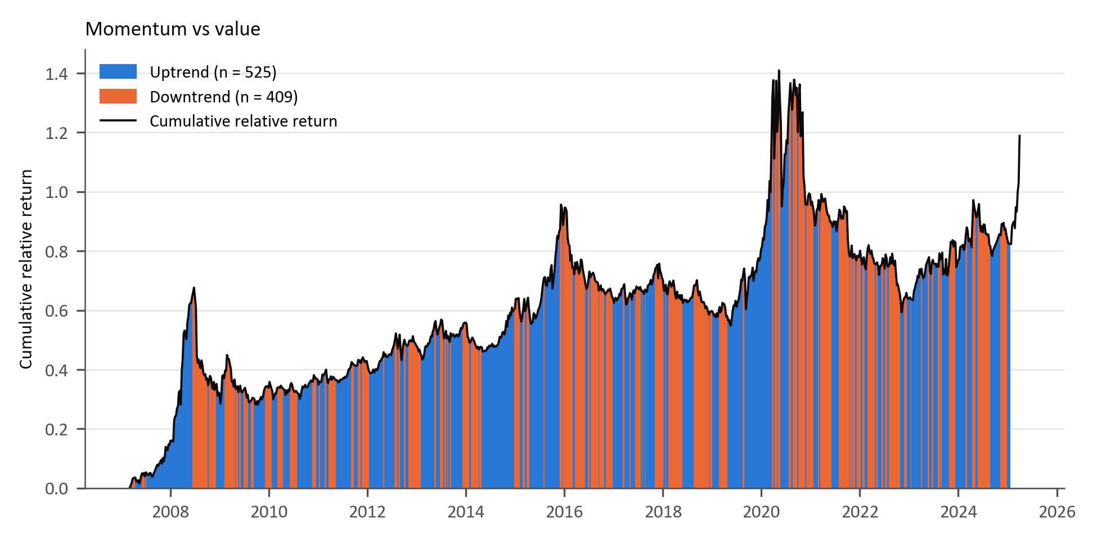
Figure 3: Trend-scanning results for momentum vs value

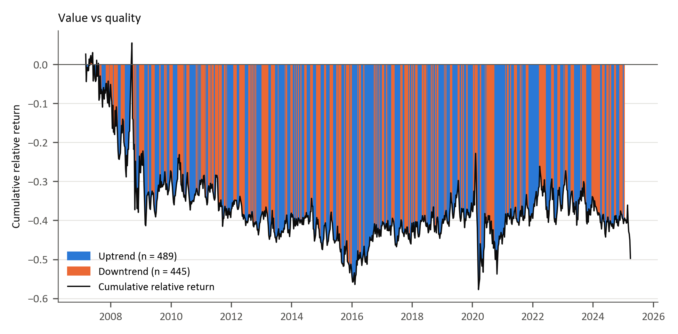
Figure 4: Trend-scanning results for value vs quality

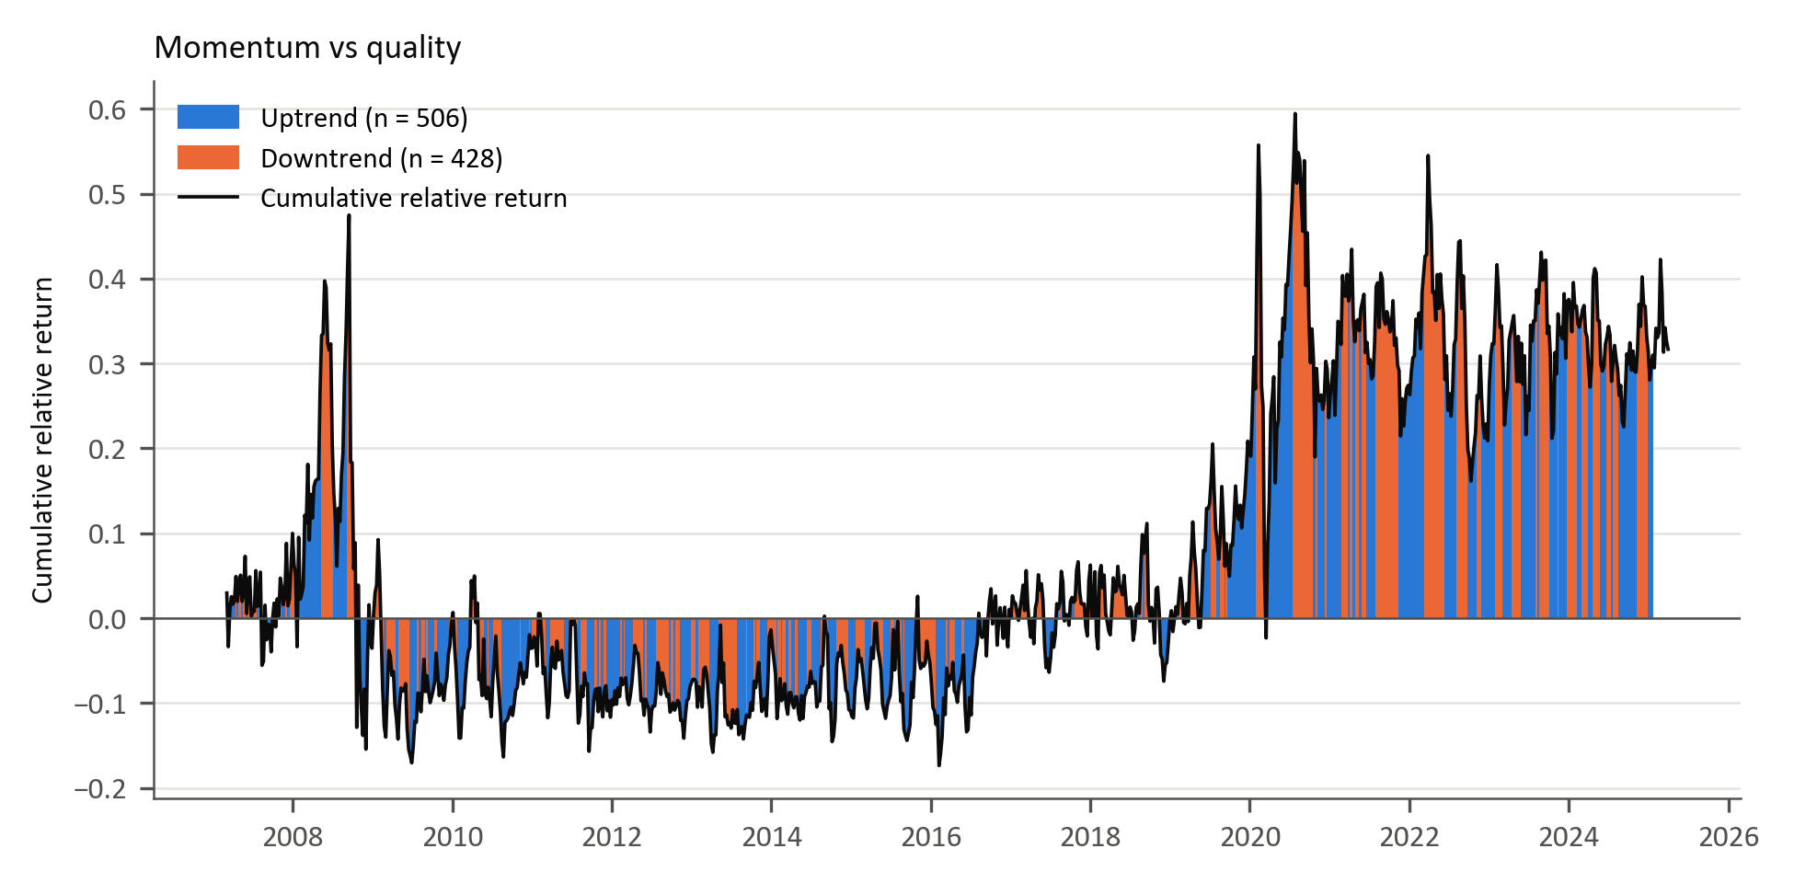
Figure 5: Trend-scanning results for momentum vs quality

Figures 3 to 5 plot the cumulative compounded relative return for each pair: momentum versus value (Figure 3), value versus quality (Figure 4) and momentum versus quality (Figure 5). The background shading indicates the trend label obtained from trend scanning. Uptrend (blue) and downtrend (orange) labels are assigned based on the maximum absolute t-statistic of the regression slope across candidate forward horizons. Rolling 12-month active returns of the individual factors are shown in Figure 1.

Feature selection
Section 2.2.1 noted that the proliferation of proposed predictors, the factor-zoo (Cochrane, 2011), raises the risk of redundant and spurious signals, and Section 2.1.1 that many correlated predictors make estimates unstable. The initial candidate set in this study contains 359 features in the categories summarised in Table 1, chosen on the basis of prior evidence (Gu, Kelly, & Xiu, 2020; Han, 2024; Cakici, Fieberg, Metko, & Zaremba, 2023; Feng, He, Polson, & Xu, 2024; Saetia & Yokrattanasak, 2022), with the candidates described and the modelling features defined in Appendix A. This is too many to estimate reliably from 914 labelled weekly observations per factor pair, so the set is reduced using mutual-information clustering. The missing-value screen removes the 15 candidates with more than 30% of weekly observations missing, leaving 344 (Appendix B, Tables B.1 and B.2).
The clustering is based on the mutual information (MI) between every pair of features (i.e. how much knowing one reduces uncertainty about the other). This measure, unlike correlation, also captures nonlinear dependence (Kraskov, Stögbauer, & Grassberger, 2004; Cover & Thomas, 2006; Peng, Long, & Ding, 2005; Guyon & Elisseeff, 2003). Each pairwise MI value is converted to a distance, so that features carrying similar information lie close together. The features are grouped by hierarchical clustering with Ward linkage, which merges features and clusters step by step while keeping the variation within each cluster small (Ward, 1963; Hastie, Tibshirani, & Friedman, 2009). This produces compact clusters, but the number of clusters follows from where the resulting tree is cut rather than being fixed in advance.

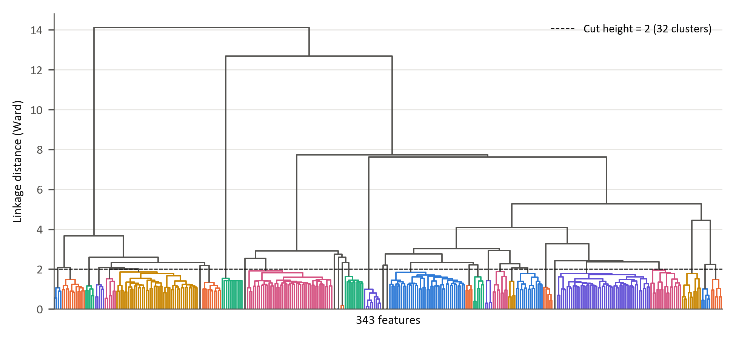
Figure 6: Hierarchical agglomerative clustering of the feature space
Figure 6 represents the entire feature space. The maximum distance for clusters selection is set at 2 (as shown by the horizontal dotted line), resulting in a total of 32 clusters. Within each cluster, the feature exhibiting the lowest average distance to other members is retained. This criterion identifies the most informationally central variable within each group. The selection is unsupervised: it does not use the labels, so no target information enters it. It is, however, estimated on 680 weeks from 26 March 2012 to 31 March 2025, which include the evaluation block, so the joint behaviour of the predictors in that block influences which features are retained. Estimated on the 514 weeks before the evaluation block, the clustering retains 21 of the 32 representatives and replaces nine with another member of the same cluster (Appendix B.4), so the two selections draw on largely the same information; the effect of the difference on predictive performance is not tested.
In addition to this clustered set, a further 18 relative-factor features were included by design. These variables capture pairwise relative performance, co-movement, and relative volatility dynamics that are directly aligned with the study’s factor-timing objective and were therefore treated as structurally relevant inputs rather than candidates for redundancy pruning. The final modelling matrix therefore consists of 50 predictors: 32 representative features selected via mutual-information clustering plus 18 relative-factor features retained on theoretical grounds.
Table 1: Summary of the 50 modelling features by category
Feature category | Features | Examples | Economic rationale | Evidence
Price-based volatility | 9 | Volatility term-structure components; USDZAR and EURUSD implied volatility; global bond and property volatility; gold price measures | Uncertainty and risk-on/risk-off conditions | (Gu, Kelly, & Xiu, 2020); (Daniel & Moskowitz, 2016)
Fundamental valuation | 6 | JSE and MSCI World fundamental components; TOP40 price-to-book and price-to-EBITDA; JSE price-to-sales; MSCI World price-to-earnings | Valuation spreads and expected mean reversion | (Cakici, Fieberg, Metko, & Zaremba, 2023)
Sentiment and risk appetite | 8 | US consumer confidence; commodity index component; gold structural-break, complexity, skewness and kurtosis measures; global equity trend and entropy | Investor risk appetite and shifts in uncertainty | (Saetia & Yokrattanasak, 2022)
Macroeconomic | 9 | SA and US yield-curve curvature; SA yield-curve slope; SA CDS slope; rand PPP valuation; euro-area bank lending conditions; USDZAR forward pricing and entropy | Growth expectations, policy stance and sovereign risk | (Fang, Chen, & Ren, 2023)
Factor relative performance | 12 | 1- and 3-month relative momentum,  12-week correlation and standardised 12-week relative return, each for the three pairs | Persistence and rotation in style leadership | (Gu, Kelly, & Xiu, 2020); (Daniel & Moskowitz, 2016)
Factor relative volatility | 6 | 12-week relative volatility and volatility ratio, each for the three pairs | Instability in relative performance | (Gu, Kelly, & Xiu, 2020); (Daniel & Moskowitz, 2016)
Note: Appendix A defines each feature, and Table B.6 in Appendix B lists every feature with its rationale and supporting evidence.

Model training

The objective function
All three models aim to classify whether the first-named factor in each pair is expected to outperform the second, based on prevailing market and economic conditions. Each model estimates the conditional probability of relative factor outperformance defined as:
$$P(y_{t}=1|X_{t})$$ | (5)
This is achieved by producing a probability score between zero and one:
$${\hat{p}}_{t}∈[0,1]$$ | (6)
A factor timing signal is generated when the probability is at least a threshold, $\left(τ\right)$, fixed at 0.5 for all models and factor pairs:
$${\hat{y}}_{t}=1\{{\hat{p}}_{t}≥τ\}$$ | (7)

Logistic regression
The simplicity and direct interpretability of linear models have contributed to their significance in finance. Logistic regression provides a transparent economic interpretation of how each predictor influences the likelihood of factor outperformance. The model assumes a linear relationship between the log-odds of the outcome and the predictor variables (Hosmer, Lemeshow, & Sturdivant, 2013; James, Witten, Hastie, & Tibshirani, 2021). Formally, the log-odds of the outcome are a linear function of the predictors:
$$logit\left(P\left(y_{t} | X_{t}\right)\right)=\ln\left(\frac{P\left(y_{t} | X_{t}\right)}{1-P\left(y_{t} | X_{t}\right)}\right)= β_{0}+X_{t}^{T}β$$ | (8)
Here, $β_{0}$ is the intercept term and $β∈R^{p}$ is a vector of coefficients measuring linear impact of each feature on the log-odds. To obtain a predicted probability from the linear predictor, the inverse of the logit, known as the logistic (sigmoid) function, is used:
$${\hat{p}}_{t}=σ\left(β_{0}+X_{t}^{T}β\right)= \frac{1}{1+e^{-(β_{0}+X_{t}^{T}β)}}$$ | (9)

Model parameters $\left(β_{0}, β\right)$are estimated by minimising the penalised log-likelihood function.
$$L(β)=\sum_{t∈D_{train}}{w_{t}}\left[-y_{t}\log{{\hat{p}}_{t}}-\left(1-y_{t}\right)\log{(1-{\hat{p}}_{t})}\right]+ λ\left(α∥β∥_{1}+\frac{1-α}{2}∥β∥_{2}^{2}\right)$$ | (10)
where $λ≥0$ controls overall regularisation strength and $α∈[0,1]$, sets the mix of LASSO $\left(L1\right)$ and ridge $\left(L2\right)$ penalties. This elastic-net penalty, common in financial applications, limits overfitting, mitigates multicollinearity and stabilises the estimates (Zou & Hastie, 2005; Tibshirani, 1996; Gu, Kelly, & Xiu, 2020).
The model is fitted with the elastic-net logistic regression of the scikit-learn Python library (Pedregosa, et al., 2011), which minimises Equation (10) with unit observation weights, C = 1/λ and L1_ratio = α. Predictors are standardised with a scaler fitted on the training window only. The solver settings and the grid for α and λ are given in Table 3.

Generalised additive models (GAMs)
Generalised Additive Models (GAMs) introduced by (Hastie & Tibshirani, 1986) extend generalised linear models by introducing nonlinear transformations of the original predictors as new additive terms in an otherwise linear model. This model enables nonlinearity while maintaining transparency. The GAM specification for binary classifications structurally resembles that of the logistic regression. Using the logit transformation, the conditional probability of outperformance is given by:
$$g\left(P\left(y_{t}=1|X_{t}\right)\right)= β_{0}+\sum_{i=1}^{p}{s_{i}(X_{t,i})}$$ | (11)
$β_{0}$ is the intercept term and each $s_{i}(.)$ is a smooth, potentially nonlinear function capturing the marginal effect of predictor $(X_{t,i})$ (Hastie & Tibshirani, 1986). The predicted probability for classification is given by:
$${\hat{p}}_{t}=σ\left(β_{0}+ \sum_{i=1}^{p}{s_{i}\left(x_{t,i}\right)}\right)$$ | (12)
Each smooth $s_{i}(.)$ is represented via a basis expansion: $s_{i}\left(x\right)=B_{i}{(x)}^{T}θ_{i}, B_{i}\left(x\right)∈R^{k_{i}}$,
$B_{i}\left(x\right)$ is a vector of spline basis functions, which control the functional relationship between a predictor variable and a conditional response, whose coefficients $\left\{θ_{i}\right\}$ must be estimated. The size of the basis expansion limits the smoothing spline’s potential complexity with a larger set of basis functions allowing greater flexibility. We use cubic splines with $k_{i}$ basis functions per smooth term. Given that each spline $s_{i}(.)$ can be visualised independently, spline bases enable GAMs to model nonlinearity while maintaining additive interpretability (James, Witten, Hastie, & Tibshirani, 2021). The number of basis functions is common to all smooth terms and is selected from {4, 5, 7, 10} (Table 3).
We estimate the coefficients $\left\{θ_{i}\right\}$ and $β_{0}$ by minimising:
$$L\left(S\right)=\sum_{t∈D_{train}}{w_{t}\left[{-y}_{t}\log{{\hat{ p}}_{t}}-\left(1-y_{t}\right)\log{(1-{\hat{p}}_{t})}\right]}+ \sum_{i=1}^{p}{λ_{i}θ_{i}^{T}S_{i}θ_{i}}$$ | (13)

The smoothness of the spline is controlled by a smoothing penalty $(λ_{i})$ and ${(S}_{i})$ is the spline penalty matrix (Hastie & Tibshirani, 1986). We use the pyGAM library in Python to implement the GAM. In the implementation, a single smoothing penalty λ is applied to all smooth terms and selected by cross-validation, and predictors are standardised within each training window, as for logistic regression.

Extreme gradient boost (XGBoost)
Tree-based ML models are non-parametric and use logic that departs markedly from traditional econometric models to capture nonlinearities within the data. These models build on the concept of decision trees, where binary groups are created by grouping observations with similar characteristics. They use a hierarchical tree structure that partitions the predictor space by recursively selecting features and splits that maximise a set improvement criterion such as information gain, entropy reduction, Gini reduction, or variance reduction depending on the task (Breiman, Friedman, Olshen, & Stone, 1984; Hastie, Tibshirani, & Friedman, 2009). This process ensures that the most informative features for predicting the target are placed higher in the tree structure.
Although decision trees are intuitive, single classification and regression trees (CART) easily overfit (Hastie, Tibshirani, & Friedman, 2009; Breiman, Friedman, Olshen, & Stone, 1984; Gu, Kelly, & Xiu, 2020). Ensemble methods like bagging and boosting address this shortcoming by combining multiple weak learners (Friedman, 2001; Breiman, 1996). This study uses boosting, in which the weak learners are added sequentially. XGBoost constructs an additive model of the form:
$$F_{M}\left(X_{t}\right)=\sum_{m=1}^{M}{f_{m}\left(X_{t}\right), } f_{m}∈F$$ | (14)
where each $f_{m}$ is a single CART (Chen & Guestrin, 2016). For binary classification, the ensemble output is mapped to probabilities using the logistic sigmoid function given by:
$${\hat{p}}_{t}= σ\left(F_{M}\left(X_{t}\right)\right), σ\left(x\right)= \frac{1}{(1+e^{-x})}$$ | (15)

At each boosting iteration $(m)$, we aim to minimise:
L(m)=t∈Dtrainwtlyt,ptm-1+fmXtσF(m−1)Xt+fmXt+Ωfm | (16)
where the logistic loss function is defined as:
$$l\left(y,p\right)=-y\log{p}-\left(1-y\right)\log{(1-p)}$$ | (17)
and tree regularisation function given by:
Ωf=γT+λ2j=1Twωj2 | (18)
$(T)$ is the number of leaves and (w(ωj) the weight of leaf j. Each tree is trained to fit the residuals of the previous iteration, allowing the ensemble to progressively correct its errors. In this study, the XGBoost model is trained using the xgboost Python library with 500 boosting rounds and the binary logistic objective. Because tree splits are unaffected by monotonic transformations, predictors are not standardised for XGBoost. This implementation follows the additive tree-boosting framework set out for XGBoost (Chen & Guestrin, 2016).

Table 2: Model comparison
Model | Model Complexity | Interpretability | Strengths | Limitations / Risks | Key Hyperparameters | References
Logistic Regression | Low | High | Transparent coefficients (economic interpretability); | Misses nonlinearities; | Maximum iterations (max_iter); | (Hosmer, Lemeshow, & Sturdivant, 2013);  (Zou & Hastie, 2005)
Logistic Regression | Low | High | Efficient with small samples; | Sensitive to multicollinearity; | Regularisation strength (λ);
Logistic Regression | Low | High | Robust to noise with regularisation | Limited predictive power in complex regimes | L1/L2 mixing ratio (α);
Logistic Regression | Low | High |  |  | Solver tolerance (tol)
GAM | Moderate | Moderate–High | Captures smooth nonlinear effects; | Cannot easily model interactions; | Number of splines (n_splines); | (Hastie & Tibshirani, 1986);  GAM formulation  (Wood, 2017);  (Gu, Kelly, & Xiu, 2020)
GAM | Moderate | Moderate–High | Retains partial interpretability; | Computationally heavier; | Smoothness penalty (λ_i);
GAM | Moderate | Moderate–High | Controls overfitting via smoothing penalty | Requires careful selection of smoothing parameters | Maximum iterations (max_iter)
XGBoost | High | Low | Captures high-order nonlinearities and interactions; | Reduced interpretability; | Learning rate (η); | (Friedman, 2001);  (Chen & Guestrin, 2016);  (Krauss, Do, & Huck, 2017)
 |  |  |  |  | Maximum tree depth (max_depth);
XGBoost | High | Low | Inherent feature selection via splits | Prone to overfitting without tuning; | Subsample ratio (subsample);
 |  |  |  | Sensitive to hyperparameter configuration | Number of boosting rounds (n_estimators);
 |  |  |  |  | Regularisation (λ, γ)

Hyperparameter tuning and model validation
Robust evaluation of predictive performance in financial time series requires validation procedures that explicitly account for temporal dependence, non-stationarity, and overlapping information sets (Campbell, Lo, & MacKinlay, 1997; Gu, Kelly, & Xiu, 2020). Conventional k-fold cross-validation assumes independent and identically distributed observations and therefore risks severe information leakage when applied to time-ordered financial data (Bergmeir & Benítez, 2012; López de Prado, 2018). To address these challenges, model tuning and evaluation are implemented using a two-stage validation architecture. Firstly, CPCV is used exclusively for hyperparameter optimisation within the training windows (López de Prado, 2018; López de Prado, 2020). Then, the optimised parameter set is used in the walk-forward validation to assess out-of-sample predictive performance.

Combinatorial purged cross-validation
The choice of hyperparameters controls the model’s complexity, limiting the potential for overfitting. CPCV generates multiple unique combinations of training and validation splits, ensuring that each split is used for validation the same number of times. The combinatorial equation is used to calculate the exact number of training/validation combinations required to construct a set of back-testing paths. A back-testing path chronologically orders the validation predictions from the different CPCV combinations to form one continuous out-of-sample time series. In our case, the number of validation splits and the total number of splits are given by$k=2$ and $N=5$ respectively.
The number of distinct training-validation combinations is given by the binomial coefficient:
$$C\left(N,k\right)= \left({N \atop k}\right)$$ | (19)
The number of back-test paths that can be constructed from these combinations is:
$$ϕ\left[N,k\right]=\frac{k}{N}\left({N \atop N-k}\right)$$ | (20)
In our case, $k=2$ and $N=5$, resulting in $C\left(5,2\right)=10$ training-validation combinations and $ϕ\left[5,2\right]=4$ back-test paths. Hyperparameters are selected on the mean ROC-AUC of the ten combinations, each computed from the predictions of a single fitted model. The back-test paths are not used for selection. Each path pools predictions from four separately fitted models whose training class shares differ, which shifts the level of their probabilities and biases the pooled ROC-AUC downwards (Appendix C.2). The paths therefore serve only as a diagnostic of how consistently the selected setting performs across the tuning sample.
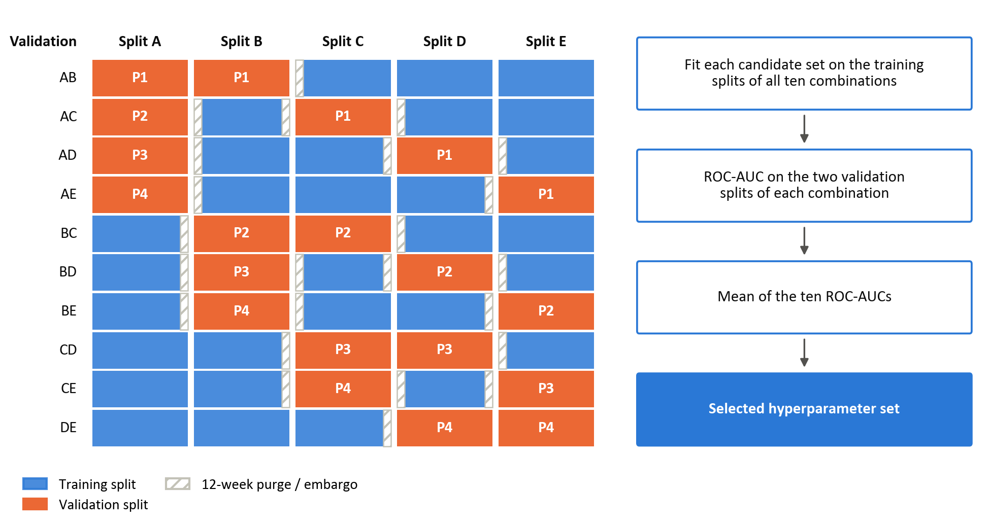
Figure 7: CPCV with N = 5 chronological splits and k = 2 validation splits, giving ten combinations and four back-test paths

In Figure 7, each row represents one combination. The orange blocks are its two validation splits, the blue blocks its training splits, and the hatched strips the 12-week purge and embargo around each validation split. The label on each validation split gives the back-test path (P1 to P4) to which its predictions are assigned.
To ensure that the validation set performance is still a good proxy for the performance on unseen data, samples in the validation set need to be reasonably independent from those in the training set. Purging addresses this by removing any training observation whose information horizon overlaps with the validation set (López de Prado, 2018). A 12-week purge before each validation split and a 12-week embargo after it exceed the ten-week label horizon (Section 3.5). The initial search uses the 746 observations that precede the evaluation block once the 12 weeks before it are purged, so that no label in the search draws on the evaluation block; the predictors of logistic regression and the GAM are standardised on that sample. Later searches use the purged training window then available (Section 3.8.2).
Table 3: Hyperparameter search grids
Model | Parameter combinations | Key hyperparameters | Tuning parameter grid
Logistic | 18 | L1/L2 mixing ratio (α) | [ 0 , 0.5 , 1 ]
Logistic | 18 | Regularisation strength (λ) | [ 0.01 , 0.1 , 1 , 10 , 100 , 1000 ]
Logistic | 18 | Solver | saga (fixed)
Logistic | 18 | Maximum iterations | 100,000 (fixed)
Logistic | 18 | Convergence tolerance | 10⁻⁶ (fixed)
GAM | 20 | Number of splines | [ 4 , 5 , 7 , 10 ]
GAM | 20 | Smoothness penalty (λ) | [1, 10, 100, 1000, 10000]
GAM | 20 | Spline order | 3, cubic (fixed)
GAM | 20 | Maximum iterations | 1000 (fixed)
XGBoost | 216 | Learning rate (η) | [ 0.01 , 0.03 , 0.1 ]
XGBoost | 216 | Maximum tree depth | [ 2 , 3 , 4 ]
XGBoost | 216 | Minimum child weight | [ 5 , 10 , 20 ]
XGBoost | 216 | L2 regularisation (λ) | [ 1 , 10 , 100 , 1000 ]
XGBoost | 216 | Subsample ratio | [ 0.6 , 0.8 ]
Note: grids are searched exhaustively. XGBoost uses 500 boosting rounds, the binary logistic objective and a fixed random seed in every configuration.

Walk-forward validation
While CPCV reduces overlap between training and validation labels during hyperparameter selection, it does not fully replicate real-time deployment. Final performance is therefore assessed using an expanding-window walk-forward framework. Walk-forward validation repeatedly trains a model on past data and evaluates it on the observations that follow, which limits leakage and gives a more realistic assessment of forecasting ability.
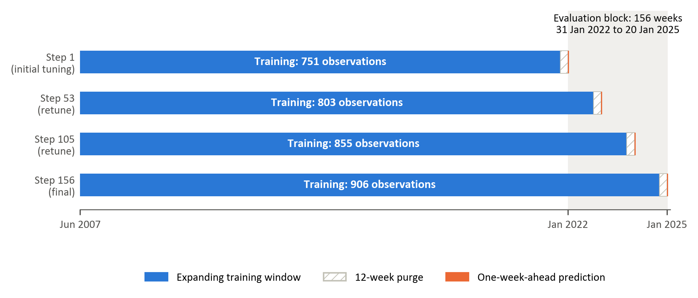
Figure 8: Expanding-window walk-forward validation with a 12-week purge and retuning every 52 predictions.
At each iteration, models are trained on an expanding window containing every labelled observation up to 12 weeks before the prediction date, and then predict the forward trend label at the next evaluation date. The training window grows from 746 observations at the first prediction to 901 at the last. Hyperparameters are re-optimised every 52 predictions, balancing adaptation to structural changes in market conditions against sensitivity to transient fluctuations. They are therefore selected three times, before the first prediction and after the 52nd and 104th predictions, producing 156 weekly forecasts of variable-horizon trend labels from 31 January 2022 to 20 January 2025.

Performance evaluation
Model performance is evaluated along three complementary dimensions, directional accuracy, ranking ability and probability quality, supplemented by confusion-matrix analysis of classification errors. These measures capture distinct aspects of classification quality and jointly provide a comprehensive assessment of predictive performance. Because the objective of the study is to identify transitions in relative factor leadership rather than forecast return magnitudes, classification-based metrics are appropriate. In financial settings characterised by heavy tails, regime shifts, and low signal-to-noise ratios, reliance on a single performance measure can be misleading. A multi-metric framework therefore improves robustness and interpretability (Dixon, Klabjan, & Bang, 2017; James, Witten, Hastie, & Tibshirani, 2021).

Directional accuracy, the proportion of correct classifications, reflects whether the model correctly identifies the leading factor within each pair (James, Witten, Hastie, & Tibshirani, 2021). While intuitive and directly interpretable from an allocation perspective, accuracy alone does not account for prediction confidence or ranking quality. Accuracy is complemented by the confusion matrix, which cross-tabulates predicted and realised classes into true negatives (TN), false positives (FP), false negatives (FN) and true positives (TP) at the 0.5 threshold (Fawcett, 2006). The matrix shows whether errors are concentrated in one class. This matters here because a model that assigns most observations to one class can attain respectable accuracy while having little ability to identify the other. The share of observations predicted positive is therefore compared with the realised positive share, and confusion matrices are reported for every model and factor pair.

To assess discrimination ability independently of any fixed decision threshold, the Receiver Operating Characteristic (ROC) curve is employed. The ROC curve evaluates the model’s capacity to assign higher predicted probabilities to periods of genuine outperformance than to underperformance periods. The Area Under the ROC Curve (ROC-AUC) summarises this discriminatory power on a scale between zero and one, where 0.5 corresponds to random classification (James, Witten, Hastie, & Tibshirani, 2021; Fawcett, 2006). Because it is also robust to moderate class imbalance, ROC-AUC is the selection criterion in the CPCV search (Section 3.8.1).

In addition to classification correctness and ranking ability, the quality of predicted probabilities is evaluated using log-loss. Log-loss penalises confident but incorrect predictions more heavily than uncertain misclassifications, thereby assessing overall probability quality rather than only the binary decision (Good, 1952; Gneiting & Raftery, 2007; Bishop, 2006; Murphy, 1973). Since the modelling framework produces probabilistic forecasts of relative factor outperformance, calibration quality is economically meaningful. Well-calibrated probabilities allow for flexible allocation rules, such as probability-weighted exposure adjustments, rather than simple binary switching between styles (Gneiting & Raftery, 2007; Dixon, Klabjan, & Bang, 2017; López de Prado, 2018).
Improvements across all three measures provide stronger evidence of genuine predictive structure than improvements in any single metric alone. Nevertheless, statistical performance does not automatically imply economic profitability. A further translation of predictive signals into portfolio outcomes can be evaluated separately through risk-adjusted performance analysis, which falls outside the scope of this study. Because the evaluation block contains only 156 weekly observations and the labels persist over several weeks, the sampling uncertainty of accuracy and ROC-AUC is estimated with a circular moving-block bootstrap, which resamples blocks of consecutive weeks and so preserves the dependence between neighbouring labels (Künsch, 1989; Politis & Romano, 1992). Blocks of 12 weeks, the length of the purge, are drawn 10,000 times, and the 2.5th and 97.5th percentiles of each statistic form its 95% confidence interval. The same resampled weeks are applied to every model, so the interval for the difference between two models’ ROC-AUCs is a paired comparison. Accuracy is also compared with the majority-class rate, the accuracy of always predicting the more frequent class. The models are not refitted in the bootstrap, so the intervals do not include the uncertainty of feature and hyperparameter selection.

Feature importance
The feature importance analysis examines which predictors drive each model’s forecasts, and whether the three models, and the three factor pairs, rely on the same information. Importance is measured with Shapley values from cooperative game theory (Shapley, 1953), as implemented in the SHAP framework (Lundberg, et al., 2020; Lundberg & Lee, 2017).
Shapley values decompose each prediction into additive contributions from the features, relative to the model’s average prediction. A feature’s contribution is its marginal effect on the prediction, averaged over all combinations of the other features, so nonlinear and interaction effects are attributed to the features involved (Štrumbelj & Kononenko, 2010). Unlike split gain in tree models or the size of a regression coefficient, the measure is defined in the same way for every model (Joseph, 2019; Joseph, 2024).
The Shapley values are computed once for each model and factor pair, for a model refitted with the initially selected hyperparameters on the 746 observations of the initial tuning sample (Section 3.8.1), and every observation of that sample is explained. For logistic regression they are exact: each contribution is the coefficient multiplied by the deviation of the standardised feature from its sample mean. For XGBoost, exact tree Shapley values are obtained with tree SHAP (Lundberg, et al., 2020). For the GAM, which has no specialised explainer, they are permutation estimates against 100 background observations drawn from the training sample, and so carry some approximation error (Štrumbelj & Kononenko, 2014).
For each model and factor pair, the ten features with the largest importance values are reported, coloured by their category in Table 1. Because the explainers and the spread of the attributions differ between model classes, the models are compared by the ranking of their features rather than by the size of the values, and a feature that ranks highly in several models is treated as stronger evidence than one that leads a single model.
The attributions describe how the fitted models use the features, not causal effects, and a high ranking does not show that a feature carries stable out-of-sample information (Molnar, 2022; Kumar, Venkatasubramanian, Scheidegger, & Friedler, 2020).

Results

Overview of the Evaluation Framework
This chapter presents the out-of-sample results of the three models for the 156 weekly predictions of the walk-forward evaluation. Section 4.2 compares the models on accuracy, ROC-AUC and log-loss for each factor pair and shows their ROC curves and weekly predicted probabilities. Section 4.3 examines the confusion matrices, focusing on the distribution of classification errors, and assesses the quality of the predicted probabilities. Section 4.4 discusses the features with the largest global SHAP importance for each model and factor pair.

Out-of-Sample predictive performance
Table 4 reports the accuracy, ROC-AUC and log-loss of each model for the three factor pairs, with 95% block-bootstrap confidence intervals (Section 3.9). XGBoost has the highest accuracy and ROC-AUC and the lowest log-loss for every pair, but the ordering does not follow model flexibility. The GAM, which adds smooth nonlinear effects to the linear specification, has a lower ROC-AUC than logistic regression for two pairs and the highest log-loss for all three. Even the strongest result, a ROC-AUC of 0.660 for value versus quality, indicates modest discrimination (Hosmer, Lemeshow, & Sturdivant, 2013), as expected when the predictable part of factor returns is small relative to noise (Israel, Kelly, & Moskowitz, 2020).

Table 4: Out-of-sample accuracy, ROC-AUC and log-loss by factor pair and model
Factor pair | Majority class | Model | Accuracy, % (95% CI) | ROC-AUC (95% CI) | Log-loss
Momentum vs value | 54.5% | Logistic | 50.0 (37.2–62.8) | 0.489 (0.335–0.641) | 1.140
 |  | GAM | 53.8 (42.3–64.7) | 0.490 (0.368–0.631) | 1.492
 |  | XGBoost | 57.1 (44.2–69.2) | 0.585 (0.407–0.768) | 0.730
Momentum vs quality | 54.5% | Logistic | 57.7 (44.2–70.5) | 0.573 (0.380–0.747) | 0.746
 |  | GAM | 58.3 (43.6–72.4) | 0.561 (0.371–0.731) | 0.938
 |  | XGBoost | 66.7 (55.1–77.6) | 0.636 (0.475–0.777) | 0.716
Value vs quality | 50.6% | Logistic | 53.8 (41.7–66.7) | 0.598 (0.454–0.737) | 0.686
 |  | GAM | 49.4 (39.1–59.0) | 0.495 (0.387–0.605) | 1.148
 |  | XGBoost | 60.3 (52.6–67.9) | 0.660 (0.565–0.753) | 0.670
Note: confidence intervals from a circular moving-block bootstrap of the 156 weeks (blocks of 12 weeks, 10,000 resamples; Section 3.9). The majority class is the accuracy of always predicting the more frequent class.

The intervals show that the evidence of discrimination is weak. Only for value versus quality does the interval for the ROC-AUC of XGBoost exclude 0.5 (0.565 to 0.753); for momentum versus value (0.407 to 0.768) and momentum versus quality (0.475 to 0.777), chance-level ranking cannot be ruled out, and no other model’s interval excludes 0.5. The lead of XGBoost over logistic regression is not significant for any pair: the intervals for the paired difference in ROC-AUC are −0.096 to 0.292 for momentum versus value, −0.069 to 0.213 for momentum versus quality and −0.046 to 0.178 for value versus quality. Its only significant lead is over the GAM for value versus quality (0.033 to 0.294). Accuracy gives a similar picture: only the intervals of XGBoost for value versus quality (52.6% to 67.9%) and momentum versus quality (55.1% to 77.6%) lie wholly above the majority-class rate, the second by less than one percentage point.
The cross-validation used for tuning did not anticipate this ranking. At the initial tuning point, the selected XGBoost settings have a mean ROC-AUC over the ten CPCV combinations of 0.519 for momentum versus value and 0.505 for momentum versus quality, below logistic regression (0.534 and 0.547) and the GAM (0.534 and 0.527); XGBoost leads only for value versus quality (0.568) (Table C.3). In the two momentum pairs, the selected XGBoost model was therefore no better than chance in cross-validation, yet it ranks first out of sample, which suggests that its lead in 2022 to 2025 is partly specific to that period.
The subsections that follow examine, for each pair, where the more flexible models gain or lose against the linear benchmark. Each factor pair is illustrated with two figures. The first figure shows the ROC curves, the vertical axis is the share of weeks led by the first factor of the pair that are classified correctly (the true-positive rate), the horizontal axis the share of weeks led by the second factor that are classified as led by the first (the false-positive rate), and each curve traces both as the classification threshold falls from one to zero. The left of each curve therefore reflects the weeks a model considers most likely to be led by the first factor, and the dashed diagonal corresponds to random classification. The second figure shows each model's weekly predicted probability that the first factor leads, with dots marking the realised class (one when the first factor led, zero when the second did) and a dashed line at the 0.5 threshold. A model is described as confidently wrong in a week when it gives the outcome that did not occur a probability above 0.9.

Momentum versus value
For momentum versus value, XGBoost's advantage lies in ranking rather than in classification or in its probabilities. It is the only model with a ROC-AUC above 0.5 (0.585), consistent with evidence that tree-based models improve style rotation on the JSE (Page, McClelland, & Auret, 2024). Its accuracy (57.1%), however, is only 2.6 percentage points above the 54.5% obtained by always predicting momentum, because it predicts momentum in 92.3% of weeks, and its log-loss (0.730) is above 0.693, the value for a forecast that gives each factor a 50% chance every week. Logistic regression and the GAM are close to random (ROC-AUC 0.489 and 0.490), with log-losses far higher still (1.140 and 1.492), and their accuracies (50.0% and 53.8%) are below the majority-class rate.
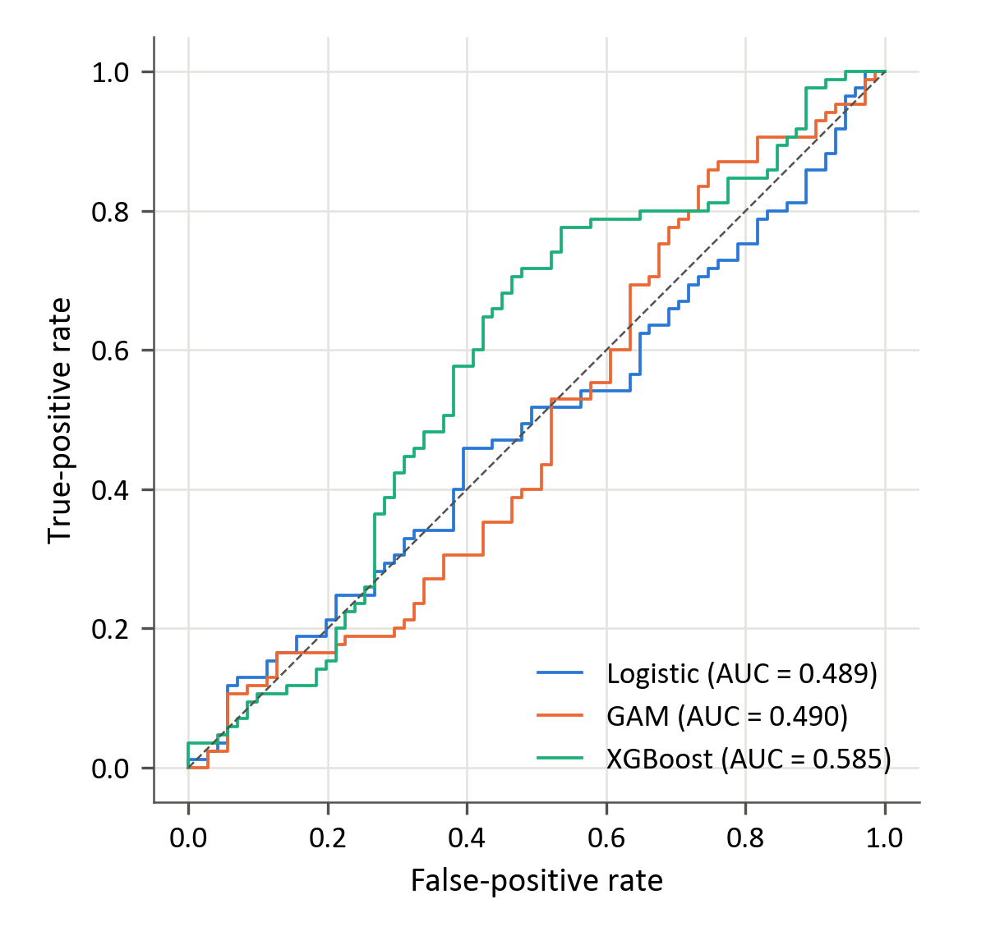
Figure 9: Out-of-sample ROC curves for momentum versus value

Figure 9 shows that XGBoost achieves the highest true-positive rate at false-positive rates between about 0.25 and 0.70. Its curve departs more clearly from the diagonal over this range, whereas the curves for logistic regression and the GAM remain closer to chance-level discrimination. However, XGBoost does not dominate at every threshold. Its advantage therefore reflects stronger overall discrimination across much of the displayed range, rather than uniformly better classification at all possible operating points.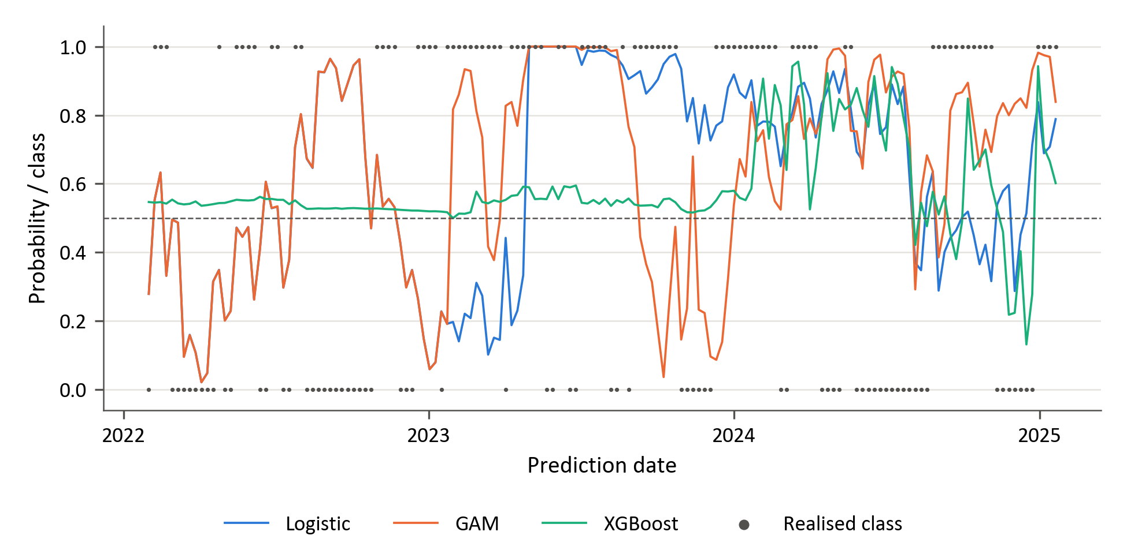
Figure 10: Walk-forward predicted probability that momentum leads value, with the realised class
Figure 10 shows that XGBoost's probabilities stay between 0.50 and 0.60 until January 2024, while its selected settings combine a learning rate of 0.01 with an L2 penalty of 1000 (Table C.6). It predicts momentum in all but one of these 104 weeks, wrongly in most weeks of the first period and correctly in 71% of the second, so its class decisions follow the frequency of momentum leadership rather than changes in leadership. From 2024, its probabilities become more variable. Until January 2023 the probabilities of the GAM coincide with those of logistic regression, because its first selected setting (λ = 1000 with four splines per predictor) makes each fitted function almost linear. Logistic regression and the GAM more frequently approach zero or one when the realised class contradicts the forecast, providing a visual explanation for their higher log-loss in Table 4. The figure therefore highlights differences in forecast confidence as well as differences in the selected leadership state.

Momentum versus quality
For momentum versus quality, XGBoost ranks and classifies the weeks better than the other models. Its ROC-AUC of 0.636 exceeds logistic regression's 0.573 by 0.063, and its accuracy of 66.7%, the highest in the study, rests on both leadership states: at the 0.5 threshold it correctly identifies 65 of the 85 momentum-led weeks and 39 of the 71 quality-led weeks. Its log-loss (0.716), however, is above 0.693. Logistic regression and the GAM reach accuracies of 57.7% and 58.3%, close to the 54.5% obtained by always predicting momentum.

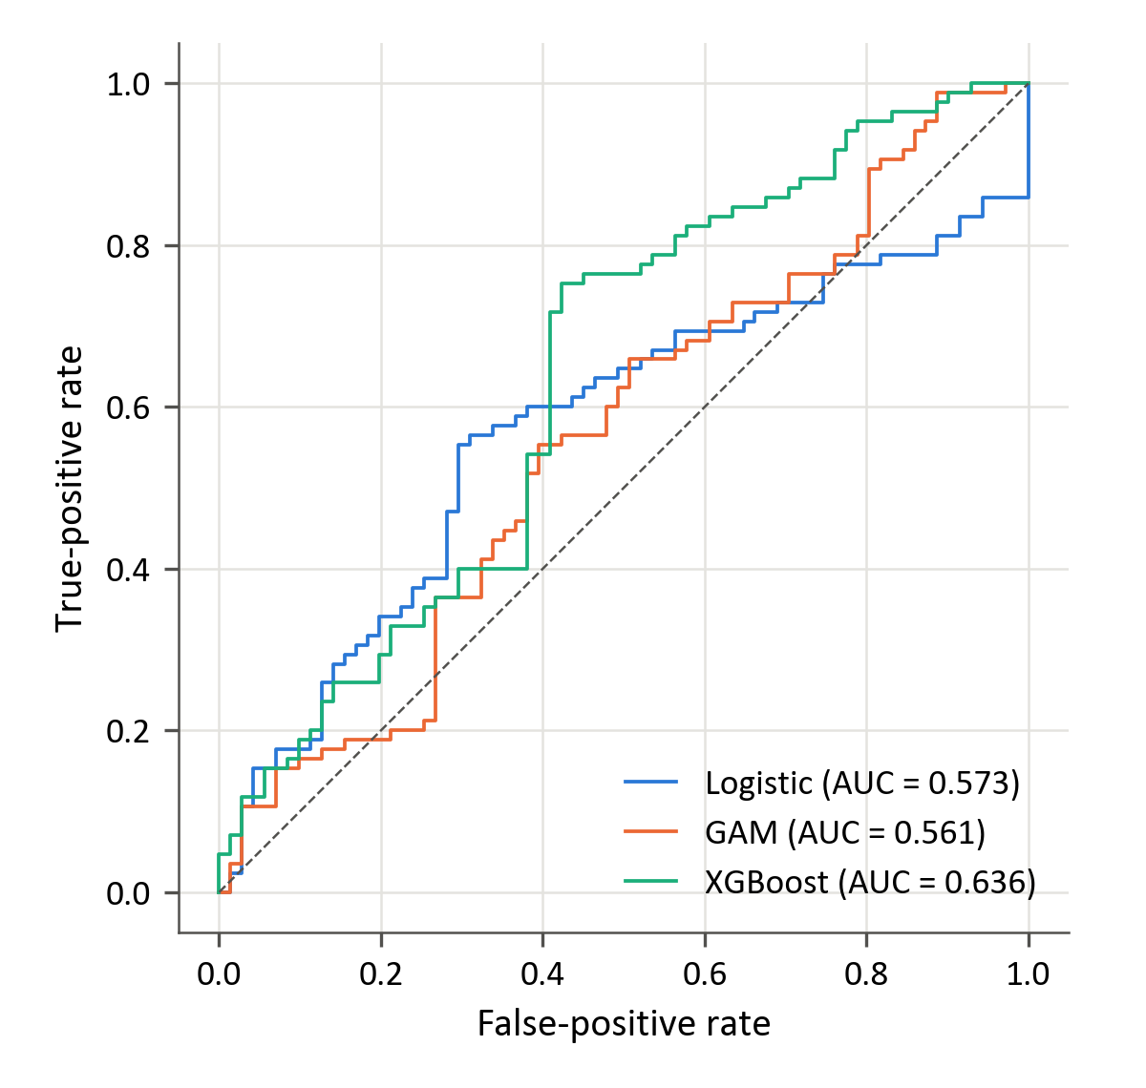
Figure 11: Out-of-sample ROC curves for momentum versus quality
Figure 11 shows that logistic regression generally achieves the highest true-positive rate at false-positive rates below approximately 0.40, whereas XGBoost leads at higher false-positive rates. The curves intersect, so neither model dominates across the full range of thresholds. XGBoost's higher overall ROC-AUC in Table 4 summarises performance across this range. The relative performance of the two models therefore depends on the trade-off between correctly identifying momentum leadership and incorrectly classifying quality-led weeks.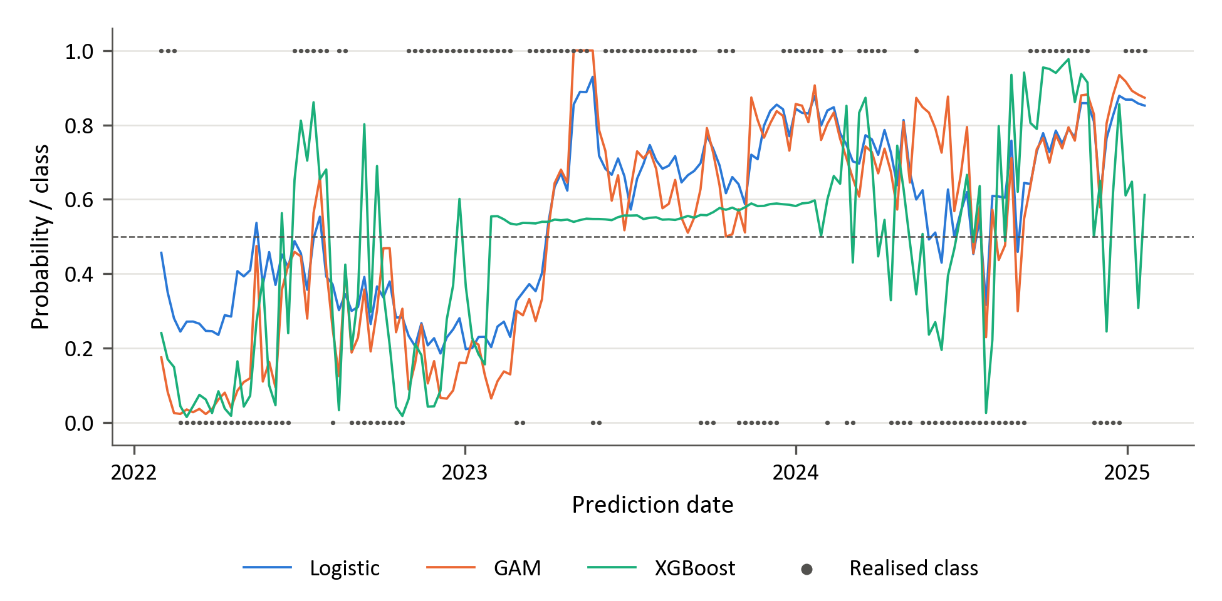
Figure 12: Walk-forward predicted probability that momentum leads quality, with the realised class
Figure 12 shows that all three models favour quality until January 2023 and momentum in most later weeks. XGBoost's probabilities have the widest range in the first and third periods. In the second, when its selected setting combines a learning rate of 0.01 with an L2 penalty of 1000 (Table C.6), they stay between 0.53 and 0.60 and it predicts momentum in every week, correctly in 73% of them. XGBoost is confidently wrong in seven weeks, five of them in the first period; the GAM is confidently wrong in nine weeks and logistic regression in one.

Value versus quality
Value versus quality provides the strongest evidence of discrimination in the study. XGBoost achieves the highest accuracy (60.3%) and ROC-AUC (0.660), together with the lowest log-loss (0.670), for this pair. It correctly identifies 44 of the 77 value-led weeks and 50 of the 79 quality-led weeks, demonstrating an ability to recognise both leadership states. Logistic regression ranks second on ROC-AUC, at 0.598, while the GAM performs approximately at chance level, with a ROC-AUC of 0.495. XGBoost’s advantage therefore extends across classification accuracy, ranking and probability quality. Nevertheless, its discrimination remains modest, and a substantial proportion of observations are still misclassified. The results identify XGBoost as the strongest fitted model for this pair, while indicating that relative factor leadership remains difficult to predict.

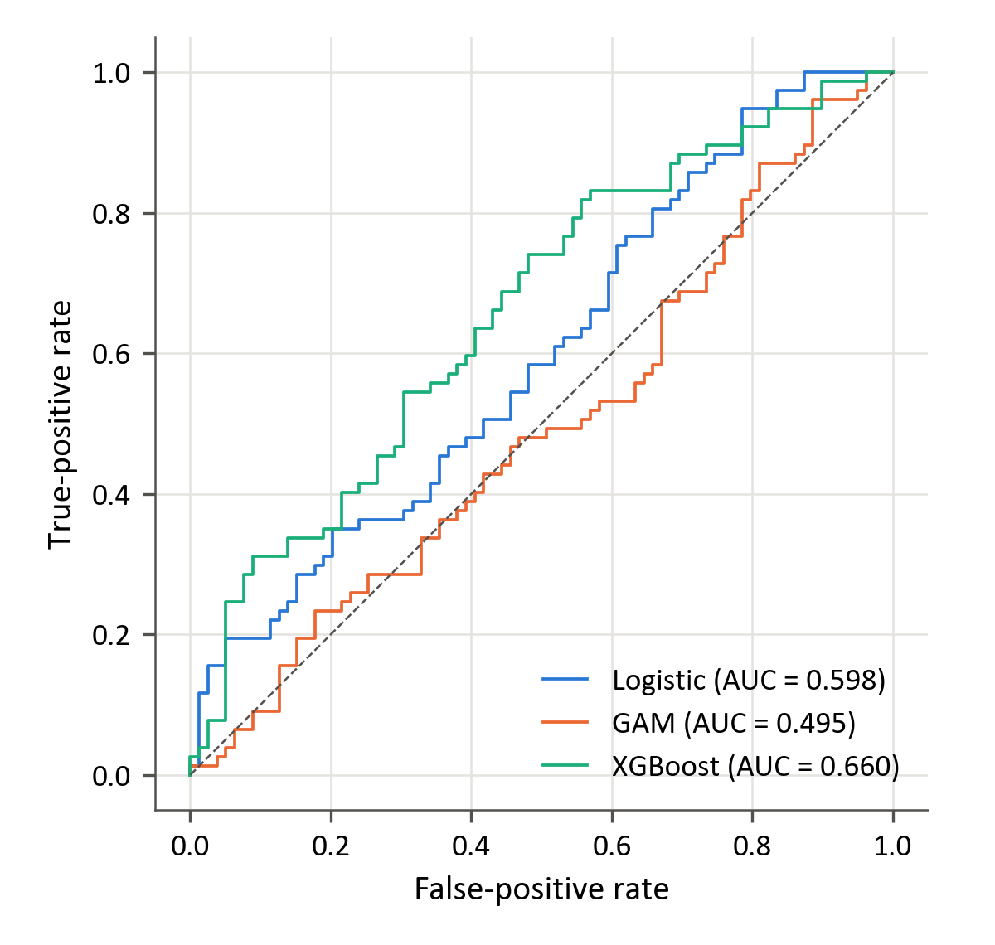
Figure 13: Out-of-sample ROC curves for value versus quality

Figure 13 shows that XGBoost achieves the highest true-positive rate over most false-positive rates between approximately 0.06 and 0.78. Its curve remains on or above the chance diagonal, and its advantage extends across a broad range of thresholds. Logistic regression also displays some discrimination, consistent with its overall ROC-AUC of 0.598 in Table 4, while the GAM curve remains close to the diagonal. The figure therefore supports the stronger overall ranking performance of XGBoost for this pair.
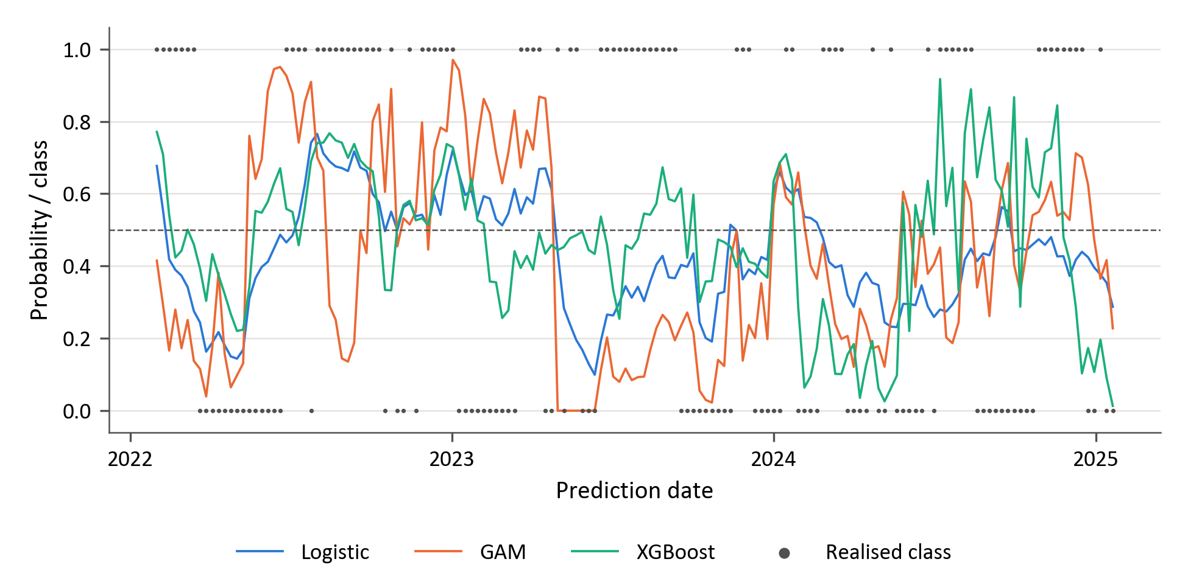
Figure 14: Walk-forward predicted probability that value leads quality, with the realised class
Figure 14 shows that XGBoost's probabilities cross the 0.5 threshold and produce forecasts of both value and quality leadership. This contrasts with the prolonged preference for a single leadership state visible in the momentum-pair probability plots. The GAM sometimes assigns probabilities close to zero when value subsequently leads, illustrating the confident errors that contribute to its higher log-loss. XGBoost's lower aggregate log-loss in Table 4 indicates better overall probability quality than the other fitted models, although the forecast errors remain relevant to its potential use in allocation decisions.

Consolidated confusion-matrix analysis and probability quality
Table 5 reports the realised class distribution in the common 156-week evaluation block. The three targets are reasonably balanced, although momentum leadership is slightly more common in the two momentum pairs. The two momentum pairs have identical class counts, although their labels differ in 34 of the 156 weeks. These counts provide the context required to interpret the confusion matrices reported below. Table 6 reports the confusion-matrix counts and predicted-positive shares. These diagnostics explain several apparent inconsistencies between ROC-AUC and accuracy.

Table 5: Realised class distribution in the 156-week evaluation block
Factor pair | Negative observations | Positive observations | Positive share
Momentum vs value | 71 | 85 | 54.5%
Momentum vs quality | 71 | 85 | 54.5%
Value vs quality | 79 | 77 | 49.4%

Table 6: Confusion-matrix diagnostics
Factor pair | Model | TN | FP | FN | TP | Predicted positive | Actual positive
Momentum vs value | Logistic | 24 | 47 | 31 | 54 | 64.7% | 54.5%
 | GAM | 25 | 46 | 26 | 59 | 67.3% | 54.5%
 | XGBoost | 8 | 63 | 4 | 81 | 92.3% | 54.5%
Momentum vs quality | Logistic | 35 | 36 | 30 | 55 | 58.3% | 54.5%
 | GAM | 35 | 36 | 29 | 56 | 59.0% | 54.5%
 | XGBoost | 39 | 32 | 20 | 65 | 62.2% | 54.5%
Value vs quality | Logistic | 55 | 24 | 48 | 29 | 34.0% | 49.4%
 | GAM | 46 | 33 | 46 | 31 | 41.0% | 49.4%
 | XGBoost | 50 | 29 | 33 | 44 | 46.8% | 49.4%

For momentum versus value, XGBoost displays the strongest asymmetry between the two classes. It correctly identifies 81 of the 85 momentum-led weeks but only 8 of the 71 value-led weeks, with 63 false positives. Its predicted-positive share of 92.3% substantially exceeds the realised 54.5%, showing that its class decisions favour momentum. Logistic regression and the GAM identify more value-led weeks, at 24 and 25, respectively, but fewer momentum-led weeks, at 54 and 59. All three models predict momentum leadership more frequently than its realised share, indicating a common tendency towards the positive class.
For momentum versus quality, XGBoost produces fewer false positives and false negatives than either alternative. It correctly identifies 65 momentum-led weeks and 39 quality-led weeks, compared with 55 and 35 for logistic regression and 56 and 35 for the GAM. Its lower error counts therefore reflect improved recognition of both leadership states. Nevertheless, all three models predict momentum leadership more frequently than its realised share of 54.5%, at 58.3% to 62.2% of weeks.
For value versus quality, logistic regression and the GAM favour quality leadership. Their predicted-positive shares of 34.0% and 41.0% are below the realised value-led share of 49.4%, and both produce more false negatives than false positives. Logistic regression correctly identifies 55 quality-led weeks but only 29 value-led weeks, while the corresponding counts for the GAM are 46 and 31. XGBoost identifies 50 quality-led and 44 value-led weeks, with similar numbers of false positives and false negatives, at 29 and 33. Its errors are consequently distributed more evenly between the two leadership states.
The highest log-losses, those of the GAM for momentum versus value (1.492) and value versus quality (1.148) and of logistic regression for momentum versus value (1.140), coincide with weakly penalised selections. The GAM was tuned to the smallest penalty (λ = 1) with ten splines per predictor at the last two tuning points for momentum versus value and at the first for value versus quality (Table C.6): about 500 basis coefficients estimated from 746 to 901 observations. Logistic regression for momentum versus value was tuned to λ = 0.01 (C = 100) at every tuning point, which leaves it almost unpenalised, and the first GAM fit for that pair is almost the same model (Section 4.2.1). Such fits follow noise in the training window and give confident out-of-sample probabilities, so these log-losses reflect overfitting rather than a property of smooth nonlinear effects. The ranking of the GAM below logistic regression may therefore reflect the grid and the selection as much as the model class: with every setting held fixed, its value versus quality ROC-AUC ranges from 0.522 to 0.582, above the 0.495 of the selected settings (Appendix C.5).

Feature importance
Figures 15–17 present the ten features with the largest global mean absolute SHAP values for each model. A relative-volatility measure, either the relative volatility or the volatility ratio of a pair, ranks among the ten leading features of every model for every pair except logistic regression for momentum versus quality. SHAP attributes model output to the input features (Lundberg & Lee, 2017). Here, the values are calculated for reference models refitted on the initial tuning sample, as described in Section 3.10. They do not aggregate the explanations of the successive walk-forward models. The rankings therefore describe the information used by these reference fits and cannot establish why predictive performance changes between evaluation periods. Mean absolute values also do not identify the direction of a feature's effect or establish an economic causal relationship.

Momentum versus value
Relative-volatility measures rank first in all three reference fits for momentum versus value, although the specific measure differs: momentum–value relative volatility for XGBoost and value–quality relative volatility for logistic regression and the GAM. This prominence is compatible with evidence that momentum risk varies over time and that momentum crashes are associated with adverse market conditions (Barroso & Santa-Clara, 2015; Daniel & Moskowitz, 2016). Logistic regression and the GAM, whose reference fits for this pair are almost the same model (Section 4.2.1), share their five leading features: two relative-volatility measures, medium-term USDZAR forward pricing, South African real-yield-curve curvature and USDZAR entropy. XGBoost instead ranks relative-volatility measures and volatility ratios in four of its six leading places, alongside short-dated USDZAR implied volatility and the level of the US equity volatility term structure. Since the models differ substantially in predictive performance, agreement on the leading feature category does not establish its sufficiency for timing. The results suggest differences in the representation and combination of information, rather than identifying the source of XGBoost's advantage. XGBoost's ten largest SHAP magnitudes for this pair sum to less than a tenth of the corresponding totals for the other pairs. This follows from its reference setting: a learning rate of 0.01, an L2 penalty of 1000 and a minimum child weight of 20 (Table C.6) shrink the leaf weights until the fitted model is close to a constant, as its flat walk-forward probabilities in the first two periods also show (Figure 10).

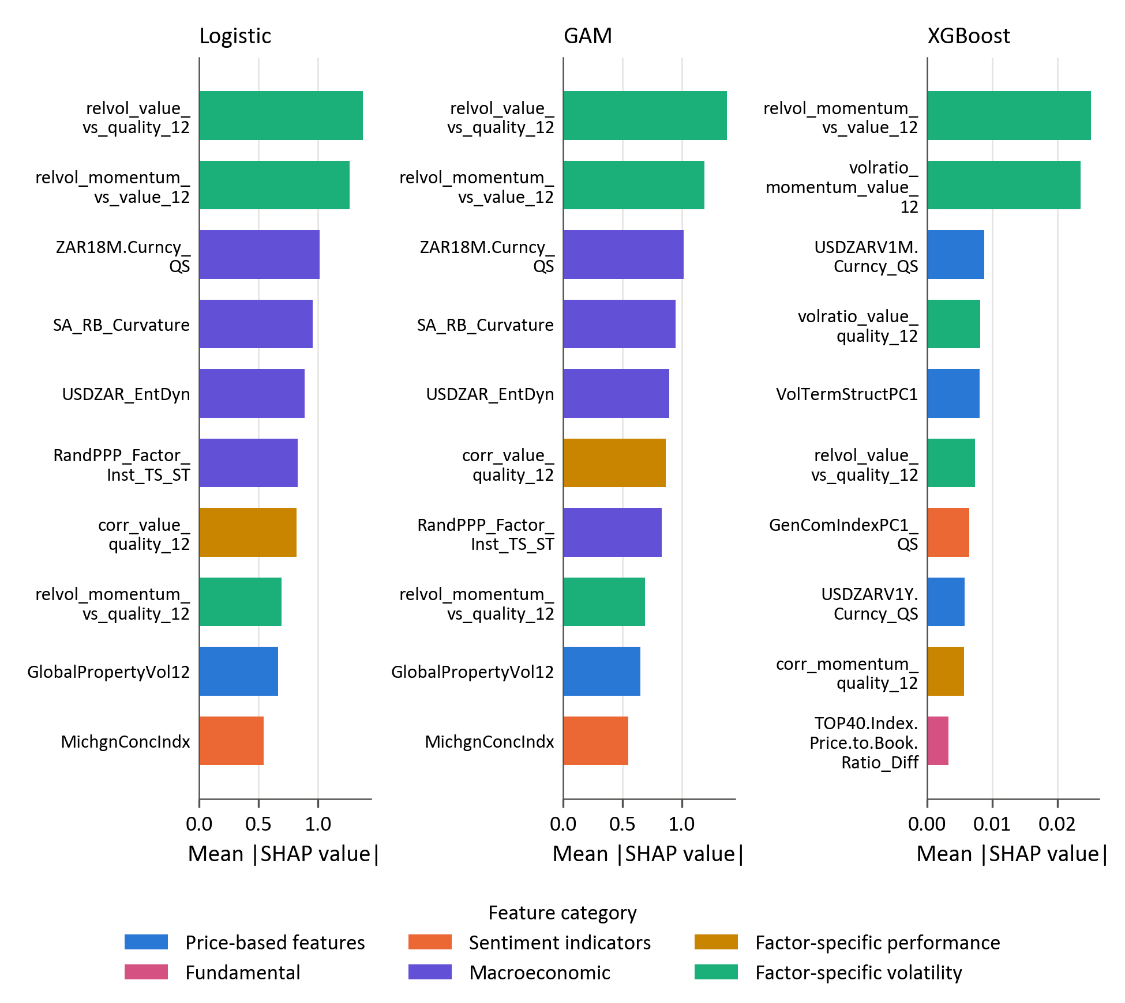
Figure 15: Global SHAP importance of the reference models for momentum versus value

Momentum versus quality

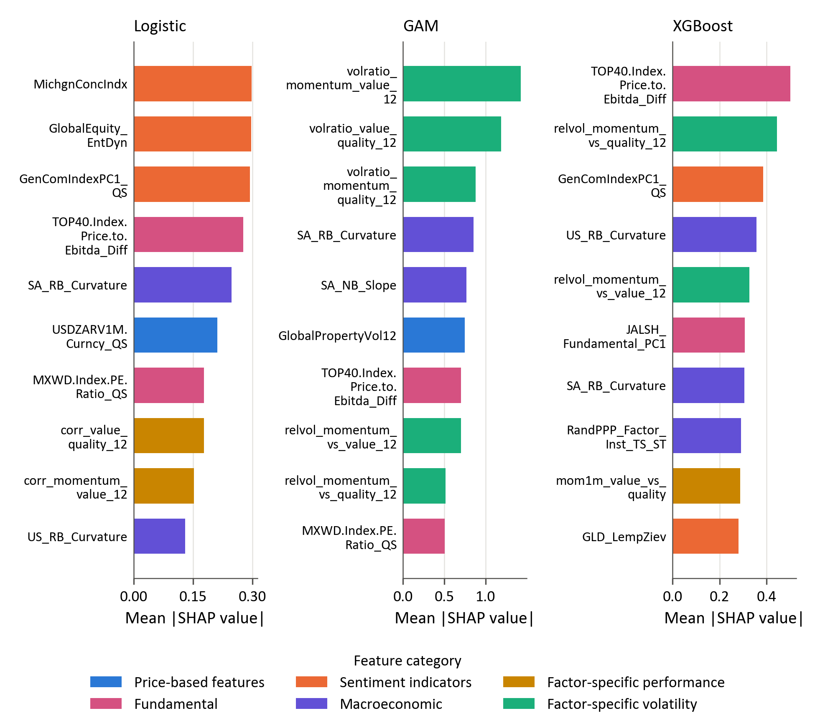
Figure 16: Global SHAP importance of the reference models for momentum versus quality

For momentum versus quality, the change in the TOP40 price-to-EBITDA ratio and the commodity index component rank among the four leading features of both logistic regression and XGBoost, and the valuation measure ranks first for XGBoost. The two reference fits otherwise differ: XGBoost also ranks the relative volatility of momentum against quality and US real-yield-curve curvature among its four leading features, whereas logistic regression ranks US consumer sentiment and global equity entropy first and second. The prominence of a valuation measure is relevant to the literature on valuation-based factor timing, which cautions that apparent valuation signals need not generate reliable timing gains (Asness, Chandra, Ilmanen, & Israel, 2017). These importance rankings do not establish that the valuation feature provides incremental predictive information about relative leadership. The GAM places greater emphasis on the volatility ratios of the three pairs, which hold its first three places, with the valuation variable ranked seventh.

Value versus quality

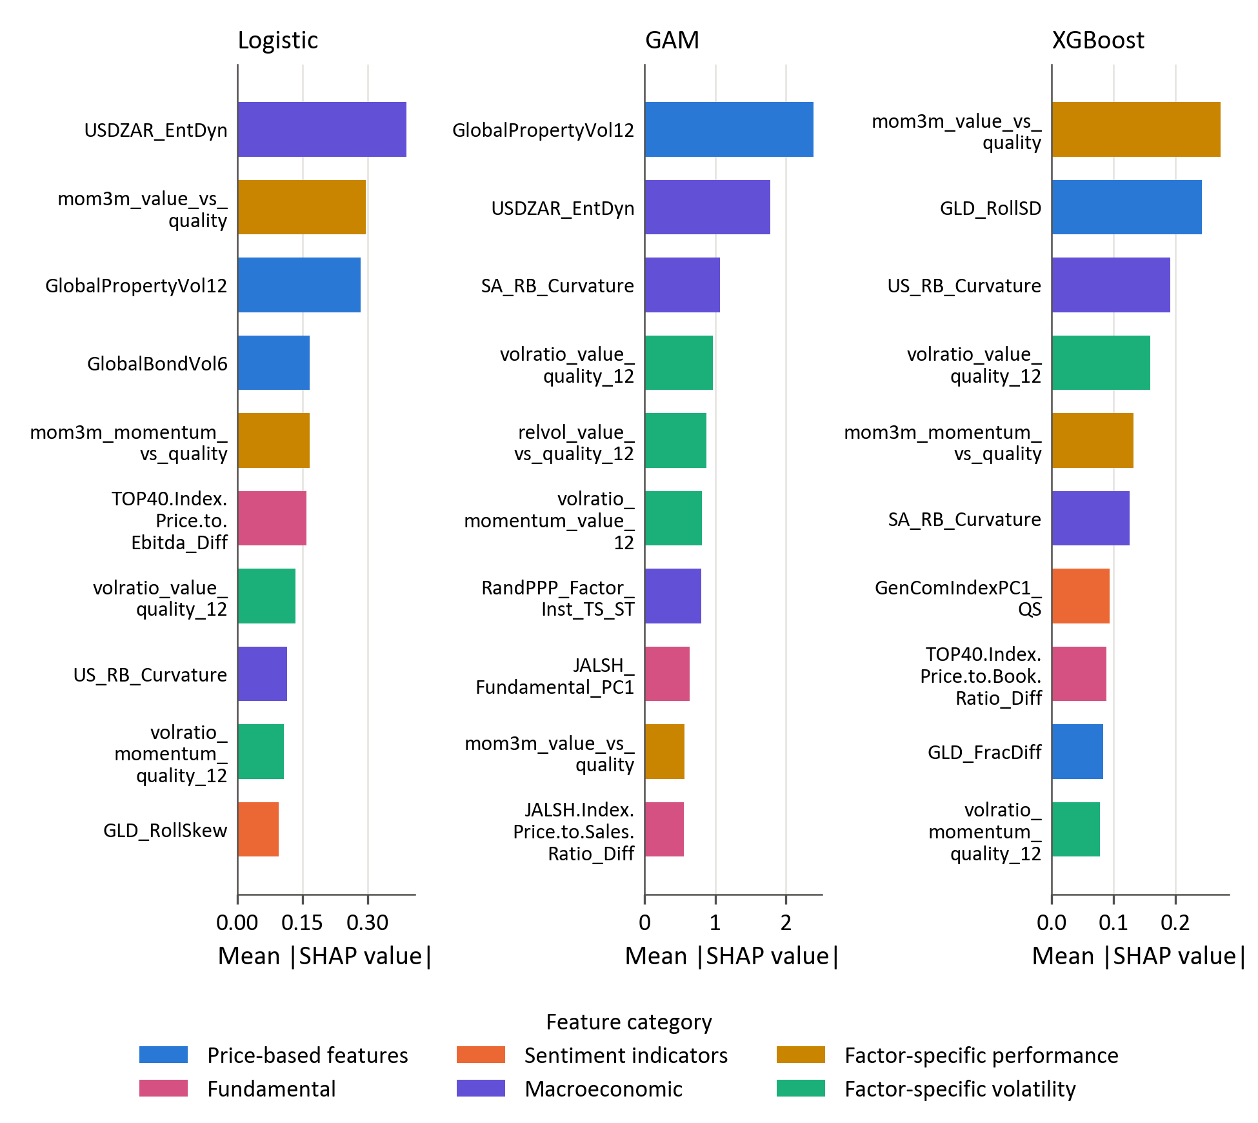
Figure 17: Global SHAP importance of the reference models for value versus quality

For value versus quality, recent relative performance is prominent in the models with the strongest overall discrimination. The three-month relative return of value against quality ranks first for XGBoost and second for logistic regression, while the corresponding momentum–quality measure appears among the five leading features of both. These rankings are compatible with the broader relevance of recent factor performance documented in the factor-momentum literature (Gupta & Kelly, 2019). The value–quality volatility ratio ranks fourth for XGBoost and the GAM and seventh for logistic regression. Logistic regression and the GAM additionally emphasise USDZAR entropy and global property volatility, whereas XGBoost assigns importance to gold volatility and US and South African yield-curve curvature.

Conclusion

Summary of key findings
Four findings emerge from the empirical analysis.
First, the evidence that relative factor leadership in the South African equity market is predictable out of sample is weak. The strongest model, XGBoost, reaches ROC-AUCs between 0.585 and 0.660 and accuracies between 57.1% and 66.7% across the three pairs (Table 4), but its 95% bootstrap interval for ROC-AUC excludes 0.5 only for value versus quality (Section 4.2). The results therefore fall between the two positions on factor timing set out in Section 1.1: relative leadership is predictable to a limited degree, and significantly so only for value versus quality.
Second, greater model flexibility does not improve predictive performance monotonically. XGBoost has the highest accuracy and ROC-AUC and the lowest log-loss for every pair, although its lead over logistic regression is not statistically significant for any pair (Section 4.2). The GAM ranks below logistic regression on ROC-AUC for two of the three pairs and has the highest log-loss for all three (Table 4). The gain is therefore associated with boosted trees, which can represent interactions between predictors, rather than with smooth nonlinear effects of individual predictors. A similar pattern is reported for US stock returns, where an additive spline model fails to outperform a linear one robustly and the gains of more flexible models are attributed to interactions between predictors (Gu, Kelly, & Xiu, 2020). XGBoost's lead in ranking holds across its hyperparameter settings for value versus quality and momentum versus value, but not for momentum versus quality, where the best fixed setting of the GAM ranks the weeks better than 82% of the XGBoost settings (Appendix C.5). The weak results of the GAM, by contrast, partly reflect weakly penalised selections that overfit the training window (Section 4.3).
Third, predictability differs markedly across the factor pairs. Value versus quality provides the strongest evidence: XGBoost ranks the weeks best (ROC-AUC 0.660), recognises both leadership states (44 of the 77 value-led and 50 of the 79 quality-led weeks) and has a log-loss (0.670) below 0.693, the value of a constant 50% forecast. For momentum versus quality, XGBoost also recognises both leadership states (65 of the 85 momentum-led and 39 of the 71 quality-led weeks) and has the highest accuracy in the study (66.7%), but its log-loss (0.716) exceeds 0.693. Momentum versus value provides the weakest evidence of timing ability. XGBoost's accuracy of 57.1% results from predicting momentum in 92.3% of weeks, so that it identifies 81 of the 85 momentum-led weeks but only 8 of the 71 value-led weeks (Section 4.3).
Fourth, the models draw on different information for each pair, and relative volatility recurs across pairs and models. Relative-volatility measures rank first in all three reference fits for momentum versus value, and the value–quality volatility ratio ranks among the seven leading features of every model for value versus quality, where the three-month relative return of value against quality leads XGBoost and ranks second for logistic regression. For momentum versus quality, the change in the TOP40 price-to-EBITDA ratio and the commodity index component rank among the four leading features of both logistic regression and XGBoost (Section 4.4). These features correspond to established timing signals, but as the rankings describe reference fits, they show which information the models use, not why XGBoost predicts better.

Implications for factor timing and quantitative asset management
The findings of this study carry several implications for quantitative asset management and factor-based investment strategies.
First, factor timing models should be assessed and applied pair by pair. The results support the use of model forecasts as one input to the tilt between value and quality, give weaker support for momentum versus quality and the least support for momentum versus value. A single rotation model applied uniformly across styles would therefore combine an informative signal with weak ones. Because the predictable component is modest, the forecasts are better suited to moderating the tilt between two factors than to switching the whole allocation between them.
Second, model complexity should be matched to the evidence rather than presumed to add value. The results do not support a general preference for nonlinear models: the additive nonlinear model performed worst on most measures, and XGBoost's advantage was obtained with shallow trees of depth two to four (Table C.6), a constrained form of flexibility that can represent interactions among only a few predictors. A regularised linear model therefore remains a necessary benchmark, and a more flexible model is justified when it improves on that benchmark out of sample across several measures and hyperparameter settings, as XGBoost does for value versus quality. Its leading features are also economically interpretable, so the added flexibility did not cost the interpretability that practitioners require (Section 2.2.4).
Third, forecasts should be evaluated on more than aggregate accuracy and ROC-AUC before they inform allocations. The momentum versus value results show that accuracy can be raised by favouring the more frequent class, and the momentum versus quality results show that a model can rank the weeks reasonably well while its probabilities are less informative than a constant 50% forecast. Allocation rules that scale exposures by the predicted probability (Section 3.9) require probabilities that improve on such a forecast, a condition met by only two of the nine fitted models, both for value versus quality (Table 4).
Finally, results from financial machine learning should be reported together with their sensitivity to the validation choices. Purged cross-validation and walk-forward evaluation limit information leakage (Section 3.8), but they do not remove the dependence of the results on the hyperparameters selected. Evaluating every setting in each model's grid (Appendix C.5) separates the conclusions that hold across settings from those that rest on a single selection, in line with the call to report all the specifications tried in machine learning backtests (Arnott, Harvey, & Markowitz, 2019).

Limitations of the study
Despite these contributions, several limitations should be acknowledged.
First, the analysis focuses on predictive performance rather than full portfolio implementation. Transaction costs, turnover, and liquidity constraints were not incorporated into the evaluation framework. These factors may materially affect the realised economic performance of factor timing strategies.
The second limitation relates to the definition of the underlying factor portfolios. In this study, the momentum, value, and quality factors are constructed using proprietary definitions derived from the investment framework of a professional asset manager. While these definitions reflect practical implementation in an institutional investment context, alternative factor constructions may produce different return dynamics and predictive relationships. Prior research has shown that factor performance can vary meaningfully depending on the choice of signals, weighting schemes, rebalancing frequency, and universe definitions. As a result, the predictive relationships identified in this study may depend partly on the specific factor definitions employed.
Furthermore, the study concentrates on three style factors: momentum, value and quality. Other factors, such as size, growth and low volatility, which were set aside for the reasons given in Section 3.2, may exhibit different time-varying behaviour.
A third limitation relates to the feature selection procedure. The mutual-information clustering retains the most central feature of each cluster without reference to the target (Section 3.6), so an informative feature can be excluded. The selected features are therefore one reasonable subset of the candidates, and the effect of the selection on out-of-sample performance is not tested. The clustering also draws on observations from the evaluation block (Section 3.6), and five of the selected features are back-filled before their first observation (Section 3.4).
Fourth, the empirical analysis is limited to the South African equity market. Although this provides valuable insight into an emerging market context, the results may not generalise fully to other markets with different structural characteristics.
Finally, the evaluation rests on a short sample. The 156 weekly predictions span three years, the labels persist over several weeks and the hyperparameters are selected three times, so the effective number of independent observations is smaller than the number of weeks (Section 3.9). The differences between the models are therefore estimated imprecisely, and the results may reflect the market conditions of 2022 to 2025 rather than a stable relationship. Cross-validation in the tuning sample also did not anticipate the lead of XGBoost in the two momentum pairs (Section 4.2).

Recommendations for future research
Several avenues for future research emerge from this study.
First, future work should extend the analysis to portfolio implementation by incorporating transaction costs, turnover constraints, and portfolio construction rules. Evaluating the economic value of ML-driven factor timing strategies requires translating predictive signals into investable portfolios. The value versus quality forecasts of XGBoost, which recognise both leadership states, are the natural starting point, and probability-weighted tilts can be compared with binary switching between the two factors.
Second, the feature selection could be estimated within each training window and combined with supervised criteria. Re-estimating the clustering on the data available at each tuning point would remove evaluation-period information from the selection, and combining information-based clustering with a supervised measure of each feature's relevance to the target may retain predictors that the unsupervised procedure excludes.
Third, combining the forecasts of the three model classes may improve robustness. For momentum versus quality the ROC curves of logistic regression and XGBoost intersect (Section 4.2.2), so neither model dominates across thresholds, and a combination of models whose errors differ can outperform its members (Dietterich, 2000). Stacked generalisation (Section 2.1.3) provides one framework for such a combination.
Finally, the analysis could be extended in scope. A longer evaluation period would give the tests of the differences between the models more power; other factors and alternative factor definitions would show whether the timing signals are robust to the construction of the factors; and applying the same framework to other emerging markets would show how market structure influences the effectiveness of machine learning in factor timing.

References

Arnott, R., Beck, N., Kalesnik, V., & West, J. (2016). How can "smart beta" go horribly wrong? The Journal of Portfolio Management, 42(2), 36-44.
Arnott, R., Harvey, C. R., & Markowitz, H. (2019). A backtesting protocol in the era of machine learning. Journal of Financial Data Science, 1(1), 64–74.
Arnott, R., Kalesnik, V., & Linnainmaa, J. (2023). Factor momentum. Review of Financial Studies, 36(8), 3034–3070.
Asness, C. S., Chandra, S., Ilmanen, A., & Israel, R. (2017). Contrarian factor timing is deceptively difficult. Journal of Portfolio Management, 43(5), 72–87.
Asness, C. S., Frazzini, A., & Pedersen, L. H. (2019). Quality minus junk. Review of Accounting Studies, 24(1), 34-112.
Asness, C., Friedman, J., Krail, R., & Liew, J. (2000). Style Timing - Value versus Growth. The Journal of Portfolio Management, 26(3), 1.
Asness, C., Moskowitz, T., & Pedersen, L. (2013). Value and momentum everywhere. The Journal of Finance, 68(3), 929-985.
Barroso, P., & Santa-Clara, P. (2015). Momentum has its moments. Journal of Financial Economics, 116(1), 111–120.
Bartram, S., Lohre, H., Pope, P., & Ranganathan, A. (2021). Navigating the factor zoo around the world: an institutional investor perspective. Journal of Business Economics, 91(5), 655-703.

Bengio, Y., Simard, P., & Frasconi, P. (1994). Learning long-term dependencies with gradient descent is difficult. IEEE Transactions on Neural Networks, 5(2), 157-166.

Bergmeir, C., & Benítez, J. M. (2012). On the use of cross-validation for time series predictor evaluation. Information Sciences, 191, 192-213.
Bessler, W. (2021). Factor investing and asset allocation strategies. Journal of Asset Management, 22(1), 1-18.
Bishop, C. M. (2006). Pattern Recognition and Machine Learning (1 ed.). New York: Springer.
Blitz, D. C. (2007). The volatility effect: Lower risk without lower return. Journal of Portfolio Management, 34(1), 102-113.
Blitz, D., Falkenstein, E., & van Vliet, P. (2014). Explanations for the Volatility Effect: An Overview Based on the CAPM Asset Pricing Context. The Journal of Portfolio Management, 40(3), 61-67.
Breiman, L. (1996). Bagging Predictors. Machine Learning, 24(2), 123-140.
Breiman, L. (2001). Random Forests. Machine Learning, 45(1), 5-32.
Breiman, L., Friedman, J., Olshen, R., & Stone, C. (1984). Classification and Regression Trees (1 ed.). New York: Chapman and Hall/CRC.

Bryzgalova, S., Pelger, M., & Zhu, J. (2023). Forest Through the Trees: Building Cross-Sections of Stock Returns. London: S&P Market Intelligence.
Cakici, N., Fieberg, C., Metko, D., & Zaremba, A. (2023). Machine learning goes global: Cross-sectional return predictability in international stock markets. Journal of Economic Dynamics and Control, 155, 104725.
Campbell, J. Y., Lo, A. W., & MacKinlay, A. C. (1997). The Econometrics of Financial Markets. Princeton: Princeton University Press.
Carhart, M. M. (1997). On Persistence in Mutual Fund Performance. Journal of Finance, 52(1), 57-82.

Cederburg, S., O'Doherty, M. S., Wang, F., & Yan, X. S. (2020). On the performance of volatility-managed portfolios. Journal of Financial Economics, 138(1), 95-117.
Chen, L., Pelger, M., & Zhu, J. (2019). Deep Learning in Asset Pricing. SSRN Electronic Journal, 1-76.
Chen, T., & Guestrin, C. (2016). XGBoost: A Scalable Tree Boosting System. Proceedings of the 22nd ACM SIGKDD International Conference on Knowledge Discovery and Data Mining (pp. 785–794). San Francisco: ACM.

Chung, J., Gulcehre, C., Cho, K., & Bengio, Y. (2014). Empirical evaluation of gated recurrent neural networks on sequence modeling. arXiv preprint arXiv:1412.3555, 1.
Cochrane, J. (2011). Presidential address: Discount rates. Journal of Finance, 66(4), 1047–1108.
Cont, R. (2001). Empirical Properties of Asset Returns: Stylized Facts and Statistical Issues. Quantitative Finance, 1(2), 223-236.
Cotturo, P., Liu, F., & Proner, R. (2024). Multi-Factor Timing with Deep Learning. SSRN Working Paper No. 4698640.
Cover, T., & Thomas, J. (2006). Elements of Information Theory (2 ed.). Hoboken: Wiley.
Daniel, K., & Moskowitz, T. J. (2016). Momentum crashes. Journal of Financial Economics, 122(2), 221-247.
Daniel, K., Hirshleifer, D., & Subrahmanyam, A. (1998). Investor Psychology and Security Market Under and Overreactions. Journal of Finance, 53(6), 1839-1885.
DeMiguel, V., Garlappi, L., & Uppal, R. (2009). Optimal versus Naive Diversification: How Inefficient Is the 1/N Portfolio Strategy? The Review of Financial Studies, 22(5), 1915-1953.
Dietterich, T. (2000). Ensemble Methods in Machine Learning. The First International Workshop on Multiple Classifier Systems (pp. 1-15). Berlin: Springer.
Dixon, M., Klabjan, D., & Bang, J. H. (2017). Classification-based Financial Markets Prediction using Deep Neural Networks. Algorithmic Finance, 6(3–4), 67–77.
Fama, E. F., & French, K. R. (1992). The Cross-Section of Expected Stock Returns. The Journal of Finance, 47(2), 427-465.
Fama, E., & French, K. (1989). Business conditions and expected returns on stocks and bonds. Journal of Financial Economics, 25(1), 23–49.
Fama, E., & French, K. (1993). Common risk factors in the returns on stocks and bonds. Journal of Financial Economics, 33(1), 3-56.
Fama, E., & French, K. (2015). A five-factor asset pricing model. Journal of Financial Economics, 116(1), 1–22.

Fang, Y., Chen, Y., & Ren, H. (2023). A Factor Pricing Model Based on Machine Learning Algorithm. International Review of Economics & Finance, 88, 280–297.
Fawcett, T. (2006). An introduction to ROC analysis. Pattern Recognition Letters, 27(8), 861–874.
Feng, G., Giglio, S., & Xiu, D. (2020). Taming the Factor Zoo. Journal of Finance, 75(3), 1327-1370.
Feng, G., He, J., Polson, N. G., & Xu, J. (2024). Deep Learning in Characteristics-Sorted Factor Models. Journal of Financial and Quantitative Analysis, 59(7), 3001-3036.
Fischer, T., & Krauss, C. (2018). Deep learning with long short-term memory networks for financial market predictions. European Journal of Operational Research, 654-669.
Fraser, E., & Page, M. (2000). Value and momentum strategies: Evidence from the Johannesburg Stock Exchange. Investment Analysts Journal, 29(51), 25–35.
Friedman, J. (2001). Greedy function approximation: A gradient boosting machine. The Annals of Statistics, 29(5), 1189-1232.
Giglio, S., Kelly, B., & Xiu, D. (2022). Factor models, machine learning, and asset pricing. Annual Review of Financial Economics, 14(1), 1-32.
Gilbert, E. (2025). Factor fusion: Crafting the future of equity solutions. Mindfields: Factor fusion – Key elements for robust performance, 20-27.
Gneiting, T., & Raftery, A. E. (2007). Strictly proper scoring rules, prediction, and estimation. Journal of the American Statistical Association, 102(477), 359–378.
Good, I. J. (1952). Rational decisions. Journal of the Royal Statistical Society: Series B, 14(1), 107–114.

Goodfellow, I., Bengio, Y., & Courville, A. (2016). Deep learning. MA: MIT Press.

Gu, S., Kelly, B., & Xiu, D. (2020). Empirical Asset Pricing via Machine Learning. The Review of Financial Studies, 33(5), 2223–2273.
Gupta, A., & Kelly, B. (2019). Factor momentum everywhere. Journal of Portfolio Management, 45(3), 13-36.
Guyon, I., & Elisseeff, A. (2003). An introduction to variable and feature selection. Journal of Machine Learning Research, 3, 1157–1182.

Haddad, V., Kozak, S., & Santosh, S. (2020). Factor timing. Review of Financial Studies, 33(5), 1980–2018.
Han, Y. (2024). Machine Learning Based Portfolio Analysis. Highlights in Business, Economics and Management, 44, 135–147.
Hanauer, M. X., & Kalsbach, T. (2023). Machine learning and the cross-section of emerging market stock returns. Emerging Markets Review, 55, 101022.

Harvey, C., Liu, Y., & Zhu, H. (2016). ...and the Cross-Section of Expected Returns. The Review of Financial Studies, 29(1), 5-68.
Hastie, T. J., & Tibshirani, R. (1986). Generalized Additive Models. Statistical Science, 1(3), 297-310.

Hastie, T., Tibshirani, R., & Friedman, J. (2009). The Elements of Statistical Learning (2 ed.). New York: Springer.

Hochreiter, S., & Schmidhuber, J. (1997). Long Short-Term Memory. Neural Computation, 1735–1780.
Hoerl, A. E., & Kennard, R. W. (1970). Ridge regression: Biased estimation for nonorthogonal problems. Technometrics, 12(1), 55-67.
Hosmer, D., Lemeshow, S., & Sturdivant, R. (2013). Applied Logistic Regression (3 ed.). Hoboken: Wiley.

Ilmanen, A., & Kizer, J. (2012). The death of diversification has been greatly exaggerated. Journal of Portfolio Management, 38(3), 15-27.
Ilmanen, A., Israel, R., Lee, R., Moskowitz, T. J., & Thapar, A. (2021). How do factor premia vary over time? A century of evidence. Journal of Investment Management, 19(4).
Israel, R., Kelly, B., & Moskowitz, T. J. (2020). Can Machines “Learn” Finance? Journal of Investment Management, 18(2), 23–36.
Jain, A. K., Murty, M. N., & Flynn, P. J. (1999). Data clustering: A review. ACM Computing Surveys, 31(3), 265-323.
James, G., Witten, D., Hastie, T., & Tibshirani, R. (2021). An Introduction to Statistical Learning (2 ed.). New York: Springer.
Jegadeesh, N., & Titman, S. (1993). Returns to buying winners and selling losers: Implications for stock market efficiency. The Journal of Finance, 48(1), 65-91.
Joseph, A. (2019). Shapley regressions: A framework for statistical inference on machine learning models. London: Bank of England.

Joseph, A. (2024). From interpretability to inference: an estimation framework for universal approximators. arXiv:1903.04209.
Kapche Fotso, H. M. (2019). Cyclicality of size, value and momentum on the Johannesburg Stock Exchange. Cape Town: University of the Western Cape.
Ke, G., Meng, Q., Finley, T., Wang, T., Chen, W., Ma, W., & Liu, T. Y. (2017). Lightgbm: A highly efficient gradient boosting decision tree. Advances in neural information processing systems, 3146-3154.
Kelly, B., Pruitt, S., & Su, Y. (2019). Characteristics are covariances: A unified model of risk and return. Journal of Financial Economics, 501-524.

Kraskov, A., Stögbauer, H., & Grassberger, P. (2004). Estimating mutual information. Physical Review E, 69(6), 066138.
Krauss, C., Do, X. A., & Huck, N. (2017). Deep neural networks, gradient-boosted trees, random forests: Statistical arbitrage on the S&P 500. European Journal of Operational Research, 259(2), 689-702.

Kumar, I. E., Venkatasubramanian, S., Scheidegger, C., & Friedler, S. A. (2020). Problems with Shapley-value-based explanations as feature importance measures. Proceedings of the 37th International Conference on Machine Learning (pp. 5491-5500). PMLR.
Künsch, H. R. (1989). The jackknife and the bootstrap for general stationary observations. The Annals of Statistics, 17(3), 1217–1241.
Lakonishok, J., Shleifer, A., & Vishny, R. W. (1994). Contrarian investment, extrapolation, and risk. The Journal of Finance, 49(5), 1541-1578.
Leippold, M., Wang, Q., & Zhou, W. (2021). Machine Learning in the Chinese Stock Market. Journal of Financial Economics, 64–82.
Leung, E., Lohre, H., Mischlich, D., Shea, Y., & Stroh, M. (2021). The Promises and Pitfalls of Machine Learning for Predicting Stock Returns. Lancaster: SSRN.
Lim, B., & Zohren, S. (2021). Time-series forecasting with deep learning: a survey. Philosophical Transactions of the Royal Society A, 2194.

Lintner, J. (1965). The valuation of risk assets and the selection of risky investments in stock portfolios and capital budgets. The Review of Economics and Statistics, 47(1), 13-37.

López de Prado, M. (2018). Advances in Financial Machine Learning (1 ed.). Hoboken: John Wiley & Sons.
López de Prado, M. (2020). Machine Learning for Asset Managers (1 ed.). Cambridge: Cambridge University Press.
Lundberg, S. M., & Lee, S. I. (2017). A unified approach to interpreting model predictions. Advances in Neural Information Processing Systems, 30, 4765–4774.
Lundberg, S., Erion, G., Chen, H., DeGrave, A., Prutkin, J., Nair, B., . . . Lee, S. (2020). From local explanations to global understanding with explainable AI for trees. Nature Machine Intelligence, 2(1), 56–67.
Ma, T., Liao, C., & Jiang, F. (2023). Timing the factor zoo via deep learning: Evidence from China. Accounting & Finance, 63(1), 485-505.
Makamo, S. (2023). Predicting Style Factor Returns and Group/sector Returns Using Long and Short-term Memory ('LSTM') Deep Learning Neural Networks. Johannesburg: SSRN.
Masongweni, V. (2025). Redefining factor portfolios in SA and global equity markets: Their existence and relevance. Mindfields: Factor fusion – Key elements for robust performance, 6-14.
McLean, R. D., & Pontiff, J. (2016). Does academic research destroy stock return predictability? The Journal of Finance, 71(1), 5-32.
Mitchell, T. (1997). Machine Learning (1 ed.). New York: McGraw-Hill.
Molnar, C. (2022). Interpretable Machine Learning. Munich: Leanpub.
Moritz, B., & Zimmermann, T. (2016). Tree-Based Conditional Portfolio Sorts: The Relation Between Past and Future Stock Returns. . SSRN Electronic Journal.
Mukoyi, L., & Ogujiuba, K. K. (2023). Comparison of Multifactor Asset Pricing Models in the South African Stock Market [2000–2016]. Journal of Risk and Financial Management, 16(1), 4.
Muller, C., & Ward, M. (2013). Style-based effects on the Johannesburg Stock Exchange: A graphical time-series approach. Investment Analysts Journal, 42(77), 1–16.
Murphy, A. (1973). A new vector partition of the probability score. Journal of Applied Meteorology, 12(4), 595–600.
Mutooni, R., & Muller, C. (2007). Equity style timing. Investment Analysts Journal, 36(65), 15–24.

Noguer i Alonso, M., Zoonekynd, V., & Srivastava, S. (2022). Equity Machine Factor Models. Equity Machine Factor Models, 1.
Page, D., McClelland, D., & Auret, C. (2022). Style rotation on the JSE. Finance Research Letters, 46(Part B), 102504.
Page, D., McClelland, D., & Auret, C. (2024). Machine learning style rotation – evidence from the Johannesburg Stock Exchange. Cogent Economics & Finance, 12(1), 1-12.
Panda, P. P., Gharanchaei, M. K., Chen, X., & Lyu, H. (2024). APPLICATION OF DEEP LEARNING FOR FACTOR TIMING IN ASSET MANAGEMENT. Pennsylvania: Arxiv.
Pedregosa, F., Varoquaux, G., Gramfort, A., Michel, V., Thirion, B., Grisel, O., . . . Duchesnay, É. (2011). Scikit-learn: Machine Learning in Python. Journal of Machine Learning Research, 2825–2830.

Peng, H., Long, F., & Ding, C. (2005). Feature selection based on mutual information: criteria of max-dependency, max-relevance, and min-redundancy. . IEEE Transactions on Pattern Analysis and Machine Intelligence, 27(8), 1226-1238.
Piotroski, J. D. (2000). Value Investing: The Use of Historical Financial Statement Information to Separate Winners from Losers. Journal of Accounting Research, 38(1), 1-41.
Piovezan, R. P. B., de Andrade Júnior, P. P., & Ávila, S. L. (2024). Machine learning method for return direction forecast of exchange traded funds (ETFs) using classification and regression models. Computational Economics, 63(5), 1827–1852.
Politis, D. N., & Romano, J. P. (1992). A circular block-resampling procedure for stationary data. In R. LePage, & L. Billard (Eds.), Exploring the Limits of Bootstrap (pp. 263–270). New York: Wiley.
Rapach, D. E., & Zhou, G. (2013). Forecasting stock returns. In G. Elliott, & A. Timmermann (Eds.), Handbook of Economic Forecasting (Vol. 2A, pp. 328-383). Amsterdam: Elsevier.
Rumelhart, D., Hinton, G., & Williams, R. (1986). Learning representations by back-propagating errors. Nature, 323(6088), 533–536.
Saetia, K., & Yokrattanasak, J. (2022). Stock Movement Prediction Using Machine Learning Based on Technical Indicators and Google Trend Searches in Thailand. International Journal of Financial Studies, 11(1), 5.
Sagi, O., & Rokach, L. (2018). Ensemble learning: A survey. WIREs Data Mining and Knowledge Discovery, 1249.
Shapley, L. (1953). A value for n-person games. Contributions to the Theory of Games, 307-317.
Sharpe, W. (1964). Capital asset prices: A theory of market equilibrium under conditions of risk. The Journal of Finance, 19(3), 435-442.

Shleifer, A., & Vishny, R. W. (1997). The limits of arbitrage. The Journal of Finance, 52(1), 35-55.

Sirignano, J., & Cont, R. (2019). Universal Features of Price Formation in Financial Markets: Perspectives from Deep Learning. Quantitative Finance, 1449-1459.
Štrumbelj, E., & Kononenko, I. (2010). An efficient explanation of individual classifications using game theory. Journal of Machine Learning Research, 11, 1-18.
Štrumbelj, E., & Kononenko, I. (2014). Explaining prediction models and individual predictions with feature contributions. Knowledge and Information Systems, 41(3), 647–665.
Sulaiman, M. A., & Labadin, J. (2016). Improved Feature Selection Based on Mutual Information for Regression Tasks. Journal of IT in Asia, 6, 11–24.
Sutton, R. S., & Barto, A. G. (2018). Reinforcement Learning: An Introduction (2 ed.). Massachusetts: MIT Press.

Tibshirani, R. (1996). Regression shrinkage and selection via the lasso. Journal of the Royal Statistical Society: Series B, 58(1), 267-288.

Vapnik, N. V. (1999). An Overview of Statistical Learning Theory. TRANSACTIONS ON NEURAL NETWORKS, 10(5), 1.
Vaswani, A., Shazeer, N., Parmar, N., Uszkoreit, J., Jones, L., Gomez, A. N., . . . Polosukhin, I. (2017). Attention is all you need. Advances in neural information processing systems , 5998-6008.
Wang, W. (2023). A comparative study of traditional linear models and nonlinear neural network model on asset pricing. China: Proceedings of the 4th International Conference on Economic Management and Model Engineering .
Ward, J. (1963). Hierarchical grouping to optimize an objective function. Journal of the American Statistical Association, 58(301), 236–244.
Welch, I., & Goyal, A. (2008). A comprehensive look at the empirical performance of equity premium prediction. The Review of Financial Studies, 21(4), 1455-1508.
White, H. (2000). A reality check for data snooping. Econometrica, 68(5), 1097-1126.
Wolpert, D. (1992). Stacked Generalization. Neural Networks, 241-259.
Wood, S. (2017). Generalized Additive Models - An Introduction with R (2 ed.). New York: Chapman and Hall/CRC.

Zou, H., & Hastie, T. (2005). Regularization and variable selection via the elastic net. Journal of the Royal Statistical Society: Series B (Statistical Methodology), 67(2), 301-320.

Appendix A: Feature definitions

Table A.1 defines the 50 modelling features: the 32 cluster representatives (Section 3.6) and the 18 relative-factor features added by design. Table A.2 explains the naming convention of the candidate features, and Table A.3 groups all 359 candidates by family; Table B.3 lists every clustered candidate by cluster.
Table A.1: The 50 modelling features
Feature | Category (Table 1) | Definition
VolTermStructPC1 | Price-based volatility | First principal component of the VIX, VIX3M, VIX6M and VIX1Y indices (level of the US equity volatility term structure)
VolTermStructPC2 | Price-based volatility | Second principal component of the same four volatility indices
USDZARV1M.Curncy_QS | Price-based volatility | One-month at-the-money implied volatility of USD/ZAR, quantile scaled
USDZARV1Y.Curncy_QS | Price-based volatility | One-year at-the-money implied volatility of USD/ZAR, quantile scaled
EURUSDV6M.Curncy_QS | Price-based volatility | Six-month at-the-money implied volatility of EUR/USD, quantile scaled
GlobalBondVol6 | Price-based volatility | Six-month realised volatility of global bond index returns
GlobalPropertyVol12 | Price-based volatility | Twelve-month realised volatility of global property index returns
GLD_RollSD | Price-based volatility | Rolling standard deviation of gold returns
GLD_FracDiff | Price-based volatility | Fractionally differenced gold price
JALSH_Fundamental_PC1 | Fundamental valuation | First principal component of the valuation ratios of the FTSE/JSE All Share Index
MXWD_Fundamental_PC1 | Fundamental valuation | First principal component of the valuation ratios of the MSCI World Index
TOP40.Index.Price.to.Book.Ratio_Diff | Fundamental valuation | Price-to-book ratio of the FTSE/JSE Top 40 Index, differenced
TOP40.Index.Price.to.Ebitda_Diff | Fundamental valuation | Price-to-EBITDA ratio of the FTSE/JSE Top 40 Index, differenced
JALSH.Index.Price.to.Sales.Ratio_Diff | Fundamental valuation | Price-to-sales ratio of the FTSE/JSE All Share Index, differenced
MXWD.Index.PE.Ratio_QS | Fundamental valuation | Price-to-earnings ratio of the MSCI World Index, quantile scaled
MichgnConcIndx | Sentiment and risk appetite | University of Michigan Consumer Sentiment Index
GenComIndexPC1_QS | Sentiment and risk appetite | First principal component of commodity spot prices, quantile scaled
GLD_StructBreak | Sentiment and risk appetite | Structural-break statistic of the gold price
GLD_LempZiev | Sentiment and risk appetite | Lempel–Ziv complexity of gold returns
GLD_RollSkew | Sentiment and risk appetite | Rolling skewness of gold returns
GLD_RollKurt | Sentiment and risk appetite | Rolling kurtosis of gold returns
GlobalEquityTS | Sentiment and risk appetite | Trend-scanning t-statistic of the global equity index (direction and strength of its recent trend)
GlobalEquity_EntDyn | Sentiment and risk appetite | Entropy of global equity returns under dynamic encoding
SA_NB_Slope | Macroeconomic | Slope factor of a Nelson–Siegel fit to the South African nominal bond yield curve
SA_RB_Curvature | Macroeconomic | Curvature factor of a Nelson–Siegel fit to the South African real (inflation-linked) bond yield curve
US_RB_Curvature | Macroeconomic | Curvature factor of a Nelson–Siegel fit to the US real (inflation-protected) bond yield curve
SA_CDS_Slope | Macroeconomic | Slope factor of a Nelson–Siegel fit to the South African sovereign credit default swap curve
RandPPP_Factor_Inst_TS_ST | Macroeconomic | Short-horizon trend-scanning t-statistic of the rand purchasing-power-parity valuation
PPP.ZA.Index_QS | Macroeconomic | Rand purchasing-power-parity valuation, quantile scaled
BCMPEBLS.Index | Macroeconomic | Euro-area bank lending survey index (bank lending conditions)
ZAR18M.Curncy_QS | Macroeconomic | 18-month USD/ZAR forward points, quantile scaled
USDZAR_EntDyn | Macroeconomic | Entropy of USD/ZAR returns under dynamic encoding
mom1m_<pair> | Factor relative performance | Difference between the two factors’ compounded returns over the last 4 weeks (three features, one per pair)
mom3m_<pair> | Factor relative performance | Difference between the two factors’ compounded returns over the last 12 weeks (three features)
zrel_<pair>_12 | Factor relative performance | Weekly return spread of the pair, standardised by its 12-week rolling mean and standard deviation (three features)
corr_<a>_<b>_12 | Factor relative performance | 12-week rolling correlation of the two factors’ weekly returns (three features)
relvol_<pair>_12 | Factor relative volatility | 12-week rolling standard deviation of the weekly return spread of the pair (three features)
volratio_<a>_<b>_12 | Factor relative volatility | Ratio of the two factors’ 12-week rolling volatilities (three features)
Note: <pair> stands for momentum_vs_value, momentum_vs_quality or value_vs_quality, and <a>_<b> for momentum_value, momentum_quality or value_quality. The 18 relative-factor features are computed from the weekly factor returns; the 32 representatives come from the candidate file and are lagged by four weeks with the rest (Section 3.4).
Table A.2: Naming convention of the candidate features
Element of the name | Meaning
_QS, _QuantileScale, _QuantScale | Quantile scaled: the percentile of the value within the series’ history, between 0 and 1
_Diff | Differenced series, a transformation towards stationarity
FracDiff | Fractionally differenced series, which removes the trend but keeps long memory
TS (_TS, _TS_ST, _TS_LT) | Backward-looking trend-scanning t-statistic of the series (ST and LT: short and long horizon)
Gret1/3/6/12, Vol1/3/6/12, RV_3/12 | Geometric return and realised volatility over 1, 3, 6 or 12 months
SB, StructBreak | Structural-break statistic
Ent, EntDyn, LempZiev | Entropy of returns under static or dynamic encoding; Lempel–Ziv complexity
RollSD, RollSkew, RollKurt | Rolling standard deviation, skewness and kurtosis of returns
PC1, PC2, PC3 | Principal components of a group of related series
Level, Slope, Curvature, Lambda, R2 | Nelson–Siegel factors, decay parameter and goodness of fit of a curve; NB and RB denote nominal and real bond curves, CDS the sovereign credit default swap curve
V<tenor>.Curncy (e.g. USDZARV1M) | At-the-money implied volatility of the currency pair at that tenor
ZAR<tenor>.Curncy, ZARI<tenor>.Curncy | USD/ZAR forward points and implied rand yields at that tenor
_YoY | Year-on-year change
Table A.3: The 359 candidate features by family
Family | Features | Examples
Equity and bond volatility indices | 13 | VolTermStructPC1; VolTermStructPC2; VolTermStructPC1_QS; VolTermStructPC2_QS; VolSpread6M; VIX.Index; …
Asset-class returns, volatility, trends and breaks | 76 | DXY_RV_12; DXY_RV_3; ACWI_RV_3_TS; ACWI_RV_12_TS; JALSH_RV_3_TS; JALSH_RV_12_TS; …
Entropy | 14 | WOG1_Ent_TS; ACWI_Ent_TS; JALSH_Ent_TS; USDZAR_EntDyn; USDZAR_Ent; MultiAssetEnt; …
Cross-asset correlations | 7 | GE_GB_Corr; LE_LB_Corr; LB_GB_Corr; LE_LB_Corr.1; GE_GB_Corr.1; GE_LE_Corr; …
Yield and credit curves | 70 | USNomBndStructBreak_Level; USNomBndStructBreak_Slope; USRealBndStructBreak_Level; USRealBndStructBreak_Slope; SANomBndStructBreak_Level; SANomBndStructBreak_Slope; …
Currency volatility, forward points and implied yields | 59 | ZAR_FwdPts_PC2_TS; ZAR_FwdPts_PC1_TS; DXY_QuantScale; DXY_TS; DXY.Curncy_QS; USDZAR_Vol_Level; …
Commodities | 27 | GLD_FracDiff; GLD_StructBreak; GLD_LempZiev; GLD_RollSD; GLD_RollSkew; GLD_RollKurt; …
Equity valuation ratios (JSE All Share, Top 40, MSCI World) | 46 | JALSH.Index.PE.Ratio_QS; MXWD.Index.PE.Ratio_QS; TOP40.Index.PE.Ratio_QS; JALSH.Index.PE.Ratio.Next.FY.Aggregated_QS; MXWD.Index.PE.Ratio.Next.FY.Aggregated_QS; TOP40.Index.PE.Ratio.Next.FY.Aggregated_QS; …
Macroeconomic, survey and sentiment indicators | 47 | LEI.Totl_TS; AAII_Bull_TS; SA_PMI_TS; MichgnConcIndx_QuantileScale; MichgnConcIndx_TS; MichgnConcIndx; …
Total | 359

Appendix B: Feature selection
This appendix reproduces the 32 mutual-information (MI) cluster representatives used in the models and tests their sensitivity to the estimation choices described in Section 3.6.
B.1: Screening of the candidate features
Tables B.1 and B.2 summarise the missing-value screen and final predictor set. MI distances use 680 weekly observations from 26 March 2012 to 31 March 2025, after forward filling.
Table B.1: From candidate features to the final predictor set
Step | Features
Candidate features in the feature file | 359
Removed: more than 30% of weekly observations missing (Table B.2) | −15
Passing the missing-value screen | 344
Clusters at a cut height of 2, one representative each (Table B.3) | 32
Relative-factor features added by design (Section 3.6) | 18
Final predictor set | 50

Table B.2: Features removed by the missing-value screen
Feature | Share of weeks missing | First available
SAImplYld_QS_Level | 64% | 05 Nov 2018
SAImplYld_QS_Slope | 64% | 05 Nov 2018
USDZAR_Vol_QS_Level | 48% | 30 Nov 2015
USDZAR_Vol_QS_Slope | 48% | 30 Nov 2015
SAImplYld_Level | 43% | 12 Jan 2015
SAImplYld_Slope | 43% | 12 Jan 2015
ZARI2M.Curncy_QS | 33% | 04 Feb 2013
ZARI2W.Curncy_QS | 33% | 04 Feb 2013
ZARI2Y.Curncy_QS | 33% | 04 Feb 2013
ZARI3M.Curncy_QS | 33% | 04 Feb 2013
ZARI3Y.Curncy_QS | 33% | 04 Feb 2013
ZARI4M.Curncy_QS | 33% | 04 Feb 2013
ZARI4Y.Curncy_QS | 33% | 04 Feb 2013
ZARI5M.Curncy_QS | 33% | 04 Feb 2013
ZARI5Y.Curncy_QS | 33% | 04 Feb 2013

B.2: Cluster membership and representatives
Table B.3: Clusters, representatives and members (cut height 2)
Representative | Category | Size | Rep. mean dist. | Within-cluster dist. | Other members
GlobalBondVol6 | Price-based features | 48 | 0.77 | 0.81 | US_RB_Level_TS; US_NB_Slope_TS; SubIndex_PC2; BCMPUSGR.Index_QS; SA_RB_Slope_TS; SABreakEvenInflPCA_TS; SA_NB_Level_TS; GlobalPropertyVol3; AAII_Bull_TS; LocalPropertyGret12; USDZARVol6; GlobalEquityVol3; US_NB_Level_TS; WOG1_Ent_TS; ACWI_Ent_TS; LocalPropertyVol3; InflGrowthSurpPC1_QS; InflGrowthSurpPC2; VolSpread6M; InflGrowthSurpPC2_QS; OVXStructBreak; JALSH_Ent_TS; BCMPUSIF.Index_QS; US_NB_Curvature_QS; SABreakEvenInflPCA_TS.1; US_NB_R2; DXY_RV_3; US_NB_Slope_QS; RepSouCDSStructBreak; LocalPropertyTS; SA_NB_Slope_TS; GlobalBondVol3; GlobalPropertyGret12; LocalEquityVol3; GlobalBondGret12; LocalBondsVol3; JALSH.Index.Forward.PE_QS; US_NB_R2_QS; GlobalPropertyTS; AAIIBULL.Index; NG1.Comdty_Diff_QS; SubIndex_PC1_TS; AAIIBEAR.Index; LocalPropertyGret6; JALSH_RV_3_TS; VIXStructBreak; USDZARVol3
VolTermStructPC2 | Price-based features | 44 | 0.86 | 0.88 | GenComIndexPC2_QS; GenComIndexPC2; GlobalEquityGret1; XAU.Curncy_Diff_QS; GlobalPropertyVol1; VolTermStructPC2_QS; LA1RollSkew; USDZARGret3; USNomBndStructBreak_Level; LA1RollKurt; LocalPropertyVol1; LocalBondsGret3; GlobalPropertyGret1; TINSALNL.Index; LocalBondsVol1; GlobalBondVol1; LocalPropertyGret1; GlobalEquitySB; GlobalBondSB.1; SANomBndStructBreak_Level; TINSALNL.Index_QS; LocalEquityVol1; AAIIBULL.Index_QS; OPCVTPCR.Index; USRealBndStructBreak_Level; USDZARSB; LocalBondsGret1; SA_PMI_TS; OPCVTPCR.Index_QS; LocalBondsSB; MOVEStructBreak; LocalPropertySB; LocalEquityGret1; GlobalBondSB; USNomBndStructBreak_Slope; AAIIBEAR.Index_QS; GlobalBondGret1; USDZARVol1; USDZARGret1; SANomBndStructBreak_Slope; LocalEquitySB; USRealBndStructBreak_Slope; LA1StructBreak
JALSH_Fundamental_PC1 | Fundamental | 42 | 0.69 | 0.75 | JALSH.Index.PE.Ratio_Diff; GE_GB_Corr; US_NB_Level; JALSH_PEvAgrgtPE_1FY; GlobalPropertyVol6; JALSH_RV_12_TS; InflGrowthSurpPC1; LocalPropertyVol6; SubIndex_PC1; SA_NB_Curvature; GlobalEquityVol6; SA_RB_Level_TS; JALSH.Index.Forward.PE_Diff; DXY_RV_12; MXWD_PEvAgrgtPE_1FY; ZAR_FwdPts_PC2_TS; US_RB_Level; LocalEquityVol6; BCMPEBLS.Index_QS; JALSH.Index.PE.Ratio_QS; ACWI_RV_12_TS; MXWD_Fundamental_PC2; MXWD_PEvFwdPE; TOP40.Index.PE.Ratio_Diff; LE_LB_Corr; SABreakEvenInflPC_1; ZAR_FwdPts_PC1_TS; LocalBondsVol6; LB_GB_Corr; JALSH_Fundamental_PC2; DXY_TS; LEI.Totl_TS; JALSH_PEvFwdPE; US_NB_Level_QS; US_RB_Slope_TS; SAFwdPts_Slope; US_RB_Level_QS; OEZAKLAF.Index_QS; SA_NB_Curvature_QS; TOP40.Index.PE.Ratio_QS; SA_RB_Level_QS
GlobalEquityTS | Sentiment indicators | 39 | 0.81 | 0.85 | LocalEquityTS; GlobalBondTS; DXY.Curncy_QS; GlobalEquityGret12; GlobalEquityGret6; GlobalBondGret6; BICLB10Y.Index_QS; GlobalEquityGret3; LocalBondsTS; SA_NB_Level_QS; GE_GB_Corr.1; ACWI_RV_3_TS; LocalEquityGret12; LA1RollSD; GlobalBondGret3; MichgnConcIndx_QuantileScale; SABreakEvenInflPC_2; US_RB_R2; GlobalPropertyGret6; ECSURPUS.Index_QS; GE_LE_Corr; LocalEquityGret6; LocalBondsGret12; DXY_QuantScale; LocalGlobalPESpreadQS; GlobalPropertyGret3; LocalPropertyGret3; GB_LB_Corr; LocalEquityGret3; USDEUR_Vol_Slope; LocalBondsGret6; BASPCAAA.Index_QS; LE_LB_Corr.1; SAFwdPts_QS_Slope; US_RB_R2_QS; VolTermStructPC1_QS; USDEUR_Vol_QS_Slope; MichgnConcIndx_TS
SA_NB_Slope | Macroeconomic | 16 | 0.74 | 0.81 | SA_CDS_Slope_QS; RandPPP_Factor_Inst; SA_CDS_Curvature_QS; USDZARV4Y.Curncy_QS; RandPPP_QuantileScale; SA_CDS_R2_QS; SA_CDS_Level_QS; USDZARV3Y.Curncy_QS; SA_NB_Slope_QS; SA_NB_R2; SA_NB_R2_QS; USDZARGret12; USDZARTS; USDZARGret6; USDZAR_Vol_Level
JALSH.Index.Price.to.Sales.Ratio_Diff | Fundamental | 14 | 0.71 | 0.80 | JALSH.Index.PE.Ratio.Next.FY.Aggregated_Diff; TOP40.Index.Forward.PE_Diff; TOP40.Index.PE.Ratio.Next.FY.Aggregated_Diff; TOP40.Index.Price.to.Sales.Ratio_Diff; JALSH.Index.PE.Ratio.Next.FY.Aggregated_QS; JALSH.Index.Price.to.Sales.Ratio_QS; TOP40.Index.Price.to.Sales.Ratio_QS; TOP40.Index.PE.Ratio.Next.FY.Aggregated_QS; TOP40.Index.Forward.PE_QS; VixMoveSpread; USDZAR_Vol_Slope; SABreakEvenInflPC_3; LEI.TOTL.Index_QS
GlobalPropertyVol12 | Price-based features | 12 | 0.58 | 0.66 | GlobalEquityVol12; LocalPropertyVol12; LocalEquityVol12; GlobalBondVol12; LocalBondsVol12; SA_RB_Level; GlobalEquityVol1; US_NB_Curvature; SAFwdPtsl_Level; US_NB_Slope; USDZARVol12
PPP.ZA.Index_QS | Macroeconomic | 11 | 0.91 | 1.00 | SA_NB_Lambda; SA_NB_Lambda_QS; SA_RB_Lambda; SA_RB_Lambda_QS; US_NB_Lambda; US_NB_Lambda_QS; US_RB_Lambda; US_RB_Lambda_QS; SA_CDS_Lambda; SA_CDS_Lambda_QS
GlobalEquity_EntDyn | Sentiment indicators | 10 | 0.82 | 0.93 | GlobalEquity_Ent; GlobalBonds_Ent; LocalEquity_EntDyn; LocalEquity_Ent; LA1LempZiev; LocalBonds_Ent; MultiAssetEnt; USDZAR_Ent; GlobalBonds_EntDyn
MichgnConcIndx | Sentiment indicators | 10 | 0.56 | 0.65 | CONCCONF.Index; EPUCCUSM.Index; CONSSENT.Index_QS; EPUCCUSM.Index_QS; SAPMI_YoY; CONCCONF.Index_QS; SACWC.Index_QS; SAPMI.Index_QS; SSICCONF.Index_QS
EURUSDV6M.Curncy_QS | Price-based features | 10 | 0.50 | 0.63 | EURUSDV9M.Curncy_QS; EURUSDV3M.Curncy_QS; EURUSDV2M.Curncy_QS; EURUSDV1Y.Curncy_QS; EURUSDV1M.Curncy_QS; EURUSDV2W.Curncy_QS; USDEUR_Vol_QS_Level; EURUSDV1W.Curncy_QS; USDEUR_Vol_Level
ZAR18M.Curncy_QS | Macroeconomic | 9 | 0.23 | 0.30 | ZAR2Y.Curncy_QS; ZAR12M.Curncy_QS; SAFwdPts_QS_Level; ZAR10M.Curncy_QS; ZAR15M.Curncy_QS; ZAR3Y.Curncy_QS; ZAR21M.Curncy_QS; ZAR5Y.Curncy_QS
MXWD.Index.PE.Ratio_QS | Fundamental | 8 | 0.66 | 0.76 | MXWD.Index.Price.to.Ebitda_QS; MXWD.Index.Price.to.Sales.Ratio_Diff; MXWD.Index.Price.to.Book.Ratio_Diff; MXWD.Index.Price.to.Sales.Ratio_QS; MXWD.Index.Forward.PE_QS; MXWD.Index.PE.Ratio.Next.FY.Aggregated_QS; MXWD.Index.Price.to.Book.Ratio_QS
USDZARV1M.Curncy_QS | Price-based features | 6 | 0.46 | 0.60 | USDZARV2M.Curncy_QS; USDZARV3W.Curncy_QS; USDZARV3M.Curncy_QS; USDZARV1W.Curncy_QS; USDZARVON.Curncy_QS
SA_RB_Curvature | Macroeconomic | 6 | 0.50 | 0.64 | SA_RB_Slope; SA_RB_Slope_QS; SA_RB_Curvature_QS; SA_RB_R2; SA_RB_R2_QS
GenComIndexPC1_QS | Sentiment indicators | 6 | 0.55 | 0.75 | LA1.Comdty_Diff_QS; GenComIndexPC1; LA1FracDiff; HG1.Comdty_Diff_QS; XAG.Curncy_Diff_QS
VolTermStructPC1 | Price-based features | 5 | 0.35 | 0.50 | VIX3M.Index; VIX6M.Index; VIX1Y.Index; VIX.Index
USDZARV1Y.Curncy_QS | Price-based features | 5 | 0.31 | 0.42 | USDZARV18M.Curncy_QS; USDZARV9M.Curncy_QS; USDZARV2Y.Curncy_QS; USDZARV6M.Curncy_QS
SA_CDS_Slope | Macroeconomic | 5 | 0.45 | 0.61 | SA_CDS_Curvature; SA_CDS_Level; SA_CDS_R2; SA_NB_Level
MXWD_Fundamental_PC1 | Fundamental | 5 | 0.41 | 0.57 | MXWD.Index.Forward.PE_Diff; MXWD.Index.PE.Ratio_Diff; MXWD.Index.PE.Ratio.Next.FY.Aggregated_Diff; MXWD.Index.Price.to.Ebitda_Diff
TOP40.Index.Price.to.Ebitda_Diff | Fundamental | 4 | 0.43 | 0.58 | JALSH.Index.Price.to.Ebitda_Diff; TOP40.Index.Price.to.Ebitda_QS; JALSH.Index.Price.to.Ebitda_QS
BCMPEBLS.Index | Macroeconomic | 4 | 0.32 | 0.47 | SACWC_YoY; LEI.TOTL.Index; OEZAKLAF_YoY
US_RB_Curvature | Macroeconomic | 4 | 0.34 | 0.46 | US_RB_Slope; US_RB_Slope_QS; US_RB_Curvature_QS
TOP40.Index.Price.to.Book.Ratio_Diff | Fundamental | 4 | 0.51 | 0.69 | JALSH.Index.Price.to.Book.Ratio_Diff; TOP40.Index.Price.to.Book.Ratio_QS; JALSH.Index.Price.to.Book.Ratio_QS
GLD_RollKurt | Sentiment indicators | 2 | 0.00 | 0.00 | XAURollKurt
GLD_LempZiev | Sentiment indicators | 2 | 0.06 | 0.11 | XAULempZiev
GLD_RollSD | Price-based features | 2 | 0.00 | 0.00 | XAURollSD
GLD_StructBreak | Sentiment indicators | 2 | 0.00 | 0.00 | XAUStructBreak
USDZAR_EntDyn | Macroeconomic | 2 | 0.00 | 0.00 | LocalBonds_EntDyn
GLD_FracDiff | Price-based features | 2 | 0.00 | 0.00 | XAUFracDiff
RandPPP_Factor_Inst_TS_ST | Macroeconomic | 2 | 0.00 | 0.00 | RandPPP_Factor_Inst_TS_LT
GLD_RollSkew | Sentiment indicators | 2 | 0.00 | 0.00 | XAURollSkew

B.3: Choice of cut height
Figure B.1 assesses cluster separation. The mean silhouette score is 0.037 at 32 clusters, indicating substantial overlap. Across partitions of 5–100 clusters, scores remain below 0.1 and reach 0.097 at 100, with no interior maximum. The cut height of 2 therefore balances compactness against merging dissimilar features, rather than identifying a clear optimum.
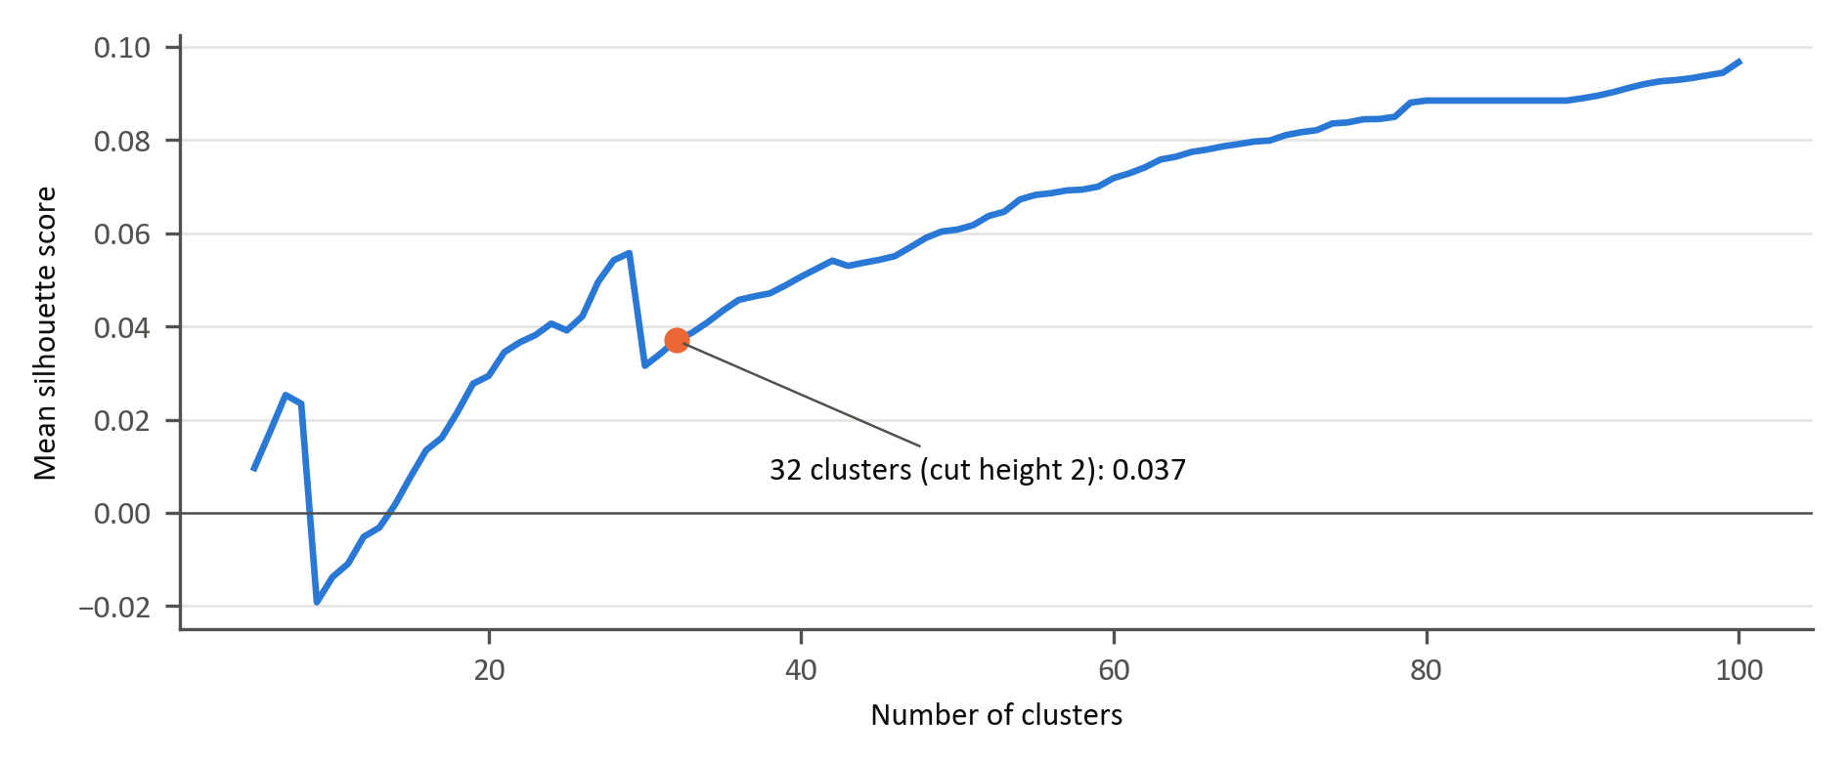
Figure B.1: Silhouette scores by cluster count using MI distances and Ward linkage
B.4: Stability of the selected features
Table B.4 tests the omitted-column correction, 10 and 30 quantile bins instead of 20, and estimation on the 514 pre-evaluation weeks ending 24 January 2022. Representative comparisons use 32 clusters because linkage heights vary with specification. A substitution retains another member of the same baseline cluster. The adjusted Rand index (ARI) measures partition agreement: 1 indicates identical partitions and 0 indicates chance agreement.
Table B.4: Selection stability under alternative specifications at 32 clusters
Alternative | Clusters at cut height 2 | Unchanged | Substituted from same cluster | Not represented | ARI
All 344 screened features (omission corrected) | 32 | 31 | 0 | 1 | 0.91
10 quantile bins instead of 20 | 40 | 20 | 8 | 4 | 0.39
30 quantile bins instead of 20 | 23 | 23 | 7 | 2 | 0.59
Pre-evaluation weeks only (Mar 2012 to Jan 2022) | 31 | 21 | 9 | 2 | 0.53
Correcting the omission replaces VolTermStructPC2 with GlobalEquityGret3. The other alternatives change 9–12 representatives, while retaining coverage of 28–30 baseline clusters (Table B.4). Pre-evaluation estimation changes 11 representatives, including nine substitutions within the same cluster. Full-sample estimation therefore affects the selection; its effect on predictive performance requires re-estimating the models. With 10 bins, a constant feature (SA_NB_Lambda) is selected, supporting removal of constant features before clustering.
B.5: Mutual information and correlation

Table B.5: Feature pairs with high MI but low correlation
Feature pair | NMI (levels) | NMI (weekly changes) | |r| (levels) | Lag-1 autocorrelation
BCMPEBLS.Index – SACWC.Index_QS | 0.50 | 0.14 | 0.17 | 0.98 / 0.97
OEZAKLAF_YoY – BCMPEBLS.Index | 0.49 | 0.09 | 0.19 | 0.98 / 0.98
BCMPEBLS.Index – LocalPropertyVol12 | 0.44 | 0.01 | 0.20 | 0.98 / 0.99
LEI.TOTL.Index – SACWC.Index_QS | 0.43 | 0.06 | 0.09 | 0.99 / 0.97
SACWC_YoY – JALSH_Fundamental_PC1 | 0.42 | 0.01 | 0.17 | 0.97 / 0.99
SACWC_YoY – USDZARVol12 | 0.42 | 0.00 | 0.03 | 0.97 / 0.99
BCMPEBLS.Index – CONCCONF.Index | 0.42 | 0.11 | 0.14 | 0.98 / 0.96
BCMPEBLS.Index – JALSH_PEvAgrgtPE_1FY | 0.42 | 0.03 | 0.02 | 0.98 / 0.97
BCMPEBLS.Index – SA_RB_Level | 0.42 | 0.01 | 0.10 | 0.98 / 0.99
BCMPEBLS.Index – JALSH_Fundamental_PC1 | 0.42 | 0.01 | 0.11 | 0.98 / 0.99
SACWC_YoY – SA_RB_Level | 0.42 | 0.00 | 0.01 | 0.97 / 0.99
MichgnConcIndx – BCMPEBLS.Index | 0.41 | 0.10 | 0.07 | 0.99 / 0.98
MichgnConcIndx – SACWC_YoY | 0.41 | 0.07 | 0.12 | 0.99 / 0.97
MichgnConcIndx – OEZAKLAF_YoY | 0.41 | 0.32 | 0.05 | 0.99 / 0.98

MI-based and correlation-based clustering therefore produce materially different selections in this dataset, but the evidence does not show that the difference arises from nonlinear redundancy. Much of the dependence that MI detects and correlation does not is shared persistence between slow-moving series.
B.6: Economic classification of the modelling features
Table B.6 lists the 50 modelling features, the 32 cluster representatives and the 18 relative-factor features added by design, by the categories of Table 1, with the economic rationale for including each and the empirical evidence that supports it. Appendix A defines each feature.
Table B.6: Economic classification of the 50 modelling features
Feature Category | Feature | Economic Rationale | Empirical Findings
Price-based features | VolTermStructPC1 | - Captures level of volatility term structure - captures future uncertainty | (Gu, Kelly, & Xiu, 2020)  Volatility consistently ranks among the most important ML predictors.  (Daniel & Moskowitz, 2016)  Momentum payoffs vary with market conditions.
Price-based features | VolTermStructPC2
Price-based features | GLD_FracDiff | - Local volatility provides a good signal for risk-on/risk-off environments.
Price-based features | GLD_RollSD
Price-based features | USDZARV1M.Curncy_QS
Price-based features | USDZARV1Y.Curncy_QS
Price-based features | GlobalBondVol6 | - Global volatility spills over across international markets.
Price-based features | GlobalPropertyVol12
Price-based features | EURUSDV6M.Curncy_QS
Fundamental | MXWD_Fundamental_PC1 |  | (Cakici, Fieberg, Metko, & Zaremba, 2023)  Value, followed by momentum, proves to be a crucial driver of stock prices globally
Fundamental | JALSH_Fundamental_PC1 | - Fundamental valuation measures (P/E, P/B, sales) capture expected mean-reversion in prices.
Fundamental | TOP40.Index.Price.to.Book.Ratio_Diff | - Book-to-price differentials identify undervalued vs overvalued stocks.
Fundamental | MXWD.Index.PE.Ratio_QS | - Sales-to-price ratio identifies cyclical undervaluation.
Fundamental | TOP40.Index.Price.to.Ebitda_Diff
Fundamental | JALSH.Index.Price.to.Sales.Ratio_Diff
Sentiment indicators | MichgnConcIndx | - Reflects household expectations and overall risk sentiment. | (Saetia & Yokrattanasak, 2022)  Technical financial indicators and sentiment indicators showed stronger predictive power than macro-economic indicators.
Sentiment indicators | GenComIndexPC1_QS | - Commodity PCA reflects global risk appetite, growth expectations, and inflation pressure.
Sentiment indicators | GLD_StructBreak | - Structural breaks in gold prices signal major shifts in global uncertainty.
Sentiment indicators | GLD_LempZiev
Sentiment indicators | GLD_RollSkew
Sentiment indicators | GLD_RollKurt
Sentiment indicators | GlobalEquityTS | - Captures momentum in investor optimism/pessimism.
Sentiment indicators | GlobalEquity_EntDyn | - Captures momentum in investor optimism/pessimism.
Macroeconomic | SA_RB_Curvature | - Yield curve curvature and slope reflects growth expectations and monetary policy stance (local and global) | (Fang, Chen, & Ren, 2023)  Factor predictability is macro-state dependent.
Macroeconomic | US_RB_Curvature
Macroeconomic | SA_NB_Slope
Macroeconomic | SA_CDS_Slope | - Credit spread slope proxies sovereign risk, economic stress, and funding conditions.
Macroeconomic | RandPPP_Factor_Inst_TS_ST | - Tracks widening and narrowing of rand valuation
Macroeconomic | PPP.ZA.Index_QS | - Rand valuation sits relative to its 5-year history.
Macroeconomic | BCMPEBLS.Index | - Euro-area bank lending conditions, which lead credit supply and economic activity
Macroeconomic | ZAR18M.Curncy_QS | - Captures medium-term USDZAR forward pricing, which reflects the rand–dollar interest-rate differential.
Macroeconomic | USDZAR_EntDyn | - Information content in FX markets
Factor-specific performance | mom1m_momentum_vs_quality | - Assets that have performed well in recent past tend to continue performing. | (Gu, Kelly, & Xiu, 2020)  Momentum signals remain among the strongest predictors in both ML and traditional frameworks.  (Daniel & Moskowitz, 2016)  Momentum payoffs vary with market conditions.
Factor-specific performance | mom1m_momentum_vs_value
Factor-specific performance | mom1m_value_vs_quality
Factor-specific performance | mom3m_momentum_vs_quality
Factor-specific performance | mom3m_momentum_vs_value
Factor-specific performance | mom3m_value_vs_quality
Factor-specific performance | corr_momentum_quality_12 | - Measures co-movement between factors identifies convergence/divergence regimes.
Factor-specific performance | corr_momentum_value_12
Factor-specific performance | corr_value_quality_12
Factor-specific performance | zrel_value_vs_quality_12 | - Standardised relative performance useful for detecting style rotation.
Factor-specific performance | zrel_momentum_vs_quality_12
Factor-specific performance | zrel_momentum_vs_value_12
Factor-specific volatility | relvol_momentum_vs_quality_12 | - Identifies instability in factor relative performance
Factor-specific volatility | relvol_momentum_vs_value_12 | - Identifies instability in factor relative performance
Factor-specific volatility | relvol_value_vs_quality_12 | - Identifies instability in factor relative performance
Factor-specific volatility | volratio_momentum_quality_12 | - Measures volatility differential driving factor rotations.
Factor-specific volatility | volratio_momentum_value_12 | - Measures volatility differential driving factor rotations.
Factor-specific volatility | volratio_value_quality_12 | - Measures volatility differential driving factor rotations.

Appendix C: CPCV and walk-forward validation

This appendix supplements Section 3.8 with the CPCV design, tuning results and sensitivity checks. The initial search uses 746 weekly observations from 23 July 2007 to 1 November 2021, which end 12 weeks before the evaluation block; later searches repeat the design on expanded samples.
C.1: CPCV splits and combinations
The initial sample comprises four splits of 149 observations and a final split of 150 (Table C.1). Each of the ten combinations holds out two splits and removes the 12 weeks before and after each from training, leaving 400–436 training observations. Table C.2 gives the combinations and path assignments.
Table C.1: The five splits of the initial tuning sample and the positive share of each pair's labels
Split | Weeks | Dates | Observations | Momentum vs value | Momentum vs quality | Value vs quality
A | 1–149 | 23 Jul 2007 – 24 May 2010 | 149 | 59.7% | 47.0% | 49.0%
B | 150–298 | 31 May 2010 – 01 Apr 2013 | 149 | 61.1% | 52.3% | 34.2%
C | 299–447 | 08 Apr 2013 – 08 Feb 2016 | 149 | 67.1% | 59.7% | 40.3%
D | 448–596 | 15 Feb 2016 – 17 Dec 2018 | 149 | 40.3% | 57.7% | 59.1%
E | 597–746 | 24 Dec 2018 – 01 Nov 2021 | 150 | 54.7% | 70.0% | 58.0%

Table C.2: The ten CPCV combinations of the initial search
Validation splits | Training observations | Validation observations | Back-test paths
AB | 436 | 298 | A: P1, B: P1
AC | 412 | 298 | A: P2, C: P1
AD | 412 | 298 | A: P3, D: P1
AE | 423 | 299 | A: P4, E: P1
BC | 424 | 298 | B: P2, C: P2
BD | 400 | 298 | B: P3, D: P2
BE | 411 | 299 | B: P4, E: P2
CD | 424 | 298 | C: P3, D: P3
CE | 411 | 299 | C: P4, E: P3
DE | 435 | 299 | D: P4, E: P4

C.2: Back-test paths and their ROC-AUCs
Each path combines predictions from four separately fitted models (Table C.2). Differences in training class shares shift probability levels between combinations, affecting pooled ROC-AUC. A baseline that predicts its training sample’s positive share scores 0.5 within each combination but has mean path ROC-AUCs of 0.438, 0.421 and 0.439 for momentum–value, momentum–quality and value–quality, respectively (Table C.3).
All selected settings exceed the baseline’s mean path ROC-AUC, and 31 of the 36 individual paths also exceed their baseline. Selection uses mean ROC-AUC across the ten combinations, each from one fitted model; path scores remain diagnostic (Section 3.8.1).
The expanding-window no-feature baseline also scores below 0.5 in walk-forward evaluation: 0.399 for momentum–value, 0.321 for momentum–quality and 0.411 for value–quality. Chapter 4’s ROC-AUCs can therefore be compared with these values as well as with 0.5.
Table C.3: ROC-AUCs of the settings selected at the initial tuning point and of a no-feature baseline, by back-test path
Factor pair | Model | Mean of ten combinations | P1 | P2 | P3 | P4 | Mean of paths
Momentum vs value | No-feature baseline | 0.500 | 0.403 | 0.407 | 0.528 | 0.414 | 0.438
 | Logistic | 0.534 | 0.536 | 0.508 | 0.490 | 0.495 | 0.507
 | GAM | 0.534 | 0.536 | 0.509 | 0.490 | 0.495 | 0.508
 | XGBoost | 0.519 | 0.436 | 0.419 | 0.523 | 0.433 | 0.453
Momentum vs quality | No-feature baseline | 0.500 | 0.420 | 0.422 | 0.414 | 0.426 | 0.421
 | Logistic | 0.547 | 0.483 | 0.528 | 0.494 | 0.551 | 0.514
 | GAM | 0.527 | 0.424 | 0.488 | 0.498 | 0.557 | 0.492
 | XGBoost | 0.505 | 0.436 | 0.501 | 0.520 | 0.466 | 0.481
Value vs quality | No-feature baseline | 0.500 | 0.413 | 0.397 | 0.554 | 0.393 | 0.439
 | Logistic | 0.536 | 0.499 | 0.487 | 0.533 | 0.435 | 0.488
 | GAM | 0.520 | 0.499 | 0.501 | 0.549 | 0.479 | 0.507
 | XGBoost | 0.568 | 0.496 | 0.499 | 0.571 | 0.470 | 0.509
C.3: GAM settings excluded from the search
Only the GAM failed to fit across all ten combinations, affecting one of its nine tuning runs, in which the penalised iteratively reweighted least-squares fit of a 10-spline setting diverged. Table C.4 records the setting and its first failed combination (Section 3.8.1).
Table C.4: GAM settings excluded from the search
Factor pair | Tuning point | Training observations | Excluded setting | First failed combination
Momentum vs value | After prediction 52 | 798 | λ = 10, 10 splines | CD

C.4: Walk-forward schedule and selected hyperparameters
Table C.5 gives the tuning schedule. The initial search uses the observations that precede the evaluation block, less the 12 weeks before it (Section 3.8.1). Each retuning search uses the purged training window available at that point, which is also the training window of the next prediction. Each selected setting is used for the following 52 predictions. Table C.6 lists the selected setting changes at 14 of the 18 retuning points.
Table C.5: Walk-forward tuning schedule
Tuning point | Predictions | Prediction dates | Tuning sample | Training observations per prediction
Initial (before prediction 1) | 1–52 | 31 Jan 2022 – 23 Jan 2023 | 746 (to 01 Nov 2021) | 746–797
After prediction 52 | 53–104 | 30 Jan 2023 – 22 Jan 2024 | 798 (to 31 Oct 2022) | 798–849
After prediction 104 | 105–156 | 29 Jan 2024 – 20 Jan 2025 | 850 (to 30 Oct 2023) | 850–901

Table C.6: Hyperparameters selected at each tuning point
Factor pair | Model | Initial (before prediction 1) | After prediction 52 | After prediction 104
Momentum vs value | Logistic | α = 1, λ = 0.01 | α = 0, λ = 0.01 | α = 1, λ = 0.01
 | GAM | λ = 1000, 4 splines | λ = 1, 10 splines | λ = 1, 10 splines
 | XGBoost | η = 0.01, depth 2, min. child weight 20, λ = 1000, subsample 0.6 | η = 0.01, depth 3, min. child weight 5, λ = 1000, subsample 0.8 | η = 0.1, depth 2, min. child weight 5, λ = 1, subsample 0.6
Momentum vs quality | Logistic | α = 0.5, λ = 10 | α = 0.5, λ = 10 | α = 0, λ = 10
 | GAM | λ = 10, 10 splines | λ = 1000, 4 splines | λ = 10000, 10 splines
 | XGBoost | η = 0.1, depth 3, min. child weight 10, λ = 1, subsample 0.8 | η = 0.01, depth 4, min. child weight 10, λ = 1000, subsample 0.8 | η = 0.1, depth 4, min. child weight 10, λ = 1, subsample 0.6
Value vs quality | Logistic | α = 1, λ = 10 | α = 1, λ = 10 | α = 1, λ = 10
 | GAM | λ = 1, 10 splines | λ = 1000, 4 splines | λ = 10000, 7 splines
 | XGBoost | η = 0.01, depth 2, min. child weight 20, λ = 1, subsample 0.6 | η = 0.03, depth 2, min. child weight 20, λ = 100, subsample 0.8 | η = 0.1, depth 2, min. child weight 5, λ = 1, subsample 0.8
C.5: Hyperparameter sensitivity
Each grid setting was held fixed across 156 walk-forward predictions: 18 logistic, 20 GAM and 216 XGBoost settings per pair, or 762 runs. One GAM setting (λ = 1, 10 splines) failed for momentum–quality and was excluded. The one setting selected throughout the evaluation, that of logistic regression for value–quality, reproduced Chapter 4’s result exactly. Table C.7 and Figure C.1 compare the fixed runs with CPCV selection.
XGBoost’s ranking advantage is broadly stable for value–quality and momentum–value: all 216 fixed settings exceed 0.5 for the former and 215 do so for the latter. For value–quality, 85% also exceed the best fixed logistic and GAM results. For momentum–quality, rankings vary: the best GAM setting (0.660) exceeds 82% of XGBoost settings. XGBoost settings achieve log-loss below 0.693 in 75% of momentum–quality and 83% of value–quality runs; no GAM setting does.
The best fixed settings are identified with hindsight. Their performance ranges describe sensitivity to hyperparameters and do not represent attainable improvements from tuning.
The GAM’s selected value–quality ROC-AUC (0.495) is below every fixed setting (0.522–0.582). Its shortfall arises in the first period, when CPCV selects the weakest penalty. Eighty per cent of fixed settings reach at least 0.580, close to logistic regression’s selected 0.598. The selected momentum–quality result (0.561) exceeds 74% of its fixed settings; all momentum–value settings remain close to 0.5.
For momentum–value, 13 of 18 logistic settings score below 0.5. CPCV repeatedly selects the weakest penalty, yielding log-loss of 1.140, equal to the worst fixed result and above the median of 0.885. For the other pairs, selected ROC-AUCs exceed 83% and 89% of fixed settings, respectively.
Table C.7: Selected and fixed-setting walk-forward ROC-AUC and log-loss
Factor pair | Model | Fixed settings | Selected ROC-AUC | Fixed ROC-AUC: median (range) | Fixed settings below selected | Selected log-loss | Fixed log-loss: median (range)
Momentum vs value | Logistic | 18 | 0.489 | 0.490 (0.381–0.551) | 39% | 1.140 | 0.885 (0.690–1.140)
 | GAM | 20 | 0.490 | 0.488 (0.481–0.528) | 85% | 1.492 | 1.309 (1.257–1.545)
 | XGBoost | 216 | 0.585 | 0.563 (0.499–0.645) | 67% | 0.730 | 0.718 (0.688–0.884)
Momentum vs quality | Logistic | 18 | 0.573 | 0.527 (0.312–0.591) | 83% | 0.746 | 0.785 (0.691–0.920)
 | GAM | 19 of 20 | 0.561 | 0.525 (0.524–0.660) | 74% | 0.938 | 0.958 (0.868–0.966)
 | XGBoost | 216 | 0.636 | 0.598 (0.397–0.697) | 67% | 0.716 | 0.687 (0.638–0.866)
Value vs quality | Logistic | 18 | 0.598 | 0.570 (0.388–0.604) | 89% | 0.686 | 0.792 (0.685–0.928)
 | GAM | 20 | 0.495 | 0.581 (0.522–0.582) | 0% | 1.148 | 1.047 (1.032–1.339)
 | XGBoost | 216 | 0.660 | 0.645 (0.536–0.702) | 74% | 0.670 | 0.669 (0.648–0.865)
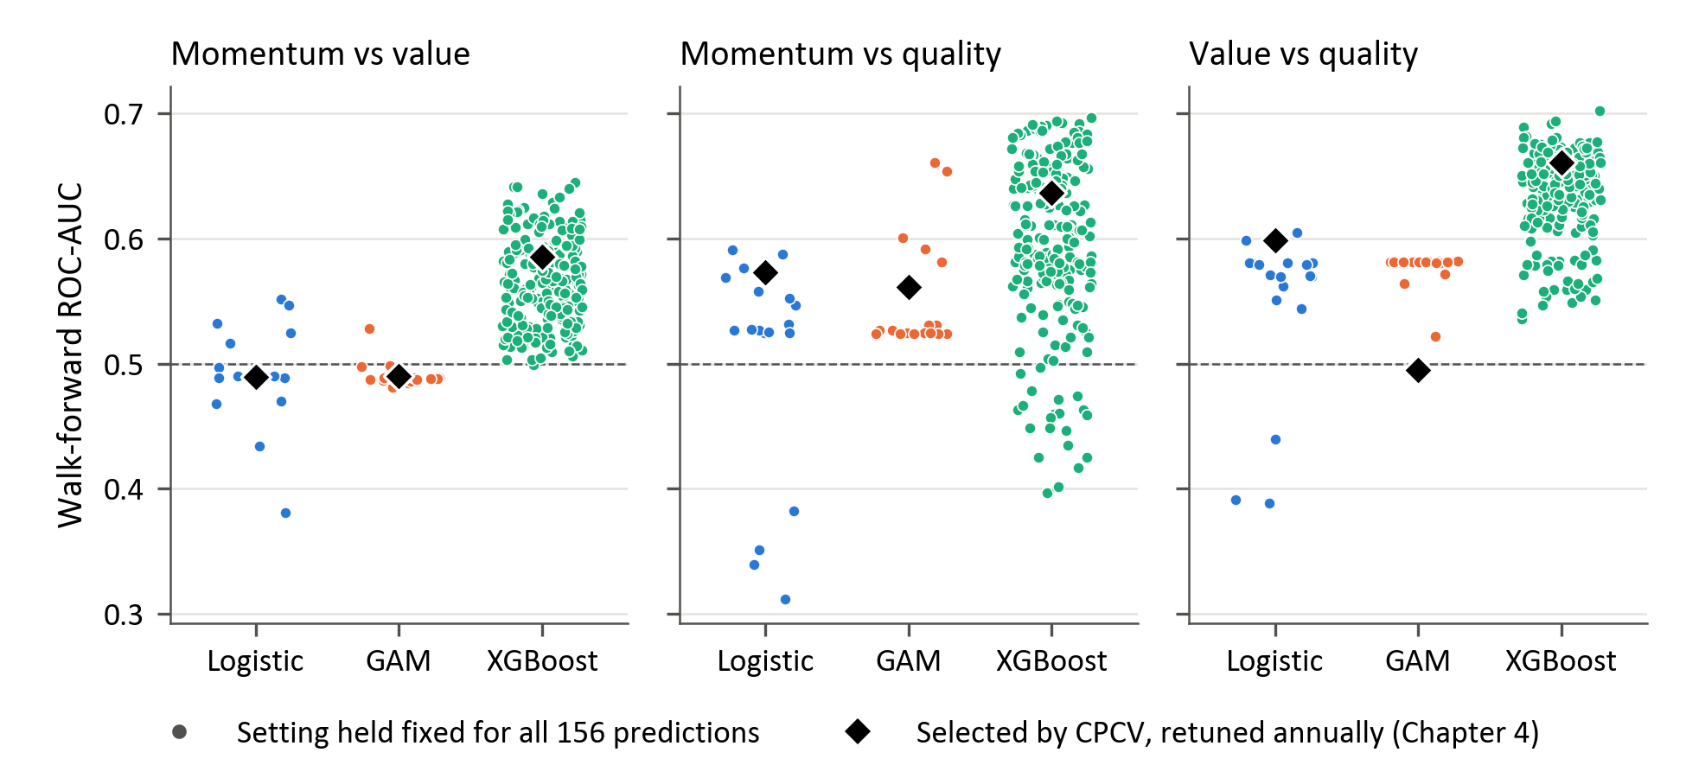
Figure C.1: Walk-forward ROC-AUC for fixed settings and CPCV selections

The relative weights of the descriptors within each factor are proprietary to Momentum Investments and are not published, so the factor composites cannot be replicated exactly from public information.
The factor returns span 939 weeks, from 9 April 2007 to 31 March 2025 (the candidate feature file covers 944 weeks from 5 March 2007). The 12-week rolling windows of the relative-factor features remove the first 11 (939 − 11 = 928), and the four-week lag removes a further four (928 − 4 = 924), so the matrix begins on 23 July 2007. Trend-scanning labels cannot be resolved for the final ten weeks (Section 3.5), leaving 914 labelled observations per factor pair (23 July 2007 to 20 January 2025).
MI is estimated after discretising each series into 20 quantile bins and normalised by the larger of the two marginal entropies; the distance is one minus the normalised MI. The Ward clustering is applied to each feature’s profile of distances to all other features, so the cut height of 2 is measured on these profiles rather than on MI distance itself. Appendix B reports the clusters and the sensitivity of the selection to these choices.
Log-loss averages (−ln p) over the 156 weeks, where p is the probability the model gave to the outcome that occurred. A forecast of 0.5 in every week, which expresses no view, therefore scores −ln 0.5 = ln 2 ≈ 0.693 whatever happens. A model with a higher log-loss has assigned its probabilities worse than this uninformative forecast, typically because it was confident about outcomes that did not occur.

